Legends, Lochs, Castles and Rebellious Highlanders: Welcome to Scotland

LycéeGalilée
3/22/2017
The Scottish Parliament
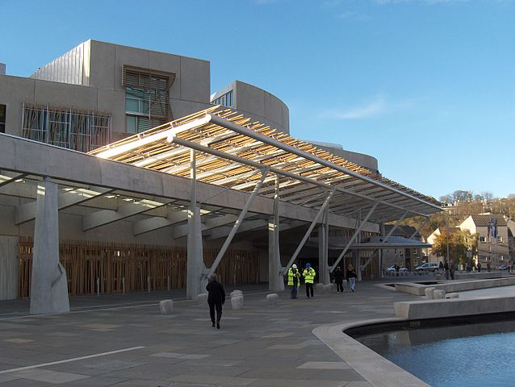
Brief history
The Scottish Parliamentis located in the capital city, Edinburgh. The Parliament is an elected body comprising 129 members known as Members of the Scottish Parliament (MSPs), elected for four-year terms.
The original Parliament of Scotland existed from the early 13th century in theKingdom of Scotland, until the Acts of Union in 1707 founding the Kingdom of Great Britain.
Figure 1 - Scottish Parliament Building (Holyrood, Edinburgh)
In 1997 devolution was accepted by the Scottish people after a referendum. As a consequence, the current Parliament was created in 1998. The Scotland Act specifies the powers of the Parliament – the areas in which it can make laws– by explicitly listing those "reserved" to the Parliament of the United Kingdom. The Scottish Parliament has the power to legislate in all areas that are not explicitly reserved to Westminster (which is open to negotiation). The first meeting of the new Parliament took place on 12 May 1999.
Since September 2004, the Parliament convenes in theScottish Parliament Building. It was designed by a Spanish architect. You can see leaf-shaped buildings and gabion walls formed from the stones of previous buildings.

The mace
In front of the Presiding Officers' desk is the parliamentary mace, which is made from silver and gold. The inlaid gold band symbolises the relationship between the Parliament, its people and the land. Engraved on the head of the mace are the words 'Wisdom, Justice, Compassion and Integrity' - these are a reference to the ideals that the people of Scotland aspire to for their Members of Parliament. The founding of the Scottish Parliament is commemorated by the words ‘There shall be a Scottish Parliament - The Scotland Act 1998' (the first words of the Act). Presented to the Scottish Parliament by the Queen upon Parliament's official opening in 1999, the mace is displayed in a glass case, suspended from the lid. At the beginning of each sitting in the chamber, the lid of the case is rotated so that the mace is above the glass, to symbolise that a full meeting of the Parliament is taking place.
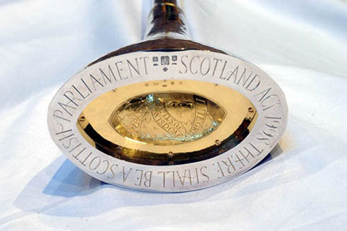
The role of religion
Since September 2012, the first item of business on Tuesday afternoons is usually Time for Reflection. A speaker addresses members for up to four minutes about faith. This contrasts with the formal style of "Prayers" in the House of Commons. Speakers are chosen to represent the religious beliefs listed in the Scottish census. Faith groups can make direct representations to the Presiding Officer to nominate speakers.
Figure 2 - The Parliamentary Mace, made of silver and gold panned from Scottish rivers

Proceedings
Debate is more informal than in some parliamentary systems.Members may call each other directly by name, and hand clapping is allowed.Speeches to the chamber are normally delivered in English, but members may use Scots or Gaelic, with the agreement of the Presiding Officer. After each election, Parliament elects one MSP to serve as Presiding Officer, whose role is to chair chamber proceedings impartially.He represents the Scottish Parliament at home and abroad. He may also discipline members who fail to observe the rules of the Parliament.
At Decision Time, the Presiding Officer proposes the motions and amendments and asks "Are we all agreed?". The MSPs first vote orally. If there is audible dissent, the Presiding Officer announces "There will be a division" and members vote by means of electronic consoles on their desks.
Throughout the building there are many repeated motifs. Can you find them? What do they represent? Choose an example

Nessy’schallange

How do you say “Scottish Parliament” in Gaelic? In Scots?or with the Scottish accent? Ask a stranger and practice with them

What are the powers devolved to the Scottish Parliament? In which areas can the Parliament make law?
…………………………………………………………………………………………………………………………………………………………………………………………………………………………………………………………………………………………………………………………………………………………………………………………………………………………………………………………………………………………………………………………………………………………………………………………………………………………………………………………………………………………………………………………………………………………………………

PARLIAMENT QUIZZ

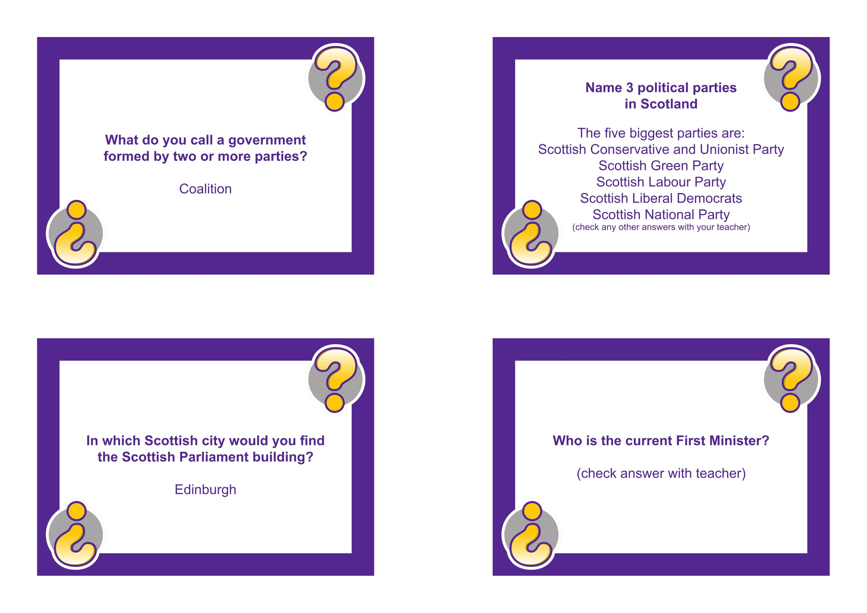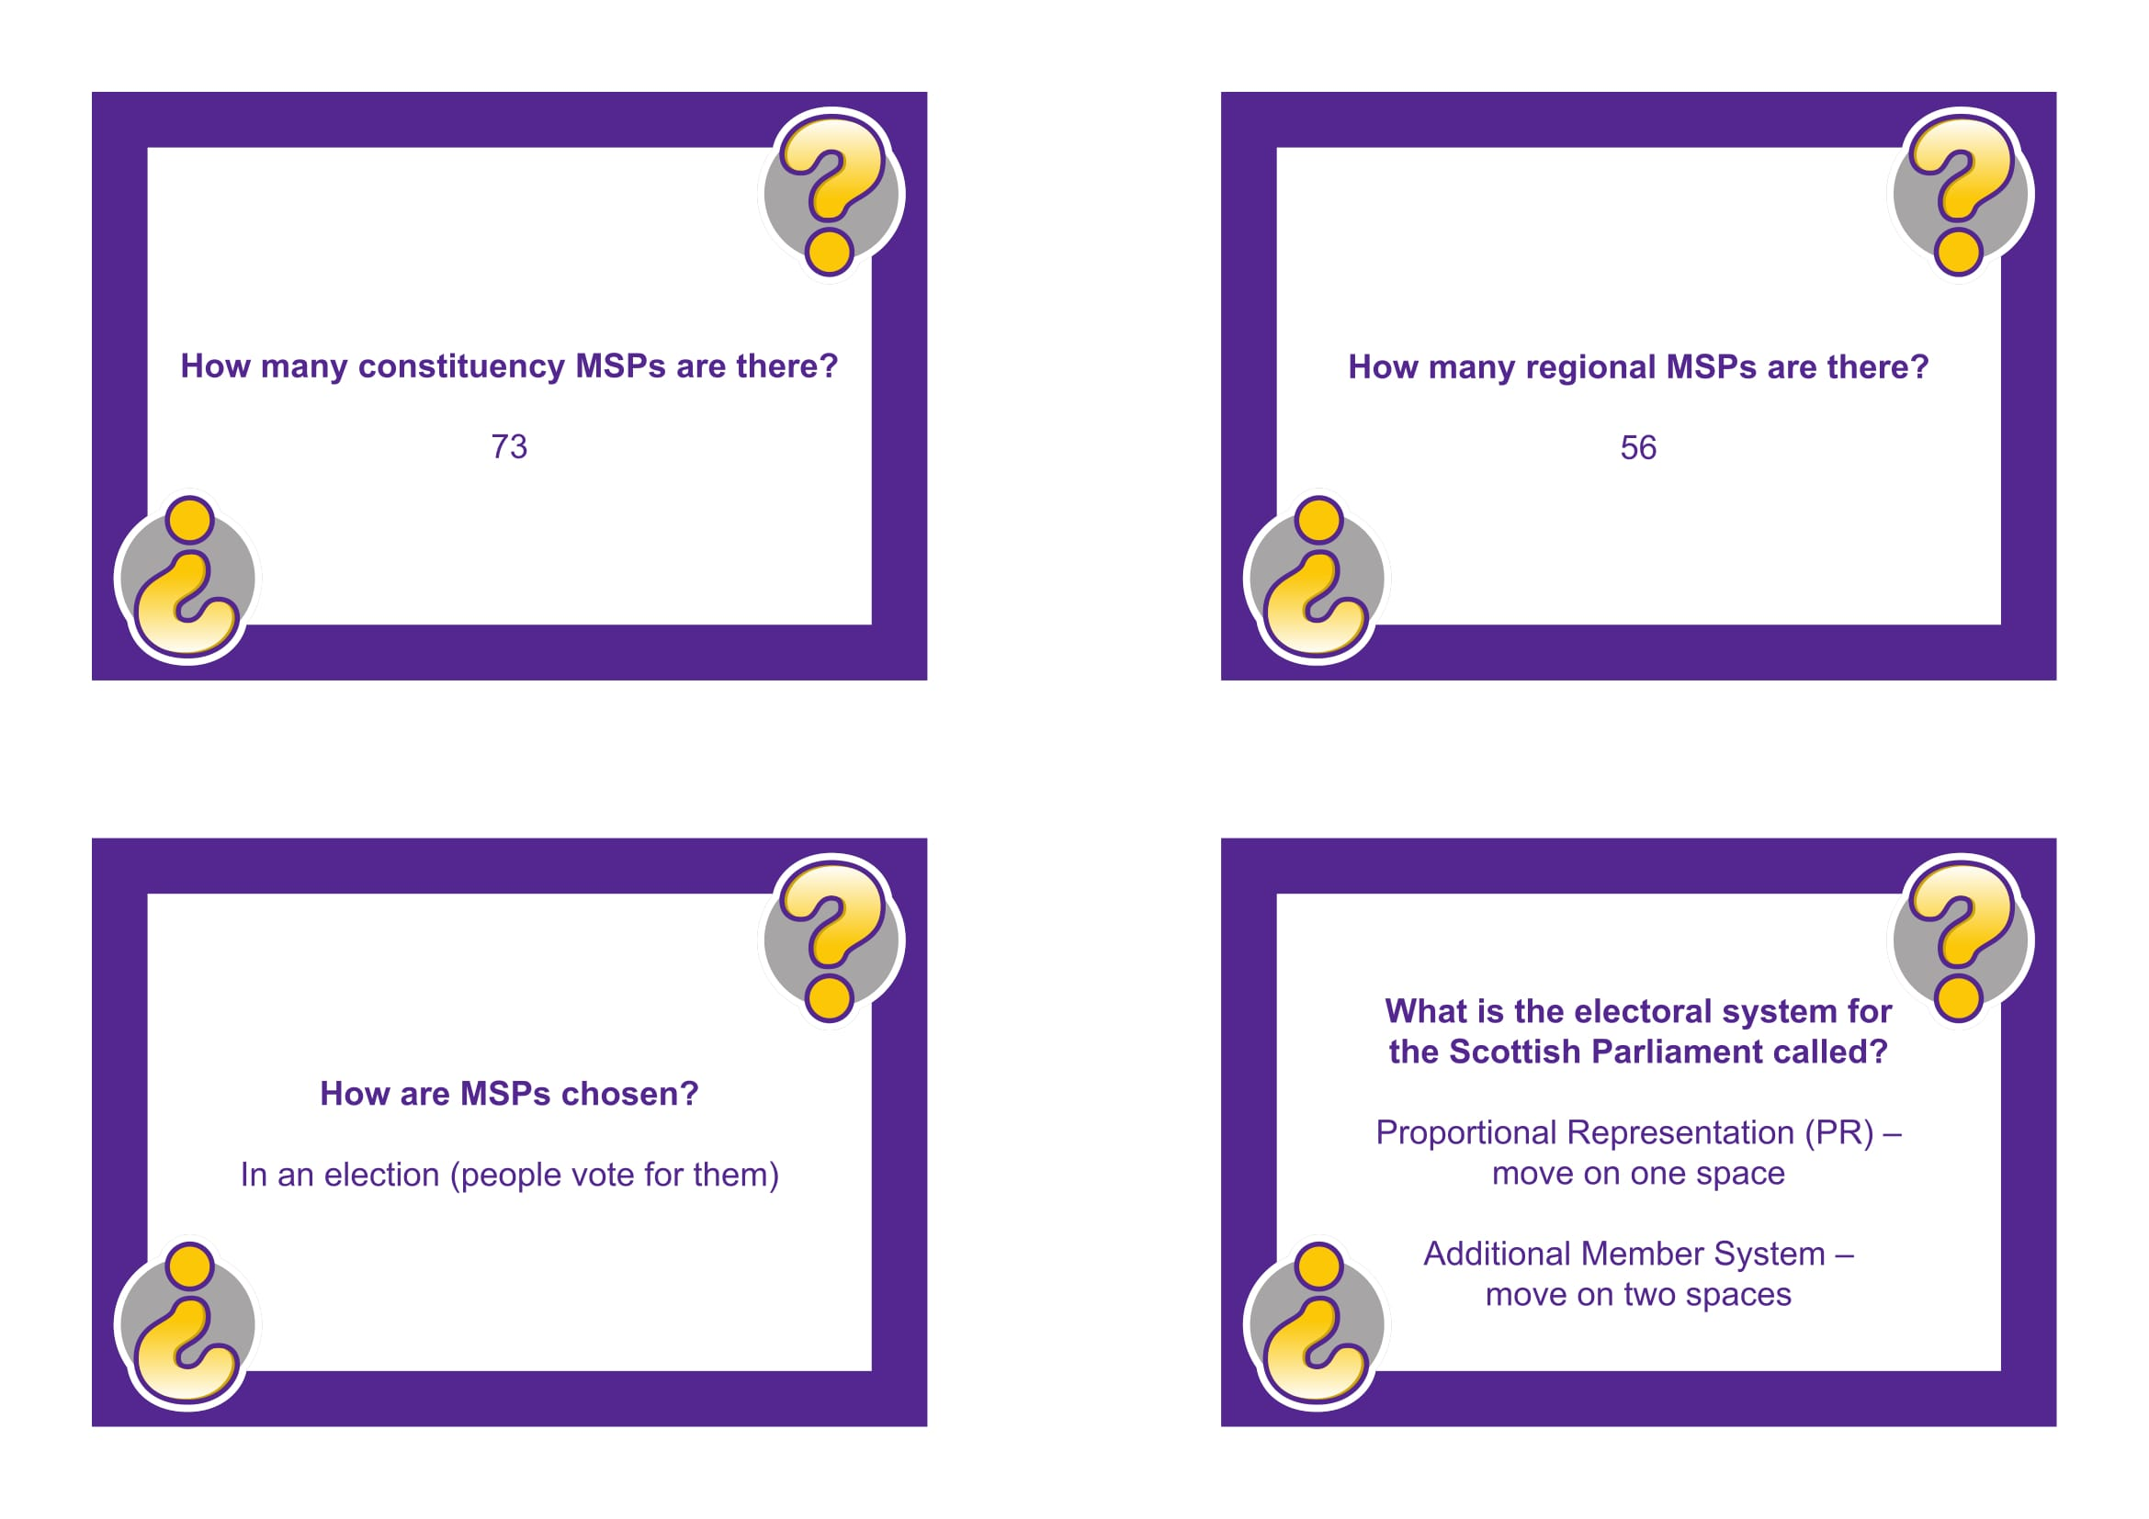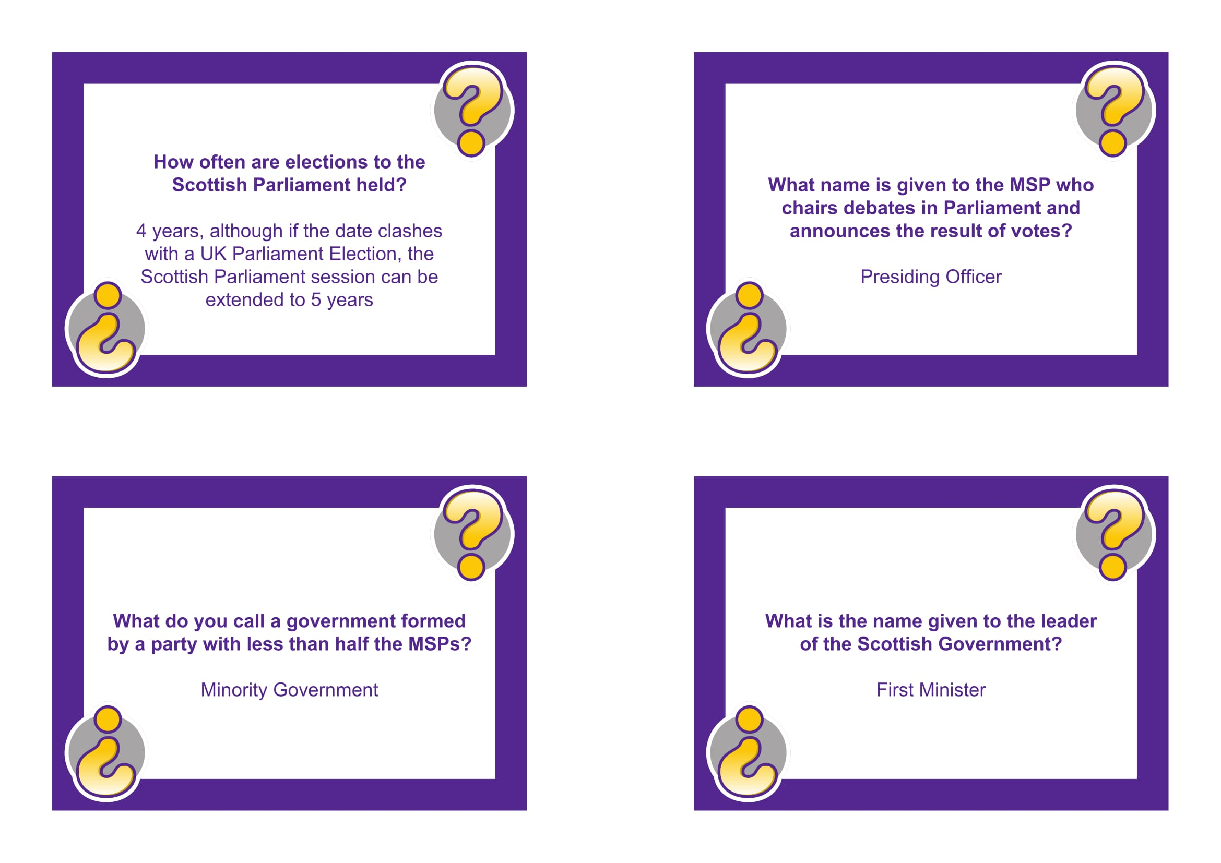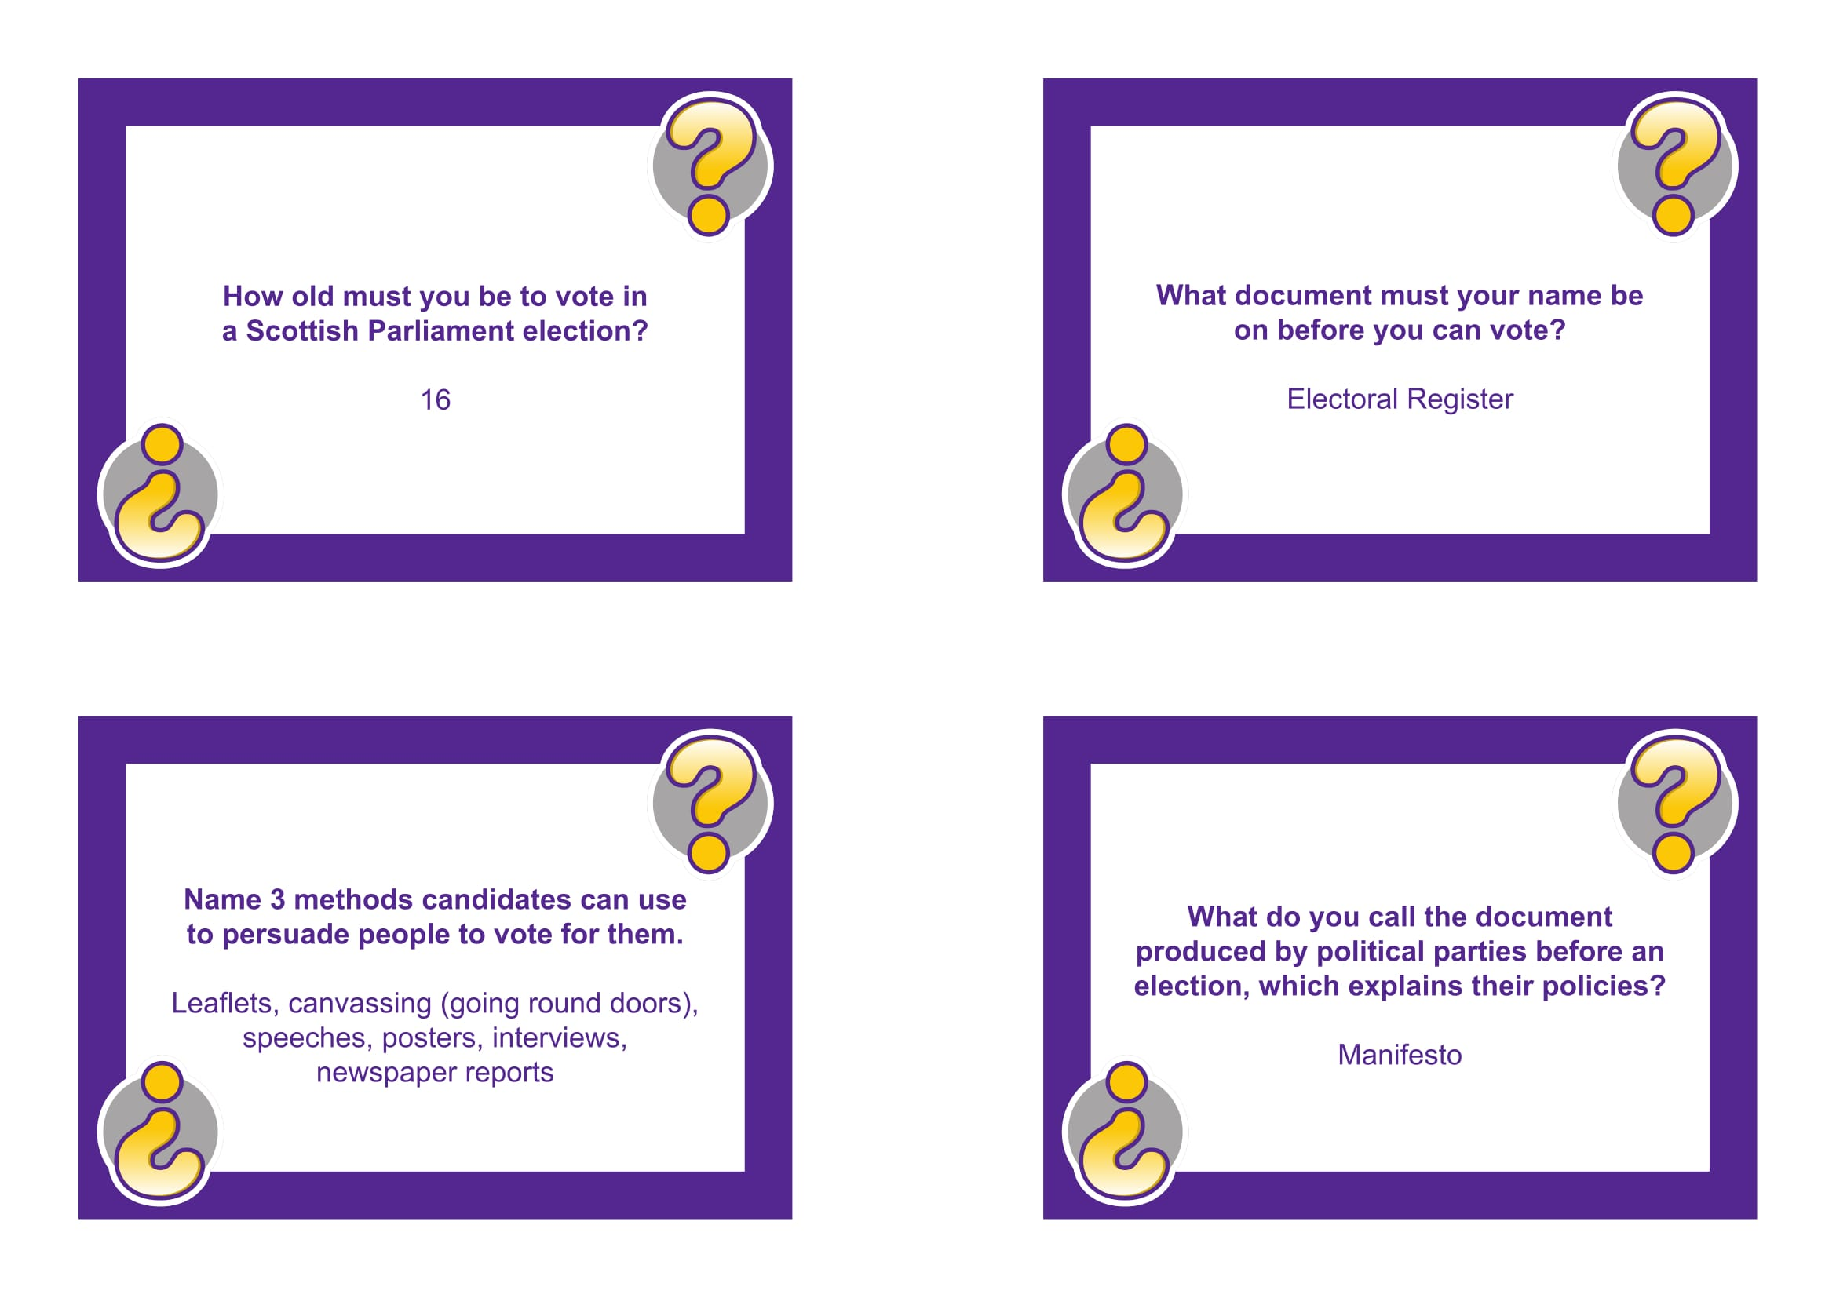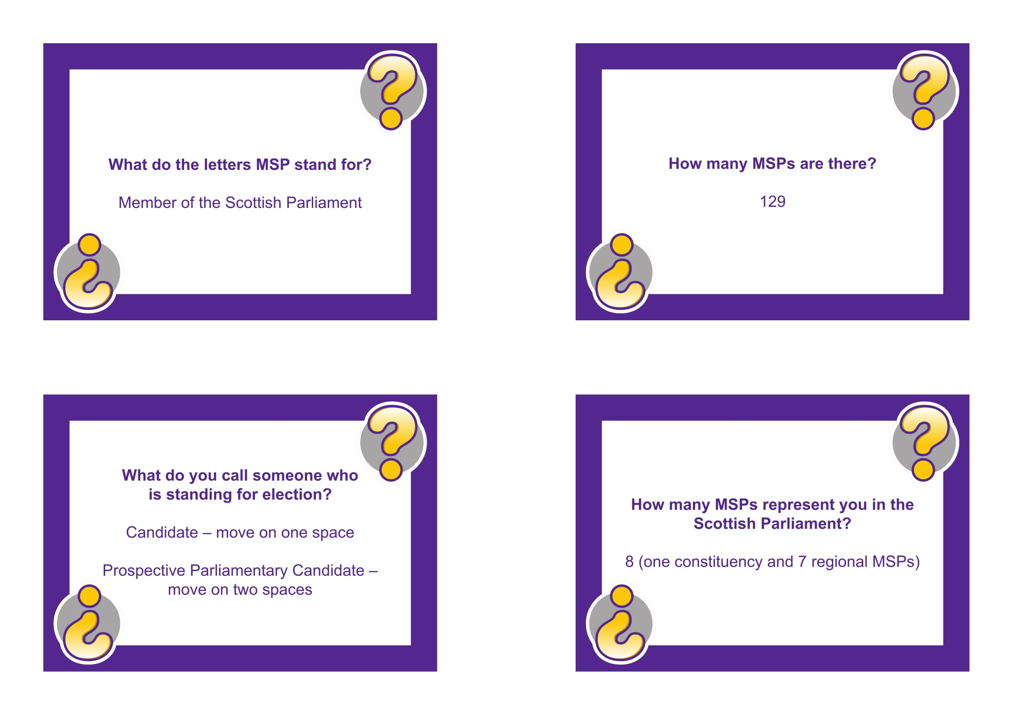

The Royal Botanic Garden Edinburgh
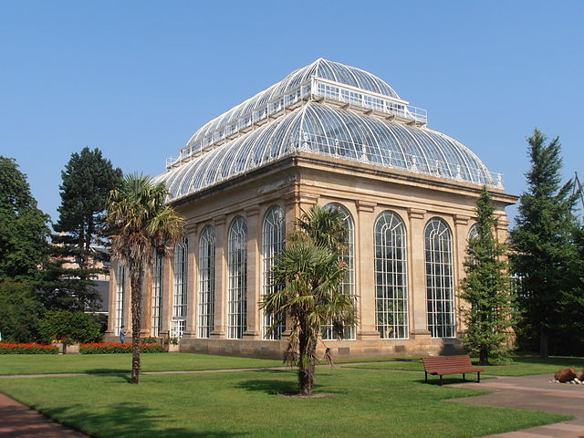
Figure 3 - The Palm House, Royal Botanic Garden Edinburgh

The Royal Botanic Garden Edinburgh(RBGE) is a scientific centre for the study of plants, their diversity and conservation, as well as a popular tourist attraction. It was founded in 1670 as a physic garden to grow medicinal plants. It is the second oldest botanic garden in Britain after Oxford's. In the early 1820s the garden moved to its present location adjacent to InverleithRow, and the Leith Walk site was built. The Temperate Palm House, which remains the tallest in Britain, was built in 1858.In 1877 the city acquired Inverleith House and added it to the existing gardens, opening the remodelled grounds to the public in 1881.

Today it occupies four sites across Scotland — Edinburgh,Dawyck, Logan and Benmore — each with its own specialist collection. The RBGE's living collection consists of more than 13,302 plant species (about 4%of all known plant species),the herbarium contains in excess of 3 million preserved specimens.
The Royal Botanic Garden Edinburgh is the main garden and the headquarters. It is a hugely important player in a worldwide network of institutions seeking to protect biodiversity. Located one mile from the city centre, it covers 70 acres (28 ha).
The Garden is home to the largest collection of wild-origin Chinese plants outside China. The Scottish Heath Garden, recreating the plantings and landscape of the Scottish highlands; the world-famous Rock Garden, which is home to over 5,000 alpine plants and the 165m-long Herbaceous Border, are backed by an outstanding century-old Beech Hedge.
The RBGE is actively involved in conservationprojects both in the UK and internationally.
In addition to the RBGE's scientific activities the garden remains a popular destination for both tourists and locals. Locally known as "The Botanics", the garden is a popular place to go for a walk, particularly with young families.

What are your favourite plants in the Garden or your favourite place? Take a picture of them; Make a movie of a perfect stranger singing a song or making a very short poem with the name of the plant you choose.

TheNational Wallace Monument

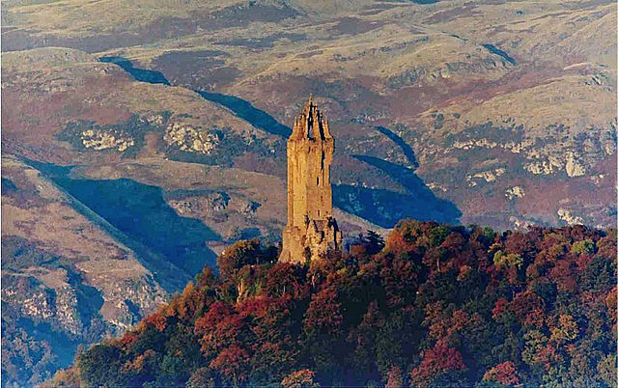
The Tower

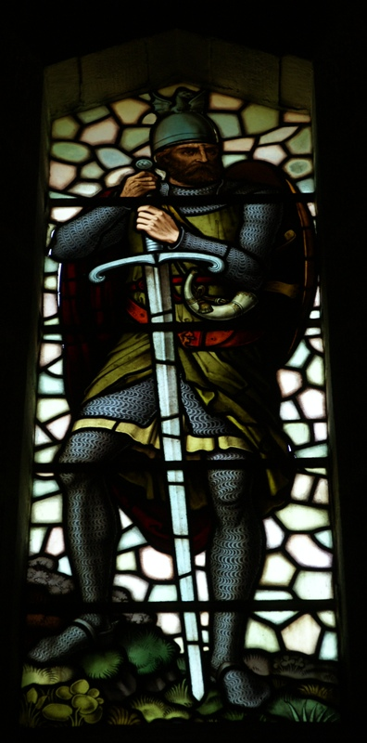
The tower was constructed following a fundraising campaign, which accompanied a resurgence ofScottish national identityin the 19th century. In addition to public subscription, it was partially funded by contributions from foreign donors, includingItaliannational leaderGiuseppe Garibaldi. Completed in 1869,the monument is a 67-metre (220 ft) sandstone tower, built in theVictorian Gothic style.
Figure 4 - Wallace on stained glass in the Wallace monument, 19th c
Figure 5 - National Wallace Monument and Ochil Hills in autumn
The tower stands on the Abbey Craig, from which William Wallace was said to have watched the gathering of the army ofKing Edward I of England, just before theBattle of Stirling Bridge in 1297. Visitors climb the 246 step spiral staircase to the viewing gallery inside the monument's crown, which provides expansive views of theOchil Hillsand theForth Valley.A number of artefacts believed to have belonged to Wallace are on display inside the monument, including theWallace Sword, a 1.63-metre (5 ft, 4 in) long sword weighing almost three kilograms. Inside is also aHall of Heroes, a series of busts of famous Scots, effectively a small nationalHall of Fame.
William Wallace, a Scottish hero of the Wars of Scottish independence

William Wallace (?-1305) was a member of the lesser nobility, but little is definitely known of his family history. When Wallace was growing up, King Alexander III ruled Scotland. His reign had seen a period of peace and economic stability. After his death, the lack of a clear heir led to a period known as the "Great Cause", with several families claiming the throne.
With civil war threatening to break out, King Edward I of England (1239-1307) was invited in by the Scottish nobility to arbitrate. But he insisted that all of the candidates recognise him as Lord Paramount of Scotland, which symbolizes his will to dominate and eventually incorporate Scotland in his kingdom. In early November 1292, he named John Balliol. John was perceived as weak, but he eventually denounced his homage to Edward and the war broke out between the two kings in 1296. In April, the Scots were defeated at the Battle of Dunbar and by July, Edward had forced John to abdicate.
Wallace is first known for his assassination of the English High Sheriff of Lanark, in May 1297. He then joined with William the Hardy and they attacked the English. This was one of several rebellions taking place across Scotland, including Moray’s in the North. The uprising suffered a blow when the nobles submitted to the English. Wallace and Moray continued their rebellions.
On 11 September 1297, an army led by Wallace and Moray won the Battle of Stirling Bridge, even though the Scottish army was vastly outnumbered. The bridge collapsed under the overwhelming weight and many English soldiers drowned. Thus, the Scots won a significant victory, boosting the confidence of their army. After the battle, Moray and Wallace assumed the title of Guardians of the Kingdom of Scotland on behalf of King John Balliol. Moray died of wounds suffered on the battlefield sometime in late 1297.
The type of engagement conducted by Wallace was characterized by opportunistic tactics. Wallace used a forest as a base for raiding. This was in contrast to the contemporary views on chivalric warfare which were characterized by strength of arms and knightly combat. Therefore, the battle embittered relations between the two nations. Around November 1297, Wallace led a large-scale raid into northern England, through Northumberland and Cumberland. In a ceremony, at the 'Kirk o' the Forest' (Selkirk), towards the end of the year, Wallace was knighted.
In April 1298, Edward ordered a second invasion of Scotland. The English regained some castles, but failed to bring William Wallace to combat; the Scots shadowed the English army, intending to avoid battle until shortages of supplies and money forced Edward to withdraw, at which point the Scots would harass his retreat.
In July however, Edward attacked the Scots army in Falkirk. The Scots lost many men, Wallace escaped, his military reputation suffered badly. By September 1298, Wallace resigned as Guardian of Scotland in favour of Robert the Bruce, Earl of Carrick and future king.
Details of Wallace's activities after this are vague, he left on a mission to the court of King Philip IV of France to plead the case for assistance in the Scottish struggle for independence. By 1304 Wallace was back in Scotland, and involved in skirmishes. Wallace evaded capture until 5 August 1305 when a Scottish knight loyal to Edward, turned Wallace over to English soldiers.
Wallace was transported to London, then taken to Westminster Hall, where he was tried for treason and for atrocities against civilians in war, "sparing neither age nor sex, monk nor nun." He responded to the treason charge, "I could not be a traitor to Edward, for I was never his subject." Following the trial, on 23 August 1305, Wallace was taken to the Tower of London, then stripped naked and dragged through the city at the heels of a horse. He was hanged, drawn and quartered. That is to say that he was strangled by hanging, but released while he was still alive, emasculated, eviscerated and his bowels burned before him, beheaded, then cut into four parts. His preserved head (dipped in tar) was placed on a pike atop London Bridge. His limbs were displayed, separately, in Newcastle, Berwick, Stirling, and Perth.

Name and describe your favourite Wallace artefact from the gallery. What do you like about it?

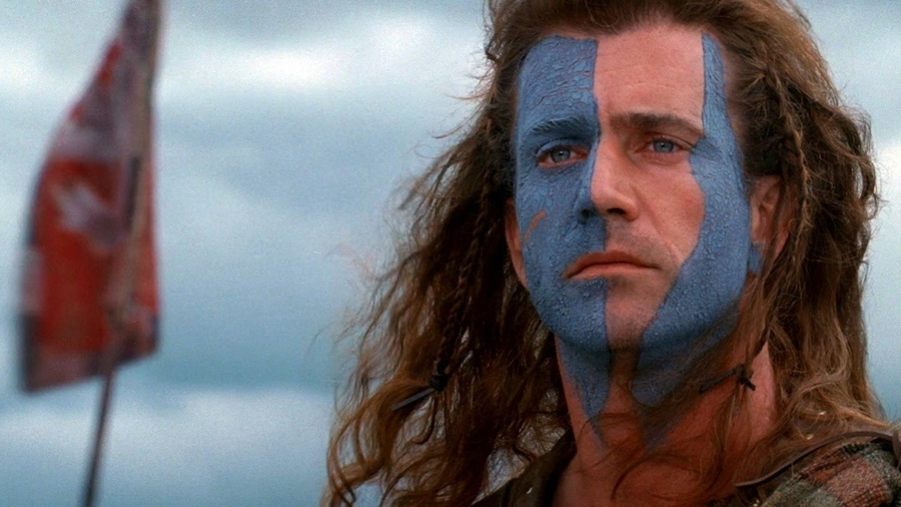
Nessy’schallange
Ask a stranger what they know about Wallace? Do they know the biopic, Braveheart (1995, starring Mel Gibson)?
Make him tell a quote from bravehart:
Magistrate: The prisoner wishes to say a word.
William Wallace:Freeeedommm!
Get a movie from this and show it to your leaders !

Why is Wallace associated with Scottish nationalism?

……………………………………………
……………………………………………
……………………………………………
……………………………………………
……………………………………………
……………………………………………
……………………………………………
……………………………………………
……………………………………………
……………………………………………
……………………………………………
……………………………………………
……………………………………………

Stirling Castle

Stirling Castle is one of the largest and most important castles in Scotland. It castle sits atop Castle Hill. Most of the principal buildings of the castle date from the fifteenth and sixteenth centuries. A few structures of the fourteenth century remain, while the outer defences date from the early eighteenth century. Several Scottish Kings and Queenshave been crowned at Stirling, including Mary, Queen of Scots, in 1542. There have been at least eight sieges of Stirling Castle, including several during the Wars of Scottish Independence, with the last being in 1746, when Bonnie Prince Charlie unsuccessfully tried to take the castle.

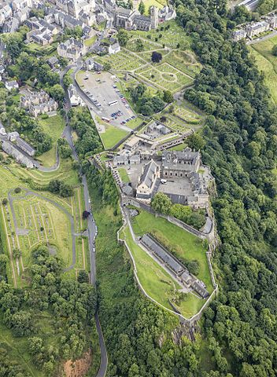
Many legends surround the foundation of the castle during the medieval times. For example, a chronicler, William Worcester, associated Stirling with the court of the legendary King Arthur.
Figure 6 - Stirling Castle, aerialview
The first record of Stirling Castle dates from around 1110.It appears to have been an established royal centre and an administration centre. Kings liked to hunt in the castle deer park.
In 1296, Edward I, King of England, invaded Scotland. The English found Stirling Castle abandoned and empty, and occupied this key site. They were dislodged the following year, after the victory at the Battle of Stirling Bridge, the Scots set up a siege during which the English starved. The castle then changed hands again and again, depending on which side (the Scots or the English) held the upper hand.
Under the early Stewart kings Robert II (reigned 1371–1390) and Robert III (reigned 1390–1406), the earliest surviving parts of the castle were built.Almost all the present buildings in the castle were constructed between 1490 and 1600. The architecture of these new buildings shows an eclectic mix of English, French and German influences, reflecting the international ambitions of the Stewart dynasty. They built a Renaissance palace. James V created the centrepiece of the castle, the Royal Palace, built by masons brought from France.He died young, leaving unfinished work to be completed by his widow, Mary of Guise. His infant daughter, Mary, Queen of Scots, was brought to Stirling Castle for safety, and crowned in the chapel royal on 9 September 1543.She was then sent in France in 1548. In the 1550s, during the Regency of Mary of Guise, Anglo-French hostilities were fought out in Scotland. Artillery fortifications were added to the south approach of the castle, and these form the basis of the present Outer Defences.
The young King James, Queen Mary’s son, was crowned nearby and grew up in the castle. Stirling became the base for James' supporters, while those nobles who wished to see Queen Mary restored gathered at Edinburgh, under William Kirkcaldy of Grange. Grange led a raid on Stirling in 1571, attempting to round up the Queen's enemies, but failed to gain control of the castle or the King.
James' first child, Henry, was born in the castle in 1594, and the present Chapel Royal was constructed for his baptism on 30 August. Like his predecessors Henry spent his childhood here, until the Union of the Crownsof 1603, when his father succeeded as King of England and the royal family left for London.
After their departure, Stirling's role as a royal residence declined, and it became principally a military centre. It was used as a prison for persons of rank during the 17th century.During this time, the castle's military role became increasingly important. A powder magazinewas built in the castle gardens, and a formal garrison installed.
The Royal Lodgings have now been returned to something approaching their former glory. A major programme of research and re-presentation, lasting 10 years and costing £12 million, was completed in summer 2011. Since January 2002, the Tapestry Studio at West Dean College has been working on a recreation of The Hunt of the Unicorn tapestries, 4 of which are now hanging in the restored Queen's Presence Chamber in the Royal Palace.

Stirling Castle Quiz
What is your favourite place/room in the castle? Why?

Why was the castle so difficult to take?

5. What would you do with a Selkirk bannock? a) put it in a rock pool
b) eat it
c) wear it on your head
It is a kind of rich fruit bread.
2. From which language is Scots most directly descended?

a) French
b) Latin
c) Gaelic
d) Old English
e) Old Norse
f) Dutch
3. Would you use a spirtlefor

a) hurling dung?
b) stirring porridge?
c) taking stones out of horses’ hooves?
6. How many are there in a deil’sdizzen? ……………………

- Is Scots…

a) a language?
b) a dialect?
c) bad English?

4. Which is the odd one out? horniegollach, clipshear, forkietailie, pismire, switchpool, gavelack

7. Which is the odd one out? pee-the-bed, powheid, carl doddie, grannie’s thimmles, sticky-willie

8. Would you keep your kebbockin

a) a cauld press?
b) a printing press?
c) a trouser press?

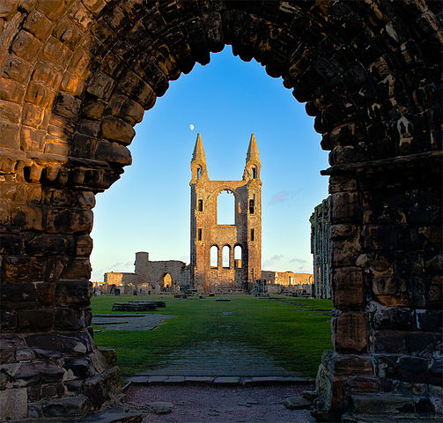
The cathedral of Saint Andrew
Figure 7 - Saint Andrews cathedral

The cathedral was founded in 1158 and became the centre of the Medieval Catholic Church in Scotland as the seat of the Archdiocese of St Andrews. It was built to supply more accommodation than the older church afforded. Today, remains of this church are the square tower, 33 metres (108 feet) high, and the quire.
Work began on the new cathedral in 1158 and continued for over a century. The west end was blown down in a storm and rebuilt between 1272 and 1279. It was dedicated on 5 July 1318. It had, besides a central tower, six turrets; of these remain two at the east and one of the two at the western extremity, rising to a height of 30 metres (100 feet).A fire partly destroyed the building in 1378; restoration and further embellishment were completed in 1440.The cathedral was served by a community of Augustinian Canons, the St Andrews Cathedral Priory.
In 1559, during the Scottish reformation, Catholic mass was outlawed, and the building was stripped of its altars and images; and by 1561 it had been abandoned and left to fall into ruin.
Large portions of the ruins were taken away for building purposes, and nothing was done to preserve them until 1826. Since then it has been tended with scrupulous care.

Saint Andrews Castle

St Andrew's Castleis a picturesque ruin located in the coastal Royal Burgh of St Andrews. There has been a castle standing at the site since the 12th century. It housed the burgh’s wealthy and powerful bishops during the years before the Protestant Reformation. In their Latin charters, the Archbishops of St Andrews wrote of the castle as their Palace.
During the Wars of Scottish Independence, the castle was destroyed and rebuilt several times as it changed hands between the Scots and the English. In 1336-1337, it was destroyed by the Scots to prevent the English from once again using it as a stronghold.
It remained in this ruined state until Bishop Walter Trailrebuilt it at the turn of the century. His castle forms the basis of what can be seen today. He completed work on the castle in about 1400. During the medieval times, the castle also served as a notorious prison. The castle's dungeonis a dank and airless pit cut out of solid rock below the north-west tower. It housed local miscreants who fell under the Bishop's jurisdiction as well as several more prominent individuals such as Duke of Rothesayin 1402and ArchbishopPatrick Graham, who was judged to be insane and imprisoned in his own castle in 1478.
During the Scottish Reformation, the castle became a centre of religious persecution and controversy. In 1521 James Beaton won the seat of St Andrews, he altered the defences to enable the castle to withstand a heavy artillery attack, which was a threat as tensions grew between English Protestantsand Scottish Catholics.In 1546 David Beaton imprisoned the Protestant preacher George Wishart(1513-1546) and had him burnt at the stake in front of the castle walls. Today, brick lettering with his initials marks the spot where he died. In May of that same year, Wishart's friends conspired against the cardinal: after overcoming the garrison, they murderedCardinal Beaton and hung his body from his window on the front of the castle.
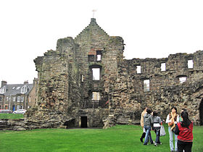
Following this murder, the Protestants took refuge in the castle and formed the first Protestant congregation in Scotland. A long siegewas ordered by the Scottish Regent, James Hamilton.

Figure 8 - A view from the courtyard, St Andrews castle

In 1547, a French fleet arrived bringing an Italian engineer who directed a devastating artillery bombardment to dislodge the Protestant. The castle was quickly rendered indefensible; within six hours. The defeated Protestants were taken away: some were imprisoned in France while others were condemned to the galleys.
With the eventual success of the Reformation in Scotland, the office of the bishop was increasingly eroded until it was finally abolished in 1689. Deprived of any function, the castle fell rapidly into ruin. By 1656, it had fallen into such disrepair that the burgh council ordered the use of its materials in repairing the pier. The principal remains are a portion of the south wall enclosing a square tower, the "bottle dungeon," the kitchen tower, and the underground mine and counter-mine (built during the siege).

The Royal and Ancient Golf Club of St Andrews

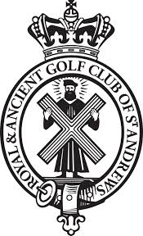
St Andrews is known worldwide as the "home of golf". This is in part because the Royal and Ancient Golf Club, founded in 1754, exercises legislative authority over the game worldwide (except in the United States and Mexico). Indeed, in 1897, the Society of Saint Andrews Golfers codified the rules of golf, and, gradually over the next 30 years, was invited to take control of the running of golf tournaments at other courses. Saint Andrews is also known because the famous links (acquired by the town in 1894) is the most frequent venue for The Open Championship, the oldest ofgolf's fourmajor championships. Visitors travel to St Andrews in great numbers for several courses ranked amongst the finest in the world.
The Royal and Ancient Golf Club had a male-only membership policy; in 2012, former British Prime Minister Gordon Brown called on the club to abandon this. In February 2015 the club's first female honorary members were announced – Princess Anne for example. At that time the club also announced, "In addition to the honorary members, a number of women have been admitted as members of the club with more set to follow in the coming months."Also in 2015, Lady Bonallack became the first woman to take part in a match as a member of the club!

1471 Parliamentary Act:
“Also that each yeoman who cannot handle a bow should have a good axe and a targe of leather to resist the shot of England, which is of no cost but the value of a hide. And that each sheriff, steward, bailie and other officer hold a wappenschaw within the bounds of their office according to the tenor of the act of parliament, so that in default of the said wappenschaw our sovereign lord's lieges will not be bereft of harness when it is needed, and that football and golf be discontinued in the future, and butts made up and shot used according to the tenor of the act of parliament.”
This act bans football and gulf so that of fighting-age would practice archery, which is a more useful skill to have for defending against the English.
What are the different kinds of green? Characterize each type, and specify its use.

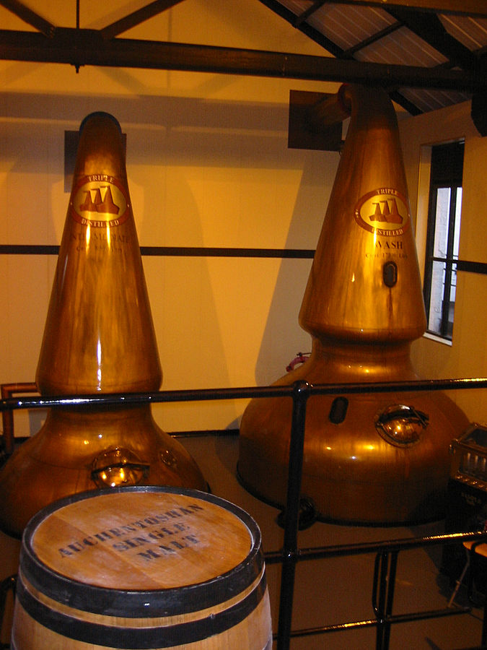
Blair Athol distillery
Figure 9 - Copper pot stills, in a Scottish distillery

Blair Athol Distillery stands at the gateway to the Scottish Highlands.It was founded in 1798. It wasoriginally named 'Aldour', after the Allt Dour burn (or stream) the distillery draws its water from.Blair Athol contributes to the Bell's Blend, the most popular blended whisky in the UKand a leading brand in South Africa and Scandinavia.
The distillery closed down in 1932. The mothballed distillery was bought by Arthur Bell and Sons, but didn't open again until it was rebuilt in 1949.

How do you make whisky? Write down and photograph the major steps.

Do Scottish think that whisky is part of the country’s emblems?

Interview someone randomly and give his/her opinion
……………………………………………………………………………………………………………………
…………………………………………………………………………………………………………………………………………………………………………………………………………………………………………

Ask people what song could be sung while drinking whisky…
Isle of Skye
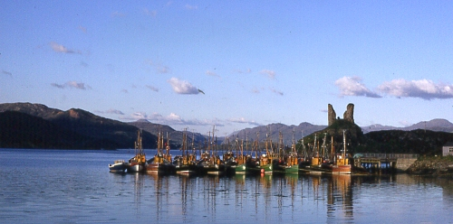
Figure 10 - Kyleakin harbour, Isle of Sky

Skyeis the largest and northernmost of the major islands in theInner Hebrides. At 1,656 square kilometres (639 sq mi), Skye is the second-largestisland in ScotlandafterLewis and Harris.Its rocky slopes provide some of the most dramatic mountain scenery in the country.The ascent ofSgùrr a' Ghreadaidhis one of the longest rock climbs in Britain and theInaccessible Pinnacleis the only peak in Scotland that requires technical climbing skillsto reach the summit.

History
The island has been occupied since theMesolithicperiod (a hunter-gatherer site from 7th millennium BC was discovered), and its history includes a long period of domination byClan MacLeodandClan Donald. Other independent clans existed like the Mackinnons. The MacDonalds ofSouth Uist were rivals of the MacLeods, and an attempt by the former to murder church-goers in retaliation for a previous massacre onEigg, resulted in theBattle of the Spoiling Dykeof 1578.Skye has a rich heritage of ancient monuments from this period. Dunvegan Castle has been the seat of Clan MacLeod since the 13th century. It is reputed to have been inhabited by a single family for longer than any other house in Scotland.
During the 18th-centuryJacobite, Flora MacDonaldbecame famous for rescuing PrinceCharles Edward Stuartfrom theHanoverian troops. The memory of Flora is strongly associated with their escape via Skye.
After this rebellion the clan system was broken up. Entire communities were replaced with sheep farms, forced emigrations to distant lands also occurred (this is known as the Clearances). Thirty thousand people were evicted between 1840 and 1880 alone, many of them forced to emigrate to theNew World. For example, the settlement of Lorgill was cleared on 4 August 1830. Every crofter (owner of a small farm) under the age of seventy was removed and placed on board a ship on threat of imprisonment, with those over that age being sent to thepoorhouse.During the 19th century, the inhabitants of Skye were also devastated byfamine.Resident numbers declined from over 20,000 in the early 19th century to just under 9,000 by the closing decade of the 20th century. The "Battle of the Braes" (1882) involved a demonstration against the eviction notices. Disturbances continued until the end of the century and on one occasion 400 soldiers were deployed on Skye to maintain order.The ruins of cleared villages can still be seen at Lorgill and Boreraig for example.
The island today
The main industries are tourism, agriculture, fishing and forestry. The local flora is dominated byheathermoor. The island's largest settlement isPortree (estimated population 2,264 in 2011), known for its picturesque harbour.There are links to various nearby islands by ferry and, since 1995, to the mainland bya road bridge.
Skye has provided the locations for various novels and feature films and is celebrated in poetry and song.Stardust, released in 2007 and starringRobert De NiroandMichelle Pfeiffer, featured scenes near Uig and Loch Coruisk. Another 2007 film,Seachd: The Inaccessible Pinnacle, was shot almost entirely in various locations on the island.Some of the opening scenes inRidley Scott's 2012 feature filmPrometheuswere shot at the Old Man of Storr.
Students of Scottish Gaelic travel from all over the world to attendSabhal MòrOstaig, the Scottish Gaelic college based nearKilmorein Sleat.
Skye has a strongfolk musictradition. TheIsle of Skye Music Festivalfeatured sets from TheFun Lovin' CriminalsandSparks, but collapsed in 2007.

Nessy’schallange
Ask someone : What’s the Gaelic name of the island?

Inverness

Invernessis regarded as the capital of the Highlands, it is the northernmost city in the country.
The population of Inverness is about 50,000 people.Inverness is one of Europe's fastest growing cities, with a quarter of the Highland population living in or around it, and is ranked fifth out of 189 British cities for its quality of life, the highest of any Scottish city.In 2014, a survey by a property website described Inverness as the happiest place in Scotland and the second happiest in the UK.
In the recent past, Inverness has experienced rapid economic growth: between 1998 and 2008, Inverness and the rest of the central Highlands showed the second greatest growth in the United Kingdom as a whole.Most of the traditional industries such as distillinghave been replaced by high-tech businesses, such as the design and manufacture of diabetesdiagnostic kits. Highlands and Islands Enterprisehas principally funded the Centre for Health Science to attract more businesses in the medical and medical devices business to the area.

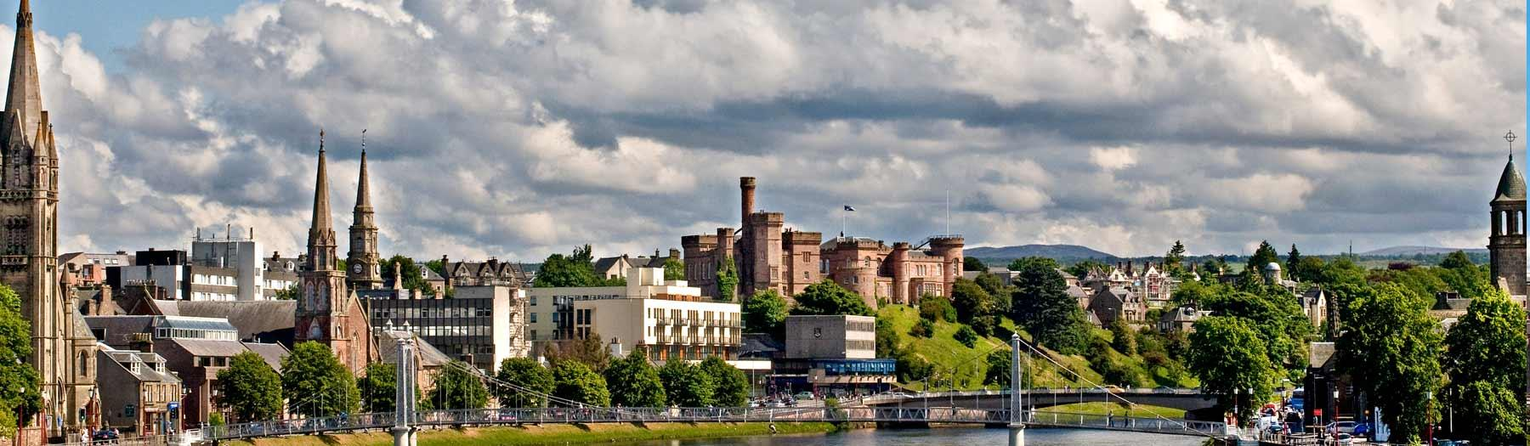
Inverness history, a few facts
At the latest, a settlement was established in Inverness by the 6th century with the first royal charter being granted in the 12th century. The Gaelic king Mac Bethad Mac Findláich (MacBeth), whose 11th-century murder of King Duncan was immortalised in Shakespeare's play Macbeth, held a castle within the city.
Medieval Inverness suffered regular raids from the Western Isles, particularly by the MacDonald Lords of the Isles. For example, in 1187 one DomhnallBán (Donald Ban) led islanders in a battle against men from Inverness Castle led by the governor's son, Donnchadh Mac AnToisich (Duncan Mackintosh).Both leaders were killed in the battle.
Inverness played a role in the first Jacobite rising in 1689. It was besieged by a contingent of Jacobites. In 1715 the Jacobitesoccupied the royal fortress. In 1727 the government built the first Fort George here, but in 1746 it surrendered to the Jacobites and they blew it up.
Culloden Moor lies nearby, and was the site of the Battle of Culloden in 1746, which ended the Jacobite Rising of 1745–1746.
On 7 September 1921, the first British Cabinet meeting to be held outside London took place in the Town House, when David Lloyd George, on holiday in Scotland, called an emergency meeting to discuss the situation in Ireland. The Inverness Formula composed at this meeting was the basis of the Anglo-Irish Treaty.
Historically, Inverness had a Gaelic speaking population, with the majority of the population having Gaelic as their first language. From approximately the end of the 19th century, Inverness suffered a decline in the number of Gaelic speakers in line with the rest of the Scottish Highlands. By the end of the 19th century, some rural areas to the south east of Inverness still had completely Gaelic speaking populations. According to the 2011 census, 4.8% of residents of greater Inverness over age 3 speak Gaelic compared to 1.1% nationally.

Culture and sports
Inverness College is the main campus for the University of the Highlands and Islands (with around 8,500 students).
Inverness is an important centre for bagpipe players and lovers, since every September the city hosts the Northern Meeting. The city is also known for theInverness cape, a garment worn in the rain by pipers, but is not necessarily made in Inverness.
Another major event in calendar is the annual City of Inverness Highland Games. The event can trace its roots back to one of the first Highland Games staged in the modern era: the True Highland Games which was staged in 1822. In 1864 the Northern Meeting Society built the world's first Highland Games stadium, the Northern Meeting Park.
Highland games are events held in spring and summer in Scotland and other countries as a way of celebrating Scottish and Celtic culture, especially that of the Scottish Highlands. Certain aspects of the games are so well known as to have become emblematic of Scotland, such as the bagpipes, the kilt, and the heavy events. While centred on competitions in piping and drumming, dancing, and Scottish heavy athletics, the games also include entertainment and exhibits related to other aspects of Scottish and Gaelic culture.
In their original form many centuries ago, Highland games revolved around athletic and sports competitions. Although quite a range of events can be a part of the Highland athletics competition, a few have become standard: the caber (a long log) toss, the stone put (a large stone of variable weight must be tossed), the Scottish hammer throw (the hammer weighs about 10 kg), the weight over the bar (a 25 kg weight must be tossed over a horizontal bar), the sheaf toss (a bundle of straw weighing 9 kg must be tossed over a bar) and the MaideLeisg.
This last example is a trial of strength performed by two men sitting on the ground with the soles of their feet pressing against each other. Thus seated, they held a stick between their hands which they pulled against each other until one of them was raised from the ground.
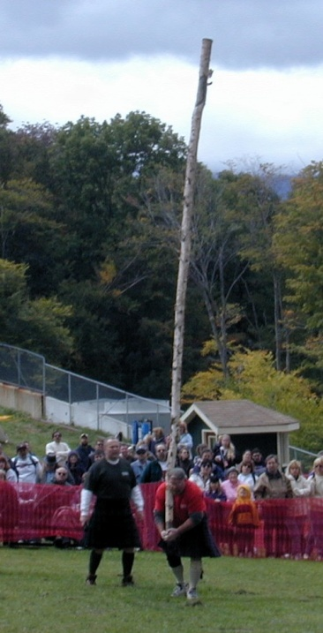
Figure 11 - An example of an heavy event: the caber toss

The Scottish KiltmakerCenter

The Scottish KiltmakerCenter is theonly visitor attraction devoted to the famous national dress. At The Scottish Kiltmaker Visitor Centre, you can meet the people who make kilts. Employing skilled men and women, the Centre enables visitors to see the different stages of kilt manufacture. A handmade kilt is a treasured possession and a statement of national identity for its wearer.

The Kilt
The history of the kiltstretches back to at least the end of the 16th century. The kilt first appeared as the belted plaid or great kilt, a full length garment whose upper half could be worn as a cloak. The small kilt or walking kilt(similar to the 'modern' kilt) did not develop until the late 17th or early 18th century, and is essentially the bottom half of the great kilt.
The word kilt comes from the Scots word kiltmeaning to tuck up the clothes around the body.
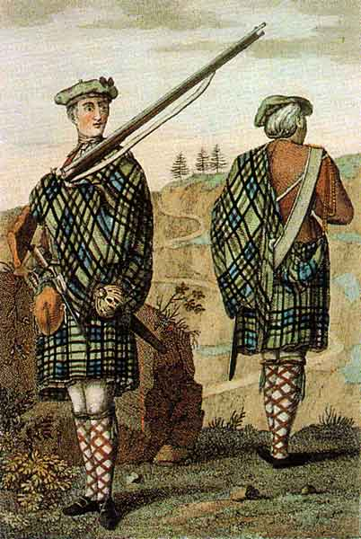
The great plaid is likely to have evolved over the course of the 16th century from the earlier woollen cloak (also known as a plaid) which was worn over a tunic. This earlier cloak may have been plain in colour or in various check or tartan designs, depending on the wealth of the wearer; this earlier fashion of clothing had not changed significantly from that worn by Celtic warriors in Roman times.

Over the course of the 16th century, with the increasing availability of wool, the cloak had grown to such a size (up to 7 yards (6.4 m) in length)that it began to be gathered up into pleats and secured by a wide belt. This garment was also known as the great kilt.
Plaids with beltloops were in use by the 1700s.
The upper half could be worn as a cloakdraped over the left shoulder, hung down over the belt and gathered up at the front, or brought up over the shoulders or head for protection (as a hood) against weather. It was worn over a léine (a full-sleeved garment stopping below the waist) and could also serve as a camping blanket.
Figure 12 - Highland soldier in 1744, wearing a great kilt and using it to protect his weapon from the rain

A characteristic of the Highland clan system was that clansmen felt loyalty only to God, their monarch, and their Chief. The Jacobite Risings demonstrated the dangers of such warrior Highland clans, because the rebellion of one chief led his whole clan into battle, sometimes hundreds of warrior clansmen. Consequently, as part of a series of measures the government of King George II imposed the "Dress Act" in 1746, outlawing all items of Highland dress including kilts with the intent of suppressing highland culture. The penalties were severe; six months' imprisonment for the first offense and seven years' transportation for the second. The ban remained in effect for 35 years.

Thus the kilt went out of use in the Scottish Highlands, but during those years it became fashionable for Scottish romantics to wear kilts as a form of protest against the ban. Once the ban was lifted in 1782, Highland landowners set up Highland Societies promoting "the general use of the ancient Highland dress".
The kilt became identified with the whole of Scotland with the visit of King George IV to Scotland in 1822, even though 9 out of 10 Scots now lived in the Lowlands. The Highland societies organised a "gathering of the Gael" and established entirely new Scottish traditions, including Lowlanders wearing a stylised version of the traditional garment of the Highlanders. At this time many other traditions such as clan identification by tartan were developed (prior to this, tartans were identified with regions, not specific clans).
After that point the kilt became an emblem of Scottish culture as identified by antiquarians, romantics, and others, who spent much effort praising the qualities of the kilt. King George IV had appeared in a spectacular kilt, and his successor Queen Victoria dressed her boys in the kilt, widening its appeal.

The only exception to the Dress Act of 1746 was made for the Highland Regiments. The kilt remained a military uniform even during the ban period. Many Scottish units wore the kilt in combat during the First World War. In particular, the ferocious tactics of the Black Watch led to their acquiring the nickname "Ladies from Hell" from the German troops that faced them in the trenches.The Highland regiments of the Commonwealth armies entered the Second World War wearing the kilt, but it was rapidly recognized as impractical for modern warfare, and in the first year of the war was officially banned as combat dress. Nonetheless, individual exceptions continued, and it is believed the kilt was last widely worn in action at the evacuation of Dunkirk in May 1940. However, on D-Day, June 1944, Lord Lovat was accompanied by his personal piper Bill Millin, who wore a kilt — and played the bagpipes — while German bullets whizzed around him. This anecdote seems to be the inspiration for a scene in The Longest Day (1962).
Why is the kilt a symbol of Scottish identity? When did it become such a symbol?

Best picture of a man wearing a kilt wins a fabulous present!!!
For the « terminale » students only : In your opinion, why is there a specific myth regarding the kilt and the Dunkirk Evacuation?

Loch Ness

Loch Ness is a large, deep, freshwater loch in the Scottish Highlands extending for approximately 23 miles (37 km). Loch Ness is best known for alleged sightings of the cryptozoological Loch Ness Monster, also known affectionately as "Nessie”. It is one of a series of interconnected, murky bodies of water in Scotland; its water visibility is exceptionally low.
Loch Ness is the second largest Scottish loch by surface area at 22 sq mi (56 km²), but due to its great depth, it is the largest by volume in the British Isles. Its deepest point is 755 ft (230 m), making it the second deepest loch in Scotland. It contains more fresh water than all the lakes in England and Wales combined.
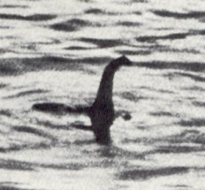
Figure 13–The “surgeon’s photograph”,
a picture of Nessie? 1934
Nessieis similar to other supposedlake monstersin Scotland and elsewhere, and is often described as being large in size, with a long neck and one or more humps protruding from the water. Popular interest and belief in the creature has varied since it was brought to worldwide attention in 1933. The scientific community regards the Loch Ness Monster as a being from folklore without biological basis, explaining sightings as hoaxes and the misidentification of mundane objects.

The earliest report of a monster in the vicinity of Loch Ness appears in the Life of St. Columba by Adomnán, written in the sixth century AD. According to Adomnán, writing about a century after the events described, Irish monk Saint Columba was staying in the land of the Picts with his companions when he encountered local residents burying a man by the River Ness. They explained that the man was swimming in the river when he was attacked by a "water beast" which mauled him and dragged him underwater.
Modern interest in the monster was sparked by a sighting on 22 July 1933, when George Spicer and his wife saw "a most extraordinary form of animal" cross the road in front of their car.They described the creature as having a large body (about 4 feet (1.2 m) high and 25 feet (8 m) long) and a long, wavy, narrow neck, slightly thicker than an elephant's trunk and as long as the 10–12-foot (3–4 m) width of the road.
In August 1933 a motorcyclist, Arthur Grant, claimed to have nearly hit the creature on a moonlit night. According to Grant, it had a small head attached to a long neck. Grant, a veterinary student, described it as a cross between a seal and a plesiosaur.
The "surgeon's photograph" is reportedly the first photo of the creature's head and neck.Supposedly taken by Robert Kenneth Wilson, it was published on 21 April 1934.According to Wilson, he was looking at the loch when he saw the monster and snapped photos. Although for a number of years the photo was considered evidence of the monster, sceptics dismissed it as driftwood, an elephant,or a bird. Analysis of the original image fostered further doubt. In 1993, the makers of a documentary analysed the uncropped image and found a suspicious white object. Since 1994, most agree that the photo was an elaborate hoax. The creature was reportedly a toy submarine built by Christian Spurling, the son-in-law of Marmaduke Wetherell. Wetherell had been publicly ridiculed by his employer, the Daily Mail, after he found "Nessie footprints" which turned out to be a hoax. To get revenge on the Mail, Wetherell perpetrated his hoax with co-conspirators Spurling (sculpture specialist), Ian Wetherell (his son, who bought the material for the fake), and Maurice Chambers (an insurance agent). Chambers gave the photographic plates to Wilson, a friend of his who enjoyed "a good practical joke".
The hoax story is disputed by Henry Bauer, who claims that the debunking is evidence of bias and asks why the perpetrators did not reveal their plot earlier to embarrass the newspaper.
Aeronautical engineer Tim Dinsdalefilmed a hump which left a wake in 1960.The 1993 documentary digitally enhanced the Dinsdale film. A person who enhanced the film noticed a shadow in the negative. By enhancing and overlaying frames, he found what appeared to be the rear body of a creature underwater: "Before I saw the film, I thought the Loch Ness Monster was a load of rubbish. Having done the enhancement, I'm not so sure".
Other videos and sightings are reported, the most recent is a five-minute video of a "mysterious wave" in the loch, recorded in 2013. According to the author the wave was produced by a 4.5 m (15 ft) "solid black object" just under the surface of the water.Sceptics suggested that the wave may have been caused by a wind gust.
Many searches were organized to hunt Nessie. A dedicated association was created, with this purpose in 1962: The Loch Ness Phenomena Investigation Bureau (LNPIB). The most recent example is the search of the loch using 600 sonar beams and satellite tracking, sponsored by the BBC in 2003. The search had sufficient resolution to identify a small buoy (a floating marker). No animal of substantial size was found and, despite their high hopes, the scientists involved admitted that this proved the Loch Ness Monster was a myth.

Try to find a complete stranger who believes Nessie and other supernatural phenomena exist (like ghosts and haunted castles).
Nessy’s challenge

Urquhart Castle

Urquhart Castlesits besideLoch Ness.The present ruins date from the 13th to the 16th centuries, though built on the site of an early medieval fortification. Founded in the 13th century, Urquhart played a role in the Wars of Scottish Independence in the 14th century. Indeed, the first documentary record of Urquhart Castle occurs in 1296, when it was captured by Edward I of England.It was subsequently a royal castle, held for the crown by a series of constables.
Over the next two hundred years, the Great Glen was raided frequently by the MacDonald Lords of the Isles, powerful rulers of a semi-independent kingdom in western Scotland. In 1395, Domhnall of Islay seized Urquhart Castle from the crown, and managed to retain it for more than 15 years.

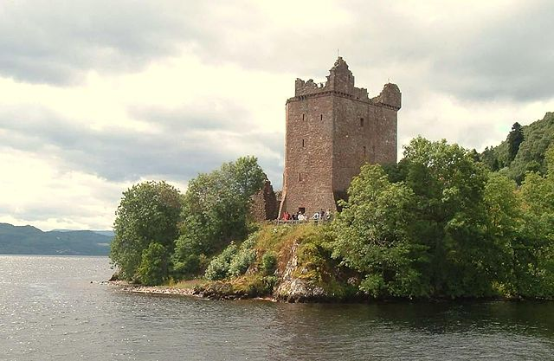
The castle was granted to the Clan Grant in 1509. Despite a series of further raids the castle was strengthened, only to be largely abandoned by the middle of the 17th century. For example, in 1544 James Grant of Freuchie became involved in a feud with the Macdonalds of Clanranald. The MacDonalds and their allies the Cameronsattacked and captured Urquhart in 1545. They succeeded in taking 2,000 cattle, as well as hundreds of other animals, and stripped the castle of its furniture, cannon, and even the gates.
Figure 14 - Urquhart Castle viewed from Loch Ness
Urquhart was partially destroyed in 1692 to prevent its use by Jacobite forces, and subsequently decayed.By the 1770s the castle was roofless, and was regarded as a romantic ruin by 19th-century painters and visitors to the Highlands. In the 20th century it was placed in state care and opened to the public: it is now one of the most-visited castles in Scotland.
In 2011 more than 315,000 people visited Urquhart Castle, making it Historic Scotland's third most visited site after the castles of Edinburgh and Stirling.

Ask your host family about the following topics

Identity
Do they feel Scottish? British?More Scottish than British?More British than Scottish? Why?
What is Scottish identity today? Is it different from British identity?
Do they know of any stereotypes and clichés associated with Scottish people or culture? How do they feel about them?
What do they think about France and French people? What is French identity according to your host family?

Brexit
Did they vote? How? Why?
What do they think of the results?

Scottish independence
Did they vote for the last referendum? How? Why?

…………………………………………………………………………………………………
…………………………………………………………………………………………………
…………………………………………………………………………………………………
…………………………………………………………………………………………………
…………………………………………………………………………………………………
…………………………………………………………………………………………………
…………………………………………………………………………………………………
…………………………………………………………………………………………………
…………………………………………………………………………………………………
…………………………………………………………………………………………………
…………………………………………………………………………………………………
…………………………………………………………………………………………………
…………………………………………………………………………………………………
…………………………………………………………………………………………………
…………………………………………………………………………………………………
…………………………………………………………………………………………………
…………………………………………………………………………………………………
…………………………………………………………………………………………………
…………………………………………………………………………………………………
…………………………………………………………………………………………………
…………………………………………………………………………………………………
…………………………………………………………………………………………………
…………………………………………………………………………………………………
…………………………………………………………………………………………………
…………………………………………………………………………………………………
…………………………………………………………………………………………………
…………………………………………………………………………………………………
…………………………………………………………………………………………………
…………………………………………………………………………………………………
…………………………………………………………………………………………………
…………………………………………………………………………………………………

