Rice domestication

Nowadays rice is without any doubt essential in the process of feeding the world. Indeed, it feeds more than half of the world’s population and it is cultivated worldwide. Agriculture was born during the Neolithic revolution and thanks to cultural advances such as domestication of animals and plants which combined with men’s permanent dwellings. Mesopotamia, Indus and Nile river are the main contemporary agriculture locations.
How was rice domesticated and spread?
Our analysis shall be twofold. On the first hand we will study the spread of rice and on the other hand we will focus on the different domestications and hybridizations.

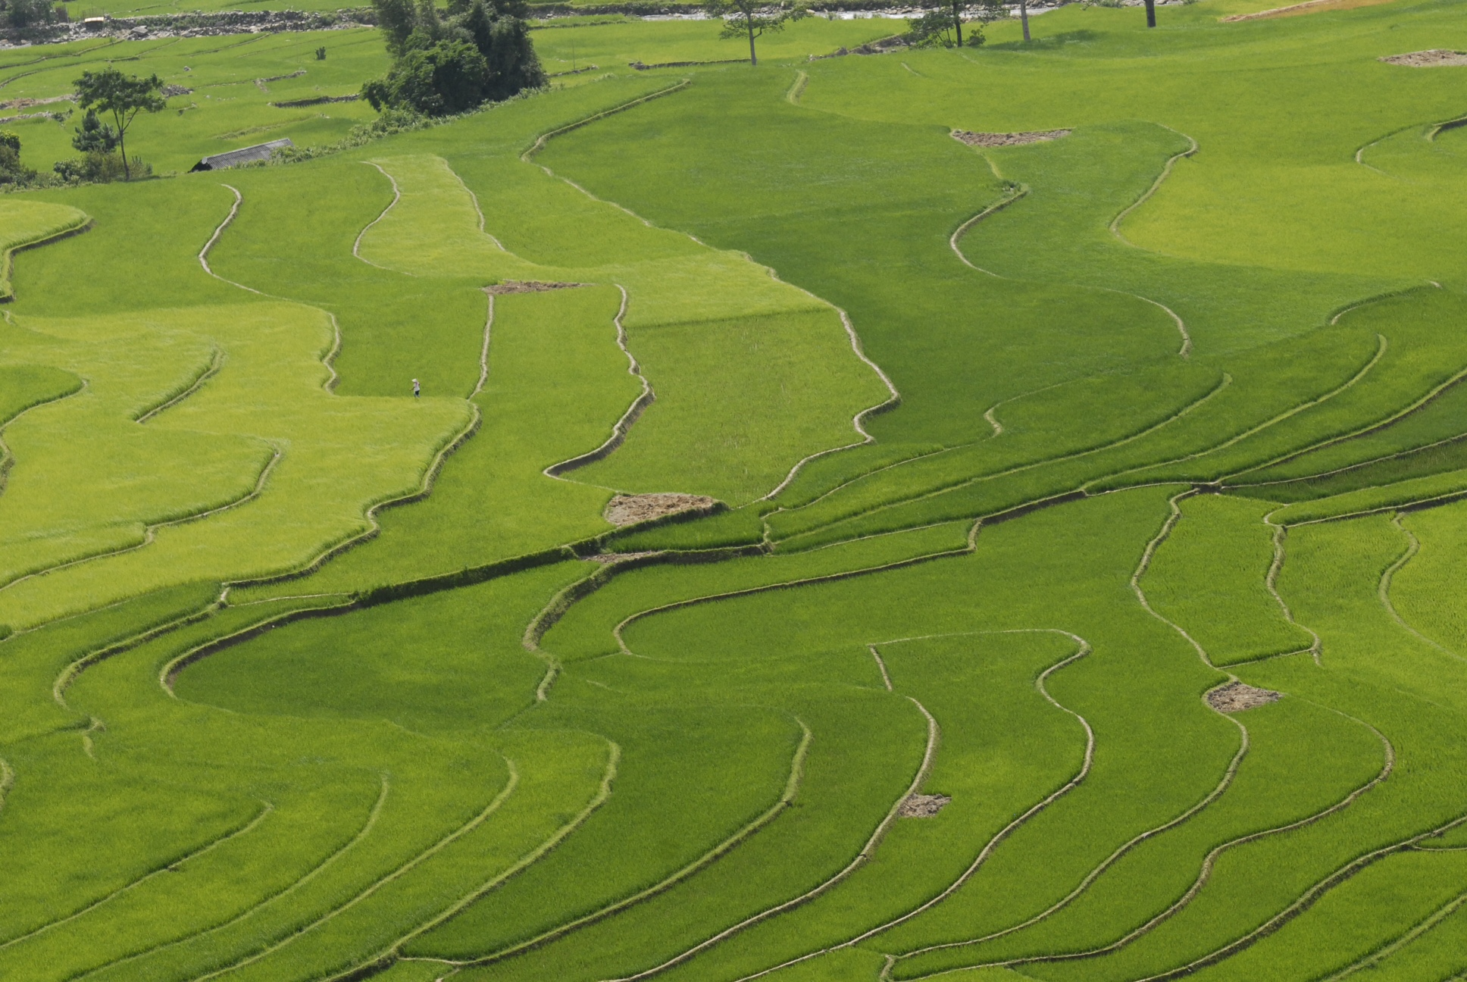

There isn’t only one type of rice: they are 21 different wild varieties and three domesticated one. There is Oryza sativa japonica in central China domesticated around 7,000 years BC, Oryza sativa indica in the Indian subcontinent domesticated and hybridized around 2500 BC and Oryza glabberima in West Africa also domesticated and hybridized between about 1500 and 800 BC. We can notice that rice was domesticated in Asia and Africa and not in Europe. Indeed the Mediterranean cultures are primarily based on wheat. The oldest evidence of the use of rice as food was found in China: four grains of rice in the Yuchanyan Cave, a rock shelter in Dao Country in the province of Hunan. We believe that the originally domesticated plant that is the source of all varieties of rice is Oryza sativa japonica domesticated from the wild species O. rufipogon in the lower Yangtze River Valley near 9,000 to 10,000 years ago by hunter-gatherers from the Jomon Culture. Nevertheless there is a debate on the origins of rice in China: not all the scholars agree that it is thanks to a subsequent spread outside of the center of domestication in the Yangtze Valley.



The domestication of rice has led to a change of the landscape. Indeed all species of rice in China are wetland species: even if it is more labor-intensive then dryland rice it is also far more profit-making thanks to its productivity. According to archaeologists its domestication consisted in moving it into a dryer environment. At first they planted it along the edges of wetlands to use natural flooding and annual rain patterns. Then they invented in China rice paddies about 5,000 BC. Some evidence of those paddy fields have been identified and dated in Tianluoshan. This technique has multiple advantages: the stability of terracing and field construction reduces environmental damages and the constant movement of the water causes the permanent replacement of nutrients taken from he field by the crops. It allows the field to stay fertile. The domestication of rice also made us to prefer one rice than another: it reduces the diversity.
In West Africa there has been a different domestication and hybridization during the period named “African Iron Age”. They crossed the Oryza sativa with the O. barthii and the result was named Oryza glaberrima. Scientists have found rice grains in northeast Niveria dates between 1,800 and 800 BC. The new variety Oryza glaberrima has been identified firstly in Mali and dates between 300 and 200BC.

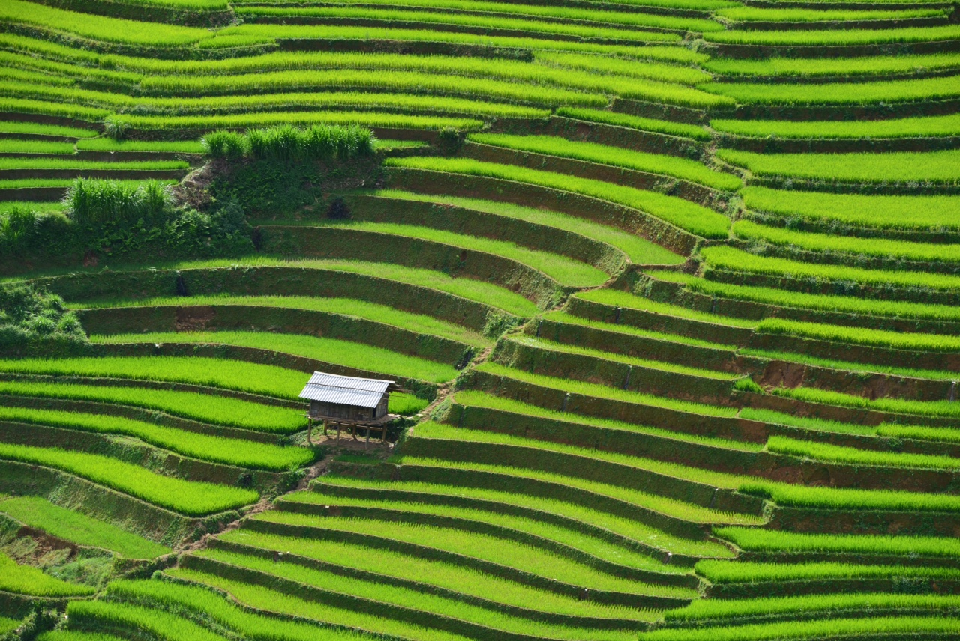

To conclude rice is essential to feed the world, but is also a crucial element in our economy. It accounts for a large portion of the world’s diet and is a basis to many places such as Asia. It takes a great part of the agriculture of many countries and has a worldwide impact through the global market. Rice also has been largely impacted by science, which potentially could be both beneficial and harmful to these rice producing countries. Rice demonstrates how food is an integral aspect to a nation’s agriculture, economy and global market.

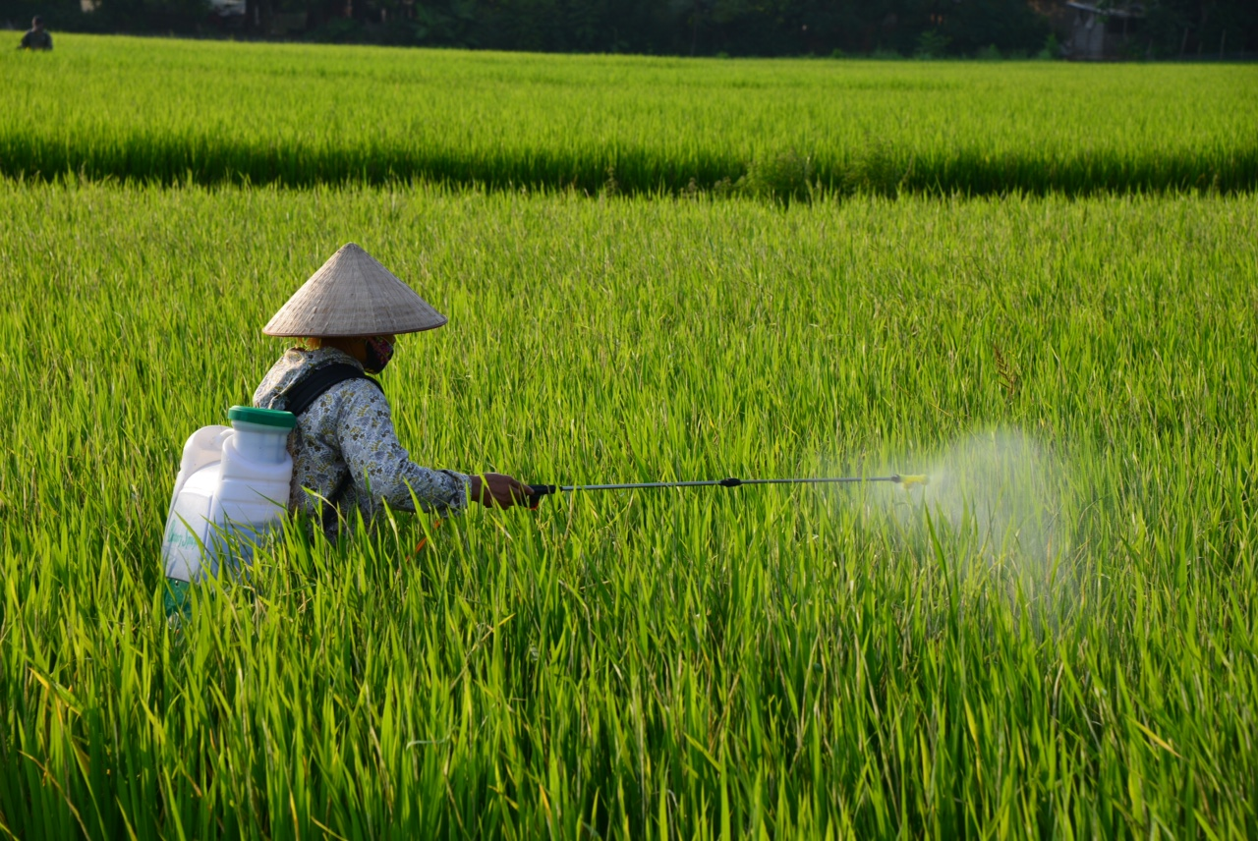

Blanc Angélique
Bost Guillaume
Rouis Célia

