Section européenne
Terminales – 2016
G1 – Historians and World War II Memories

Home Front memories

Source 1: A trip back in time: 'The 1940s House', Rob Owen, Post-Gazette TV Editor, November 03, 2002

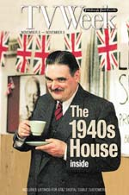
"1940s House" takes the same concept as "1900 House" -- ask a modern family to live the lifestyle of another era -- and applies it to the London home front during World War II. Three generations of the Hymers family move into a suburban London home outfitted in early 1940s technology and accouterments. Patriarch Michael has always been interested in World War II, "an obsession," according to his wife, Lyn.
[…] Their daughter Kirstie, 29 when the series was produced, also moves in, along with her sons, Ben, 10, and Thomas, 7. Typically, it begins with family members looking bewildered over, say, baking a cake from scratch or hair care of the era. […]
A War Cabinet, comprising mostly historians, evaluates the family's behavior and whether it conforms to the period. They also choose some of the obstacles to throw in the family's way. The family has to make blackout windows, build a bomb shelter in the back yard and go into it during frequent mock air raids in the middle of the night. They're also forced into rationing, and the '40s-era shop where the family gets groceries often has empty food shelves. In one memorable scene, Kirstie and Lyn argue over who's had less food.
[…] Lyn said a woman living in the 1940s had a more clearly defined role as a housewife than modern women do. "Your job in life, your aim, was to get food on the table and look after the family. Modern women have so many different things to aspire to. Life is full of pressure for modern women," she said. "[Back then] there was harder physical work, but mentally it was much less pressure, and we were closer as a family without a shadow of a doubt." […] "Of all the hundreds of letters we've gotten, the children come out very well," Lyn said. "They were hungry, but you didn't see them grumble. How could we adults grumble? It was so hard to see the children hungry, but they didn't mind. They had a wonderful time." Regardless of PBS's poor scheduling, she thinks the series will resonate, especially with viewers who lived through the era. "Americans played such an awfully big part in that war," Lyn said. "Lots of lives were lost, so to the older generations it's quite relevant. And here we are perhaps waiting to go to war again, and this time the Brits are supposed to help the Americans."
Source: Post-Gazette.com, news website of the Pittsburgh Post Gazette, a Pennsylvania newspaper (http://old.post-gazette.com/tv/20021103owen1103p1.asp)

- Introduce the document.
- List the elements of the home front (or Blitz) memory mentioned in the text.
- In your opinion, why was a reality tv show produced on this topic?
Wordbox
Bewildered = perplexe
Groceries = courses, provisions
Shelves (plural noun) = étagères, rayons
Grumble (to) = râler, rouspéter, se plaindre
PBS = chaîne de télévision publique américaine (Public Broadcasting Service)
Scheduling = programmation

Source 2: What crisis? Jon Henley on the poster we just can't stop buying, Jon Henley, The Guardian, 18 March 2009

This [poster] was the third in a series. The first, designed to stiffen public resolve ahead of likely gas attacks and bombing raids, was printed in a run of more than a million and read: Your Courage, Your Cheerfulness, Your Resolution Will Bring Us Victory. The second, identically styled, stated: Freedom Is In Peril.
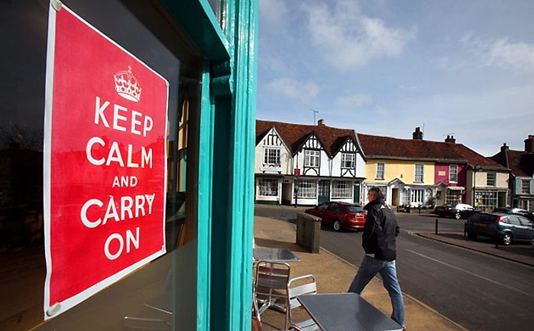
From August 1939, both posters began appearing all over the country, on billboards, in shops, on railway platforms. The third, though, was held back. This one was for the real crisis: invasion. A few may have made their way on to select officials' walls, but the vast majority of the British public never got to see it. This poster enjoined: Keep Calm And Carry On.
And suddenly these days, it's everywhere, from homes to pubs to government offices. The Lord Chamberlain's Office at Buckingham Palace, the prime minister's strategy unit at No 10, the Serious Fraud Office, the US embassy in Belgium, […] the officers' mess in Basra have all ordered posters. Even David Beckham has the T-shirt, we are told.
For 60 years, the poster had been forgotten. Then, one day in 2000, Stuart Manley, co-owner of Barter Books [a bookshop], […] saw [in a box] "A big piece of paper folded up at the bottom. I opened it out, and I thought, wow. […] So we framed it and put it up on the bookshop wall. And that's where it all started."
Figure 1 - In Woodbridge, The Galley restaurant, proudly displaying a copy of the poster
Photograph: Graham Turner for The Guardian
Today, you can buy Keep Calm and Carry On mugs, doormats, T-shirts, hoodies, cufflinks, baby clothes and flight bags from any number of retailers. […] There are even spoofs. Facsimiles of the poster itself, which Barter Books initially reproduced after a rash of customers asked to buy its copy (one offered £1,000), have sold in their tens of thousands. […]
Alain Samson, a social psychologist at the London School of Economics, says that in times of difficulty, "people are brought together by looking for common values or purposes, symbolised by the crown and the message of resilience. The words are also particularly positive, reassuring, in a period of uncertainty, anxiety, even perhaps of cynicism."
Source: http://www.theguardian.com/lifeandstyle/2009/mar/18/keep-calm-carry-on-poster

- Are the poster and its moto Home Front memories?
- Why can we say that this poster is an example of a memory being instrumentalized?
Wordbox
Stiffen (to) = renforcer, raffermir
Resolve = détermination
Lord Chamberlain = haut fontionnaire de la Cour (Lord Chambellan), qui conseille le souverain
Officers’ mess = salle de détente et de restauration dans une base militaire, réservée aux officiers
Basra = ville située en Irak
Fold (to) = plier
Frame (to) = encadrer
Doormat = paillasson
Cufflink = bouton de manchette
Facsimile = copie, reproduction

