Section européenne
Terminales – 2016
G1 – Historians and World War II Memories

The Dunkirk Spirit

- Read source 3 and observe the map to understand what happened in Dunkirk in 1940. Was the Battle of France a success?
- Introduce sources 1, 2 and 4.
- Using sources 1, 3 and 4 explain why can we say that memory differs from history.
- How is the use of the “Dunkirk spirit” criticized in source 2?

Source 1: Blog written by a history teacher (27 may 2010)
http://journeymanblog.blogspot.fr/2010/05/dunkirk-spirit-myth-reality.html
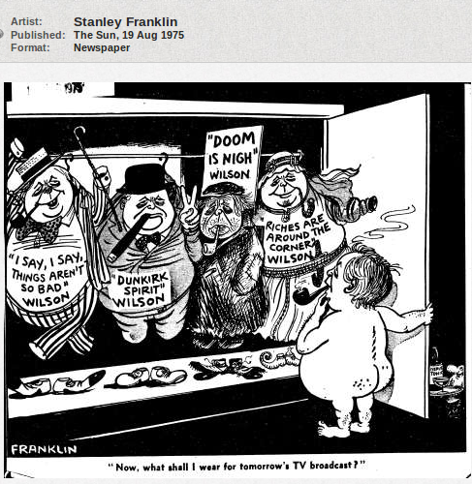
Inevitably with the 70th anniversary of the evacuation of the BEF this week the idea of the 'Dunkirk Spirit' is being much touted around. [...] If there is such a thing as national character [...] then perhaps the Dunkirk Spirit is a particularly British form of stoicism, quiet understatement and dry-humor, along with a discovery of collective spirit provoked by adversity. [...] For my Mum and Dad's generation Dunkirk and the events of 1940 holds a special place in their memory. [...] I think that for them it marks the start of the 'People's War'. Only this weekend they were reminiscing how my Granddad in the river police wanted to take his boat over to France but wasn't allowed to because it might be needed in case of invasion - whilst a firefighter Uncle did go over on a fire-boat [...].
The involvement of civilians and their boats in the rescue operations was in this respect very symbolic. [...] The talk of 'phony war' rapidly switched - after France fell so quickly to the German blitzkrieg - to a genuine fear of an invasion of the British Isles. Along with a much-mythologized but undeniable sense of standing alone - without European allies, support from the Commonwealth still to be mobilized, and with the USA standing aloof.
For them there was/is a real sense that Dunkirk was a turning point in the national psyche. But even then - as now - there was much misinformation about the evacuation:[...] there were bitter arguments over the evacuation of French troops [...]. Ironically many French troops who were evacuated to Britain were then pointlessly returned to ports in Western France just in time for the mass surrender.
Source 2 (Harold Wilson is Prime Minister at the time)
Most fundamentally the threat of invasion averted by the 'miracle of Dunkirk' was probably more perceived than real. Historians have speculated endlessly whether the German forces had either the means or desire to stage an invasion. [...] It's now fairly well established that the Nazis harbored hopes for a negotiated settlement with an isolated Britain [...]. And it's equally well established that there were factions within the British ruling class [...] who felt the same way. Recently discovered evidence suggests that even Churchill didn't discount this at one point.

bitter = amer
surrender = reddition, capitulation
threat = menace
avert (to) = éviter, prévenir
harbor (to) = nourrir (un sentiment, un espoir), abriter
settlement = réglement, accord
Wordbox
BEF (British Expeditionary Forces) = corps expéditionnaire des forces britanniques
Tout (to) = vanter les mérites de, faire la promotion
Reminisce (to) = se rappeler, raconter ses souvenirs
whilst = pendant que, tandis que
Phony war = Drôle de guerre
Aloof = à l'écart, distant

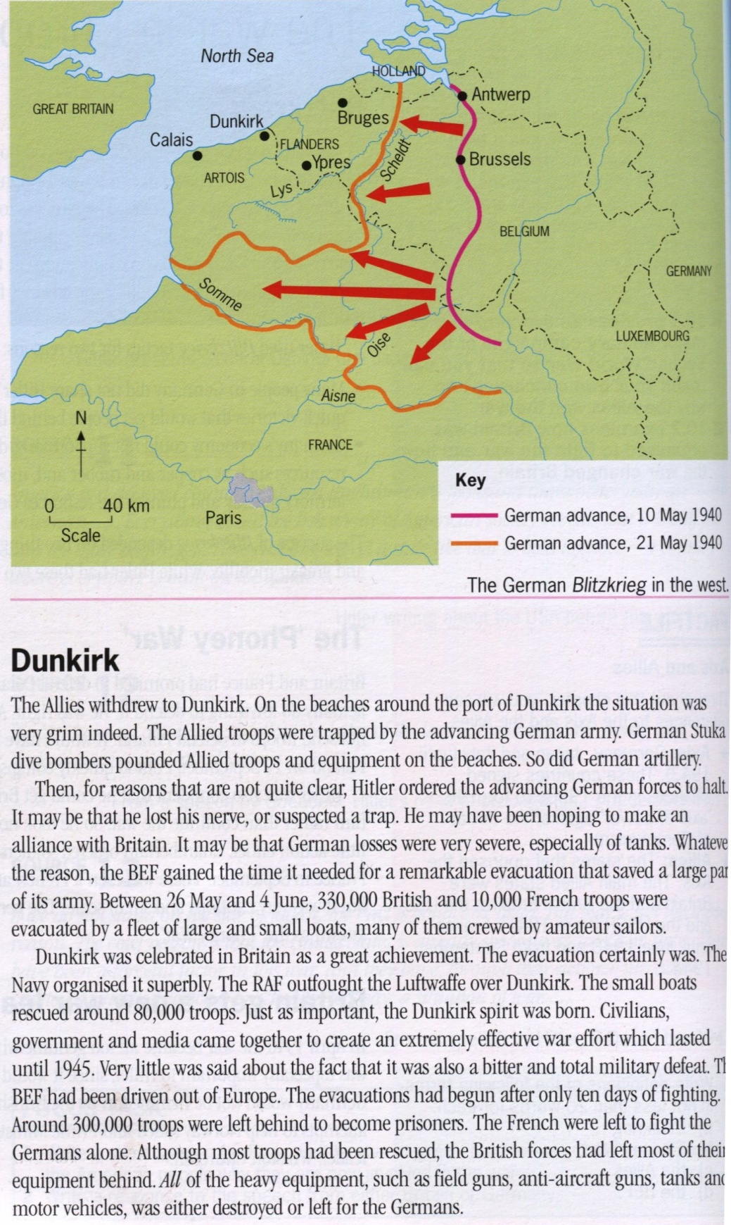

Wordbox
grim = sombre
pound (to) = frapper, pilonner, marteler
outfight (to) = battre
RAF (Royal Air Force)
Luftwaffe = armée de l'air allemande

Source 3 - GCSE Modern World History, Ben Walsh (ed), 1996

Source 4: Churchill speech before the House of Commons, 4 June 1940
We shall go on to the end. We shall fight in France, we shall fight on the seas and oceans, we shall fight with growing confidence and growing strength in the air...
We shall defend our Island, whatever the cost may be; we shall fight on the beaches, we shall fight on the landing grounds, we shall fight in the fields and in the streets, we shall fight in the hills; we shall never surrender...

