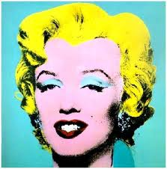
Building up your analysis of Marilyn Monroe, 1962
by Andy Wahrol

- answer each section with key words only.
- read the instruction & react.

1)- focus on the colors & on the background
- choose adjectives to describe the colors:

- what impression do they create ?

2)- Describe the style of the painting ? what does it look like ?

3)- How is the effect achieved ( atteint) ?

4)- focus on the different parts of Monroe’s face : for each of them say what you notice.
- Her eyes :
- Her theeth :
- Her mouth :
- Where could you see such a face ?

5)- what do you think of this painting ? Justify

