The Devil Wears Prada (film)
Partly From Wikipedia, the free encyclopedia

The Devil Wears Prada
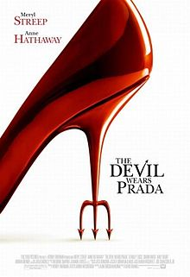
Theatrical release poster
Directed by | David Frankel
Produced by | Wendy Finerman  Karen Rosenfelt
Screenplay by | Aline Brosh McKenna
Based on | The Devil Wears Prada by  Lauren Weisberger
Starring | Meryl Streep  Anne Hathaway  Emily Blunt  Stanley Tucci  Simon Baker  Adrian Grenier
Music by | Theodore Shapiro
Cinematography | Florian Ballhaus
Editing by | Mark Livolsi
Distributed by | 20th Century Fox
Release date(s) | June 30, 2006
Running time | 109 minutes
Country | United States
Language | English
Budget | $35 million
Box office | $326,551,094
The Devil Wears Prada is a 2006 comedy-drama film,adaptation of Lauren Weisberger's 2003 novel of the same name.
It is a caricature of U.S. Vogue editor Anna Wintour and the world of fashion

The Plot
Andrea "Andy" Sachs (Anne Hathaway) is a young journalist and she becomes a junior personal assistant to Miranda Priestly (Meryl Streep), the editor-in-chief of Runway fashion ething with them.
Miranda is a kind of devil because she humiliates her staff.
Andrea will manage to survive.
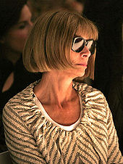
Anna Wintour,
on whom Miranda is supposedly based, was at first skeptical of the film but later came to appreciate it.
The film was a commercial success.

