Charlie and the Chocolate Factory
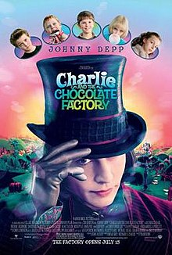
Theatrical release poster
Directed by | Tim Burton
Produced by | - Brad Grey  - Richard D. Zanuck
Screenplay by | John August
Based on | Charlie and the ChocolateFactory  by Roald Dahl
Starring | - Johnny Depp  - Freddie Highmore  - David Kelly  - Helena Bonham Carter  - Noah Taylor  - Missi Pyle  - James Fox  - Deep Roy  - Christopher Lee
Narrated by | Geoffrey Holder
Music by | Danny Elfman
Cinematography | Philippe Rousselot
Edited by | Chris Lebenzon
Production  companies | - The ZanuckCompany  - Plan B Entertainment  - Village Roadshow Pictures
Distributed by | Warner Bros. Pictures
Release date | - July 10, 2005(Grauman'sChineseTheatre)  - July 15, 2005 (United States)  - July 29, 2005(United Kingdom)
Running time | 115 minutes^{[1]}
Country | - United States  - United Kingdom^{[2]}
Language | English
Budget | $150 million^{[3]}
Box office | $475 million^{[4]}

