« A Christmas Carol »
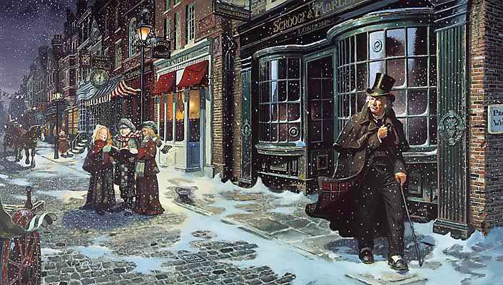

A Christmas Carol was written by Charles Dickens in 1843. It was written in prose.
It tells the story of an old man named Ebenezer Scrooge and his transformation into a gentler man after visitations by ghosts of his former business collaborator Jacob Marley and the ghosts of Christmases Past, Present and Yet to come.
Scrooge is the symbol of winter and winter is followed by spring and a new life. So, Scrooge has a cold heart at the beginning of the book but the innocence of his childhood and youth is restored at the end of the story.
Charles Dickens’ book is a social criticism, a morality tale and a ghost story. His Carol had a great influence in replacing old Christmas traditions of England. It brings images of joy and happy life and images of darkness and sadness.
It remains popular and has been adapted many times to film, on stage, opera and other media.

Adapted from Wikipedia.
