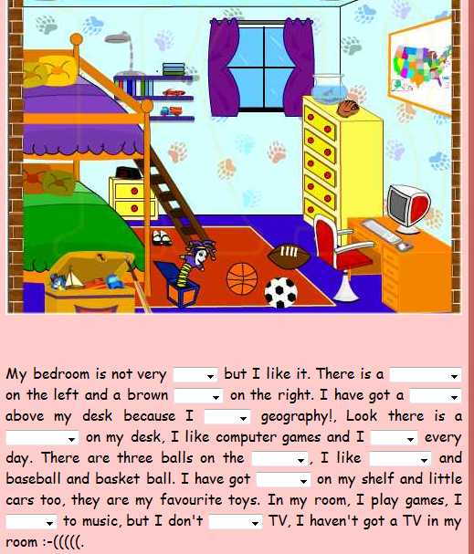
Answers : big – bed – desk – a poster or a map – computer - play – floor – rugby or soccer – some books or a lamp – listen – watch

