Who is Banksy?

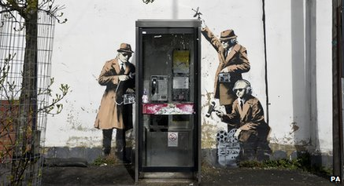
New artwork thought to be by Banksy has appeared in Bristol and Cheltenham recently. But who is Banksy and why is his artwork such a big deal?
Who is Banksy?
Banksy is an anonymous British graffiti artist known for his artwork, often done in public places such as the walls of houses.
He began spray-painting trains and walls in Bristol in the early 1990s and expanded his settings throughout England, then all over the world by the early 2000s.
For efficiency he usually uses stencils, enabling him to create his paintings with great detail in a short time.
Identity unknown?
His identity is unknown, despite lots of people trying to guess who he is. In 2008 the newspaper, The Mail on Sunday, revealed who they thought Banksy was, but his identity is still unconfirmed.

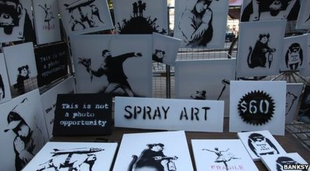
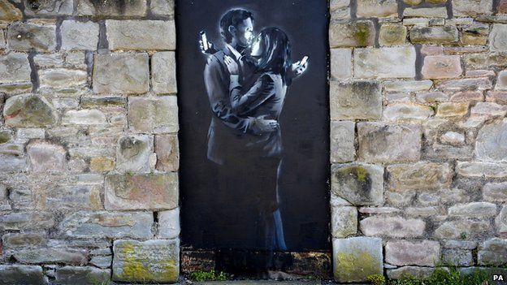
Controversial?
His artwork is often rebellious and there are lots of people who love what he does, paying thousands of pounds for it and considering it art.
But there are others who don't support it and consider it vandalism. Some of his graffiti has been painted over soon after it appeared.
In London in 2005 in an exhibition of his work, he released 200 live rats in the gallery. Rats are a common theme in his work.
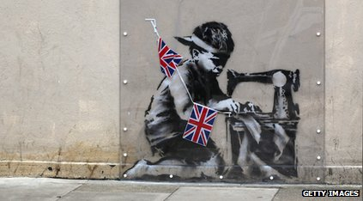
Most expensive
In an auction in 2008, Banksy's Keep It Spotless was sold for a record $1.8m - that's just over £1 million.
In the same year a mobile home that contained a Banksy, was given a £500,000 price tag - not because the trailer was special but because it contained artwork by the Bristol artist.
In 2013, Banksy even opened a stall in New York's Central Park, selling signed original canvasses for $60 (about £35).
Most recently a piece of Banksy artwork appeared on a wall near a youth centre. A row has erupted after the centre's leader removed it and wanted to sell it to raise money for the youth club.
From Newsround October 2014

