Day trip to Chartres
Out of my 2 5th forms one was lucky to go to Chartres this year so the other one prepared questions to ask about this trip then the pupils commented their day out.

Questions from the 5th Pascal
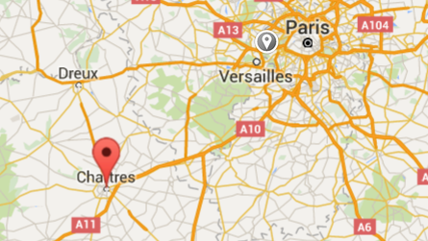
Where is Chartres?
How far is it from Paris?
Is it far away from Lardy ?
How long does it take to go to Chartres ?

What is Chartres like?
Was it beautiful ?
Is it a big town ?
Can we skate in Chartres?

What must I see if I go there ?
What's the best place to make a photo?

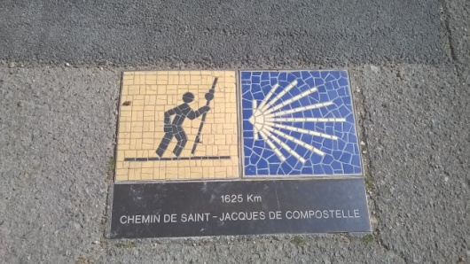
Is the cathedral is beautiful ?
How old is the cathedral ?
How many stained glasses are there in the cathedral ?
When was the cathedral built ?

Did you learn anything ?

Answers and comments from the 5th Euclide

Hello on Monday 2nd May 2016 we went to Chartres by bus with the 5th form Descartes. It was a techno trip with the secondary school.

In the morning, We visited the cathedral.
The cathedral of Chartres is beautiful, very tall and big .
It is very large and has many stained-glass window .

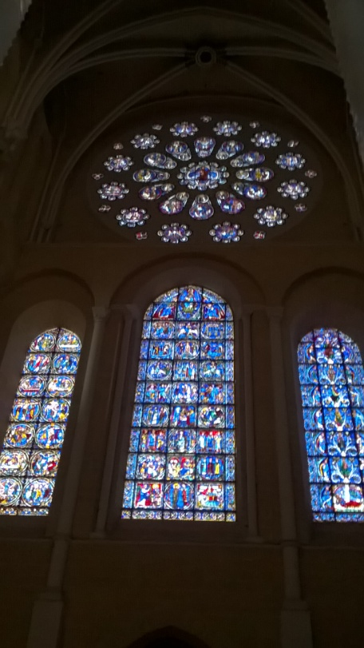
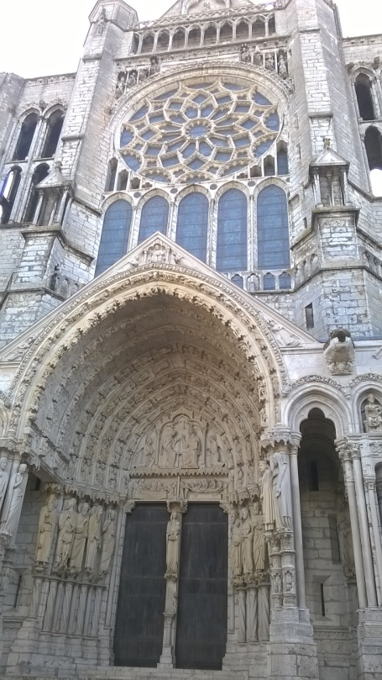
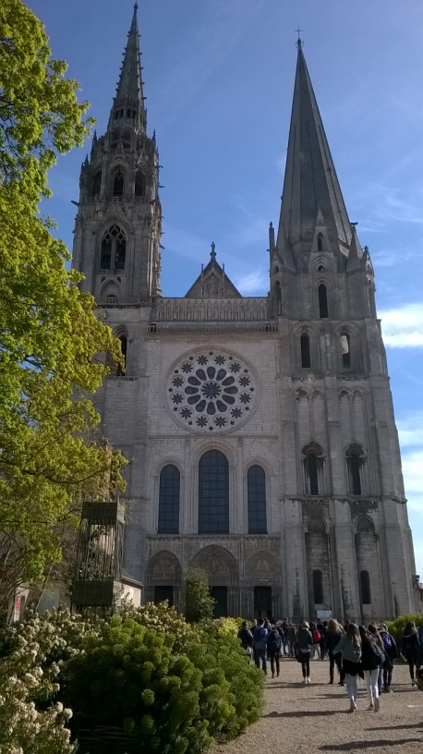
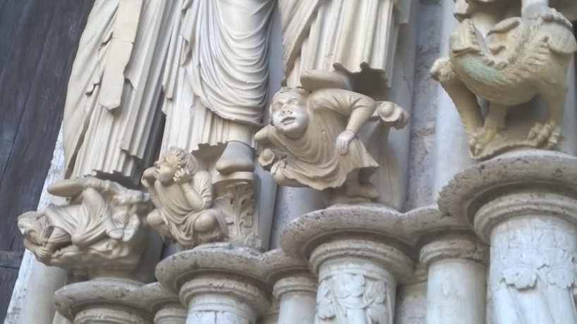
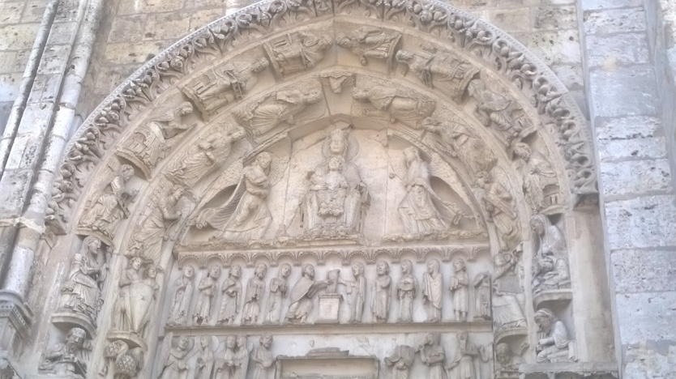

We saw many gargoyles.
It was good and interesting. because we learnt many things. For example the statues tell stories.
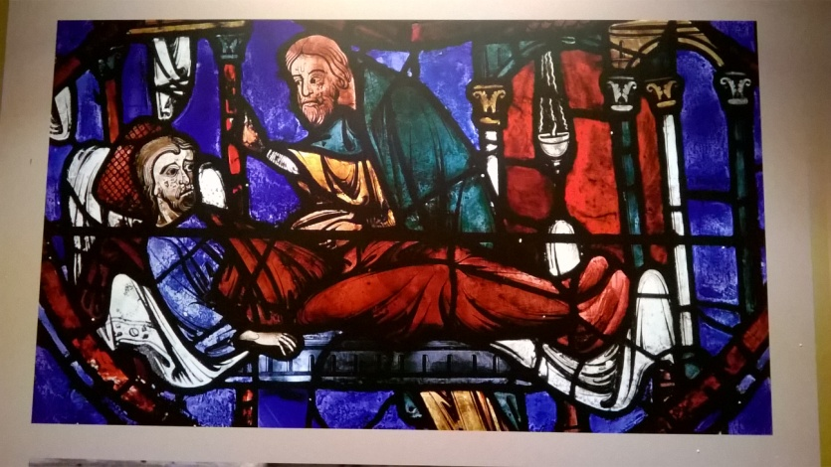
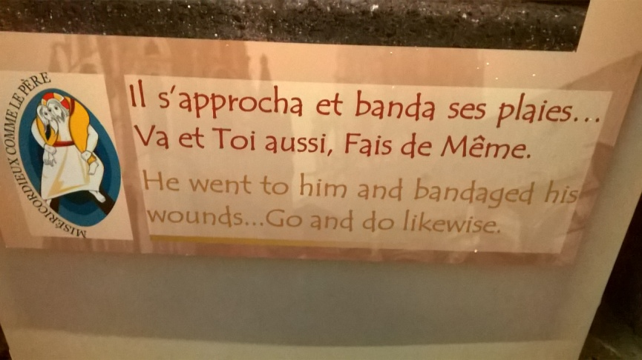

The cathedral is smaller than the Eiffel tower they started the restoration in 2008 and will finish in 2020 they built cathedral in the middle age.

We took some pictures and answered questions.

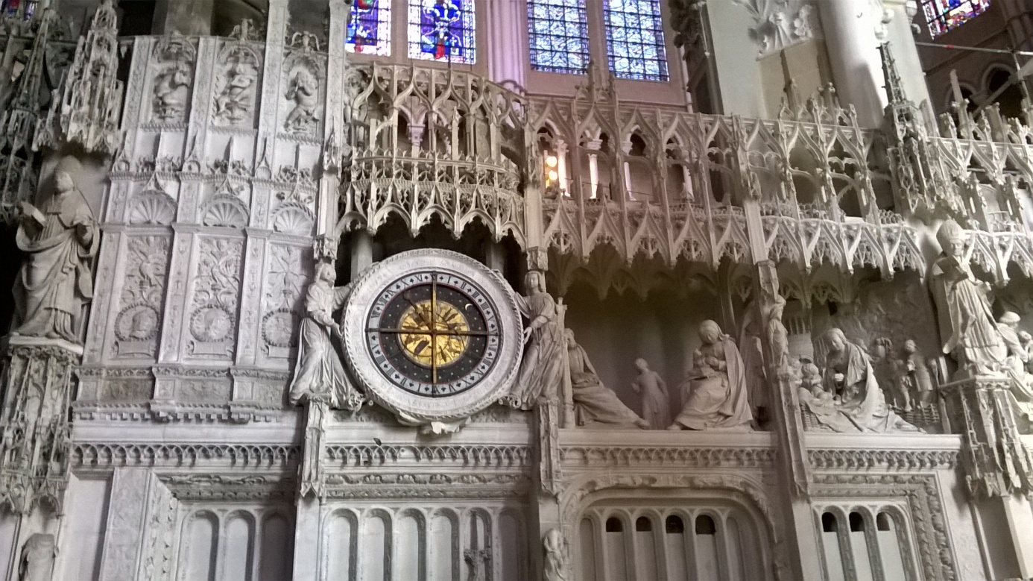

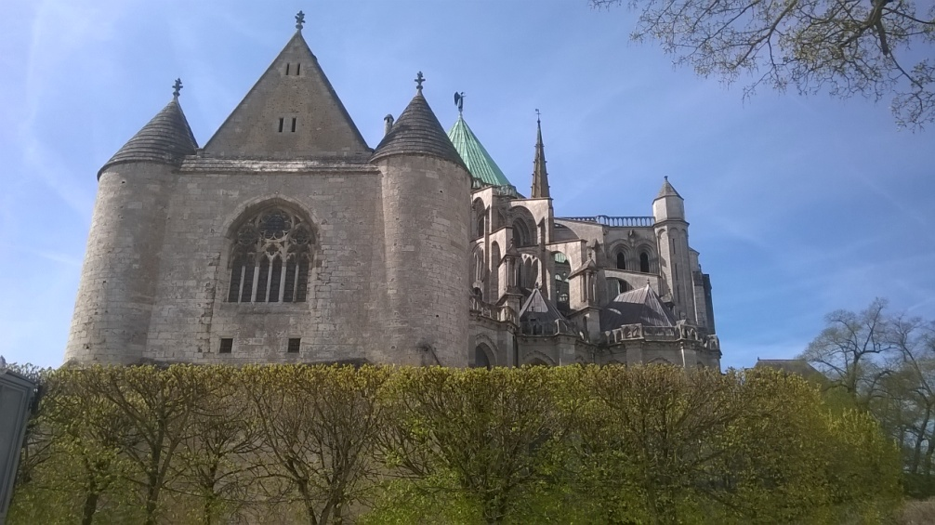

Later, at Midday, we ate in the park on the grass and it was cool.
We had a picnic in a garden. We took sandwiches, many candies and cakes.

The weather was nice. It was sunny.

In the afternoon we visited the town, the ancient city, with our team.
We had to fill up a quiz and answer 25 questions but the it wasn't very easy.

Sadly, some didn’t have the time and answered 22 questions out of 25.
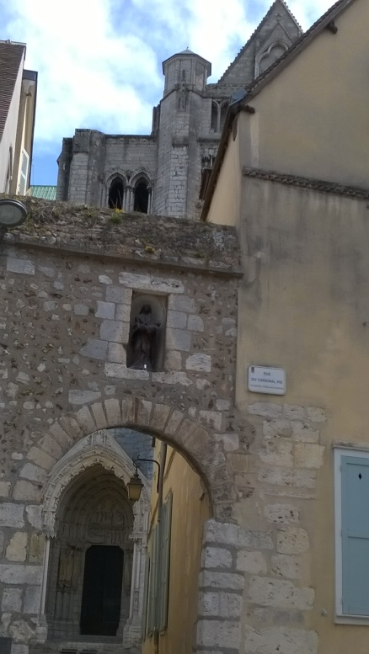
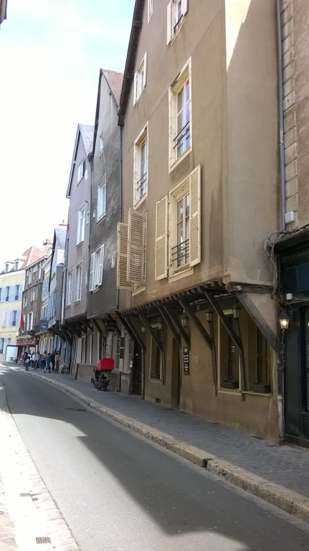

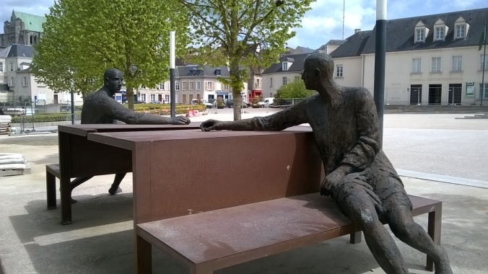
The ride to go and come back was very long and in the evening some slept all the time.

