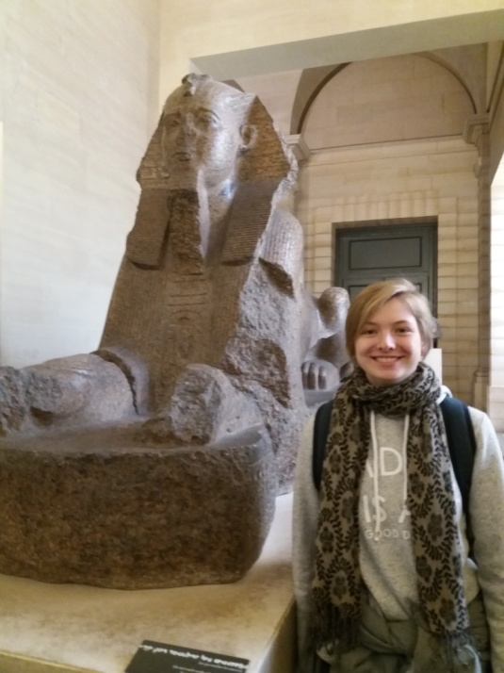
Report after the interview of an Australian girl
Her first name is Laura and her surname is Cheek which means “joue” in French.
She is sixteen. She has a little sister who is 13. Her father is Greek, his name’s Robert. Her mother is an architecture nerd.
This may explain the fact that she has chosen to study history, geography and languages at school.
She told us that they could decide the subjects they learn so she doesn’t have to study math or sciences. Some pupils thought she was lucky.
The other subjects which are taught are Japanese, German, Cooking, drama, sports and sewing.
She said her best quality was to be good at talking. Indeed she was at ease talking to 2 fourth forms for 2 hours.
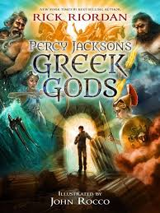
She did gym for 11 years and she plays soccer pretty well in a front position but she can’t play boomerang.
She doesn’t mind shopping but she prefers going walking to the bush.
One of the films she prefers is Spiderman.
She enjoys making and building things.
She likes reading, adventures books especially. Her favorites are Artemis Fowl and Percy Jacksons stories.
She’s got Google and she is on Facebook.
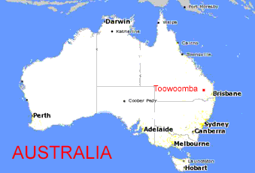
She also writes and would like to become a writer for books or films.
She lives in Toowoomba in the state of Queensland, 2 hours from the beach or the sea side and near Brisbane.
The landscape there is hilly because it’s near the great dividing range mountains.
(Look at this map for the relief : http://www.mapsofworld.com/australia/)

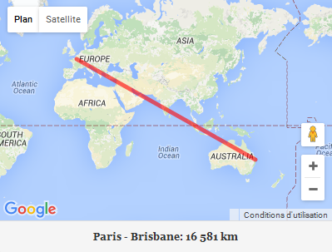
She arrived in France 6 weeks ago and it took her 26 hours to come from Australia. Her plane stopped in Abou Dabi in The United Arab Emirates.
She is leaving to go back home in one week. She said it would take her 35 hours with the time difference.
She is on holiday as it’s the summer holiday in Australia now. Her best friend Caitlin is in France too.

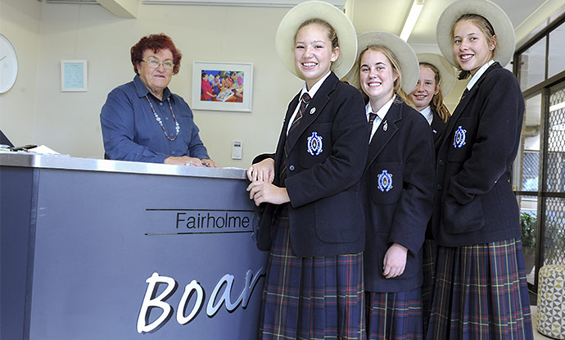
They’re here with 4 other Australian girls and they have correspondents in the Lycée Cassin in Arpajon. All of them are really happy with this exchange and learn a lot.
They are in a private girl school called Fairholme college. http://www.fairholme.qld.edu.au/
They must wear a uniform which they find awful and it’s really strict.
The French pupils went to Australia during the summer holiday.
It’s very hot in summer often more than 40° and warm in winter around 18°. They never have snow or earthquakes but there are fires, tornadoes and floods.
One tornado hit Brisbane 2 years ago but it didn’t damage in town because they only had the end of it.
She likes France very much. She said everything is small and close or near as opposed to her country where everything is far and when you want to go somewhere you must drive for hours.
One thought that she often took the plane then but she said she didn’t. She added that she had been to Sidney once when she was 8 years old but she hadn’t been to the opera house.
She spent her best Christmas ever here and she went to the Eiffel tower and the Mont St Michel and loved it.
One of us wanted to know if she believed in father Christmas and she answered : “definitely”
She ate some snails but didn’t like them and she doesn’t want to taste frog legs.
She asked us if there were canteens in every school in France and she said it was great because they had to take a packed lunch.
In Australia they eat kangaroo and crocodile. For her, the first one is good but the last one is strange or weird.
She likes eating pasta and drinking apple juice.
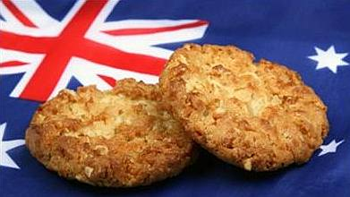
She likes cooking breakfast and Anzac biscuits.
(http://www.anzac.com/anzac_biscuits.html)
We asked her if there were any French restaurants in her country and she said there were.
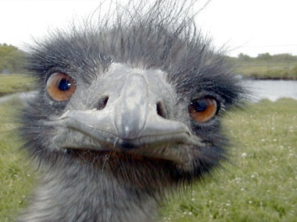
There are also kebabs but they aren’t in sandwiches like in France but on sticks and they are made on any meat ( beef, chicken or kangaroo).
Because Australia is an island there are animals that only live there like Koalas, emus and kangaroos.

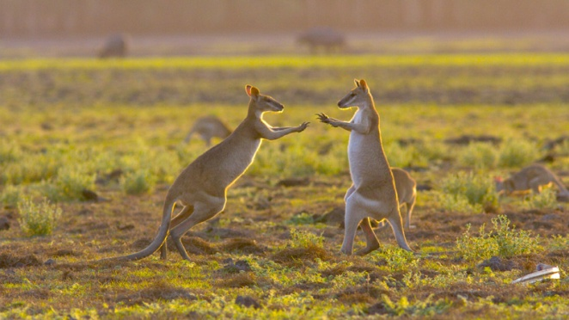
She has touched one in a zoo but they can be really dangerous and kill you if you approach them in the street. Some are as tall as a person or even taller.
She has been surfing and there are sharks in the sea but little ones.
If you are afraid of spiders you’re in trouble in Australia because some are as big as your hand.
There are also a lot of snakes which can be 2 meters long.
One pupil in the 5th form Aubrac asked her if she understood the teacher and she answered she did but she also understood them and they understood her.
They asked her if she spoke French and if she could say something in French. She said ‘Bonjour, je m’appelle Laura”.
One asked if they were going to go to Australia and she told them they could if they had a subject to study. So perhaps they will go when they are in high school but before that they can follow Australia day is on 26th of January.
Finally we thanked her for coming and answering our questions.
She gave Mrs Sallibartan her e-mail so that we could continue to ask her more questions if we wanted.
She was also glad she had come to visit us.
We wished her to be published one day so that we could read her books and even to be really famous to be translated in French.

