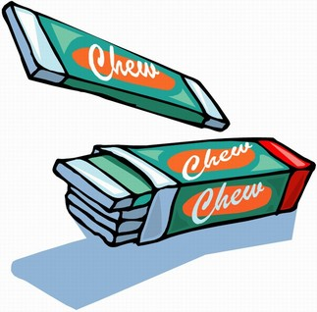
Chat: Should chewing gum be banned?
Celebrity chef Jamie Oliver says he would ban chewing gum if he was Prime Minister because it's ruining Britain's streets. He says people should be stopped from chewing it until a gum can be invented that causes less mess on our roads, paths and pavements. But is he right? Should chewing gum be banned?
I think that chewing gum should be banned because it can get on your clothes and can be hard to get off. Jessica, London
I don't think it should be banned because it makes your breath smell nice and is fun to chew on. Sam, Oxfordshire
I think chewing gum should be banned because since you can't swallow it people spit it on the street and it makes a disgusting mess. Also you get it stuck to your shoe and it is horrid. Victoria, Scotland
I think it should be banned because at my school it is everywhere. It is under desks on chairs and on the floor so when you sit down it goes on your clothes from the desks and it gets all stuck in your hair and it is disgusting. Amy, Hemel Hempstead
I think chewing gum should be banned because it makes our road messy and it's practically littering when people spit it on the floor. Leslie, London
I agree that it should be banned to a certain degree however chewing gum is such a big thing in the United Kingdom that banning it altogether is a step too far. Jamie Oliver is a very inspirational person and I think that decisions he makes have a massive impact all over Britain. Minnie, Sheffield
I think chewing gum should be banned because when you're on a train it is always down the back of the seats. Emilia, Oundle
Chewing gum should be banned because it gets stuck to your shoes and it takes you forever to take off and at school you touch it under the table because somebody stuck it there. Libby, Kingston Upon Thames
Chewing gum shouldn't be banned but don't spit it out on the floor. Matthew, Newport
I think chewing gum should be banned because it sticks to the roads which makes them look dirty and unpleasant" Safyan, Luton
"I think that this is pointless. I enjoy chewing gum and bubble gum. Chewing gum is especially good because I think it is good for your teeth. What they should do is make laws much stricter about spitting it on the floor, and place more bins on streets and paths." Harry, St Albans
"Yes ban it, because in school there is loads of it under the desks and it's disgusting" Nathan, Sunderland
"I think it is a silly idea because it's tasty and you can have some fun by blowing bubbles" Michael. Epsom
"I think chewing gum should be banned because it is bad for the environment" Rory, Harrogate
"I think chewing gum should be banned because it is a pointless food that gets stuck on roads" Imogen, Suffolk

