**EASTER.**

**Do you want to know what Easter is? Then read the text**.

Easter is always on Sunday, because people thought Jesus woke up from the dead on the first day of the week. Easter is the first Sunday coming after the first full moon in spring. But it can come as early as March 22 or as late as April 25. It is a holidays of spring sun, awakening of new life and death of winter.

The symbols of Easter are eggs, rabbits and chickens, spring flowers and new clothes. On Easter Sunday people give coloured eggs to children and friends. Eggs come to the breakfast tables on Easter Day or are hidden about the house and garden for the children to find. Children keep one of the most beautifully coloured eggs for a year or two. Now children usually get chocolate eggs.

People have a good time with egg-rolling. They roll coloured, hard-boiled eggs down a hillock until the eggs break.

People think - eating hot cross buns at breakfast on Good Friday morning is a magic thing.

London meets spring with Easter Parade each year. The ship made of very many spring flowers, bears the Easter Princess.

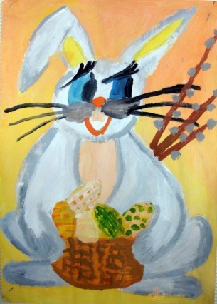

**Answer the questions.**

When do people celebrate Easter?

What are the Easter symbols?

Why are they symbols?

Where can children find eggs?

How long do children keep one of the most beautiful eggs?

What is eggs-rolling?

Why do people eat hot cross buns on Good Friday morning?

What is Easter Parade?

**Learn to read the words and sentences.**

[i :] eat, East, Easter, Easter eggs, Easter Day; Eggs come to the breakfast tables on Easter Day.

[i ] symbol, the symbol; The symbols of Easter are eggs, rabbits and chicken.

[a:] hard-boiled, garden, dark, coin, noisy; hard-boiled eggs; They roll coloured, hard-boiled eggs down a hillock.

[^] sun, summer, run, bun-buns, hot cross bun; People think-eating hot cross buns at breakfast is a magic thing.

[әu] so, no, cold, roll-rolled; They roll coloured hard-boiled eggs.

[eә] pear, near, bear, it, bears; The ship bears the Easter Princess.

**Draw your own Easter card and write a wish.**

* + Happy Easter!
  + Happy Easter

Happy spring

Happy, happy everything!

* With best wishes to you for a wonderful Easter!

**Make a show of your Easter cards in the class.**