***SEQUENCE – STREET ART***

***COURSE 1***

**1. Look at the 5 pictures**

🡪 *Regarde les 5 photos (pour les voir mieux, regarde p. 80 de ton manuel).*

1. Say which one you prefer and why

🡪*Dis laquelle tu préfères et pourquoi*

1. Associate these words with the French translation, and then with each picture

*🡪Associe chaque adjectif avec sa traduction française, puis met ceux qui correspondent sous chaque photo*

|  |  |
| --- | --- |
| 1. Ugly 2. Beautiful 3. Funny 4. Disturbing 5. Witty 6. Striking 7. Colourful 8. Dull 9. Aggressive 10. Provocative 11. Cheeky | 1. Beau/belle 2. Provocant(e) 3. Agressif (ve) 4. Insolent(e) 5. Laid(e) 6. Terne, fade 7. Coloré 8. Drôle 9. Perturbant(e) 10. Fin, intelligent(e) 11. Frappant(e), saisissant(e) |

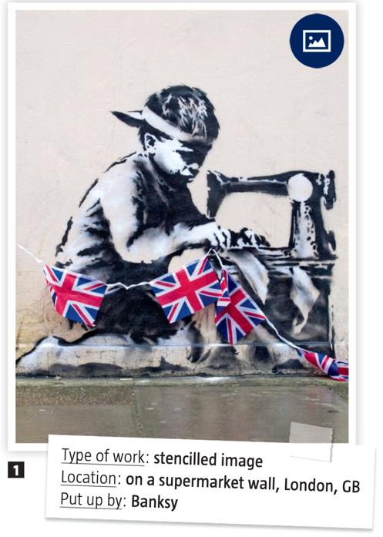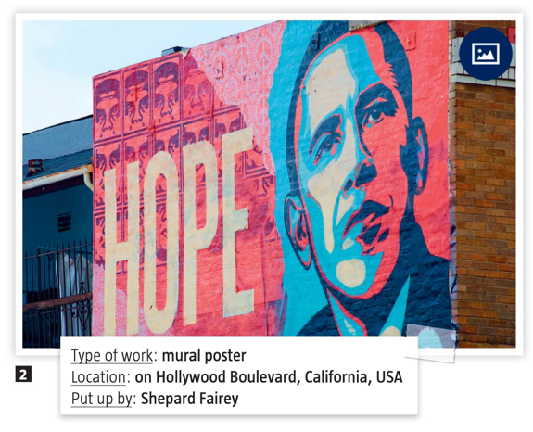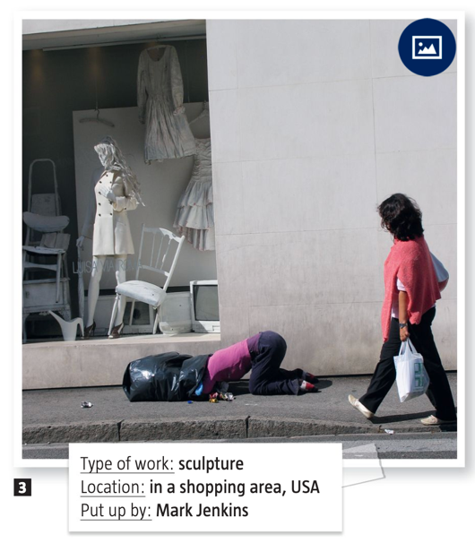

|  |  |  |
| --- | --- | --- |
| 1/ | 2/ | 3/ |

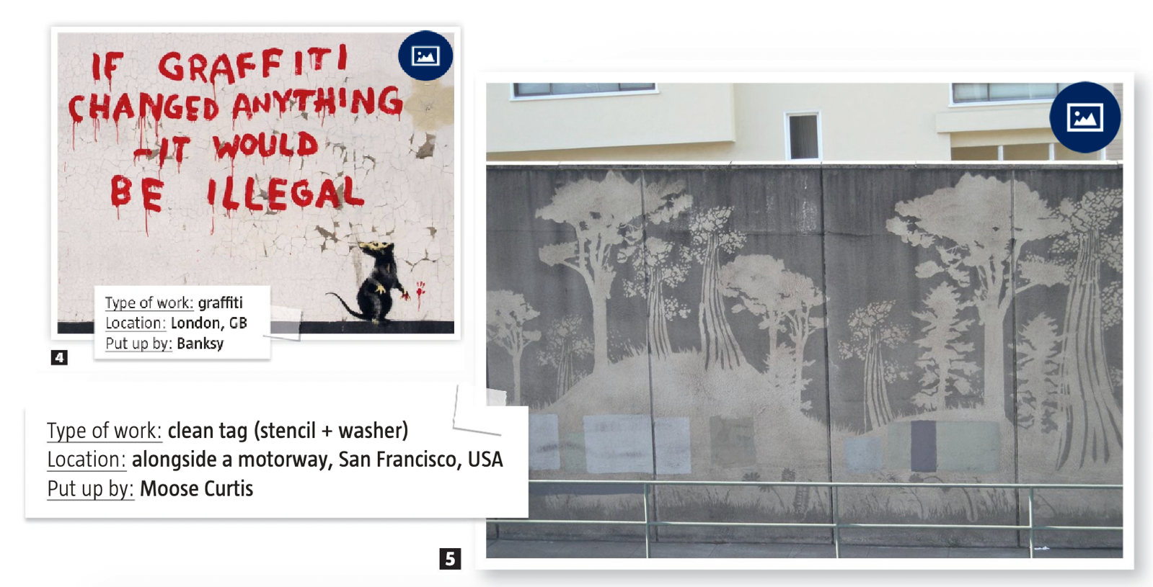

|  |  |
| --- | --- |
| 4/ | 5/ |

**2. Imagine the artists’ reasons for creating these pieces**

🡪 *Imagine les raisons que les artistes ont eu pour créer chaque œuvre (ex : pour dénoncer qqchose, pour soutenir qq…)*

*🡪 N’oublie pas d’utiliser ‘to’ + verbe. Ex: picture 1 🡪 the artist did this piece* ***to denounce*** *child labour.*

1. *The artist did this piece to*
2. *The artist did this piece to*
3. *The artist did this piece to*
4. *The artist did this piece to*
5. *The artist did this piece to*

**3. Grammaire : rappel sur les verbes réguliers/irréguliers**

Rappel : au prétérit et au participe passé, les verbes réguliers se terminent par -**ed** (qui a 3 prononciations différentes je te rappelle 🡪 ‘t’, ‘d’ et ‘id’.

Mais certains verbes sont appelés les verbes irréguliers, et ne suivent pas cette règle. Les plus importants sont à la fin de ton manuel d’anglais, et au fur et à mesure de cette séance, nous allons les apprendre/réviser ensemble.

Il y en aura donc à apprendre à la fin de chaque séance. Et surtout, tu peux t’entraîner sur le Quizlet que j’ai créé ici : <https://quizlet.com/Sophienglish/folders/verbes-irreguliers/sets>

Le fonctionnement d’un quizlet est super, tu peux apprendre, te tester, jouer, écouter la prononciation… Essaie le maximum de fonctionnalités :

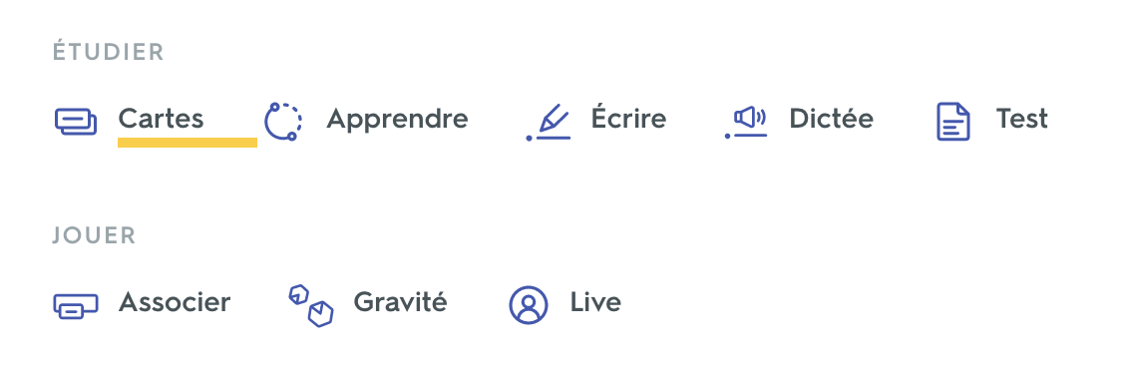

**Voici donc les premiers verbes à apprendre : les triplés 🡪 ceux qui ne changent pas.**

**Le lien Quizlet pour ce groupe de verbes :** <https://quizlet.com/fr/502237518/les-triples-flash-cards/>

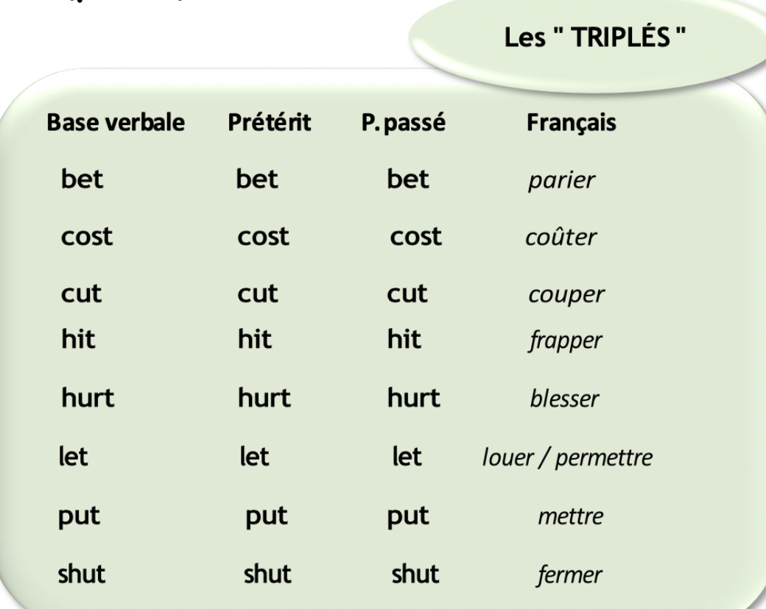

***COURSE 1 - CORRECTION***

**1. Look at the pictures**

🡪 *Regarde les photos (pour les voir mieux, regarde p. 80 de ton manuel).*

1. Say which one you prefer and why

🡪*Dis laquelle tu préfères et pourquoi*

(My answer) I love picture 3 because it really looks like a real person and I’m sure people were puzzle and afraid when they saw the sculpture on in the street.

1. Associate these words with the French translation, and then with each picture

*🡪Associe chaque adjectif avec sa traduction française, puis met ceux qui correspondent sous chaque photo*

* **Ugly** = Laid(e)
* **Beautiful** = Beau/belle
* **Funny** = Drôle
* **Disturbing** = Perturbant(e)
* **Witty** = Fin, intelligent(e)
* **Striking** = Frappant(e), saisissant(e)
* **Colourful** = Coloré
* **Dull** = Terne, fade
* **Aggressive** = Agressif (ve)
* **Provocative** = Provocant(e)
* **Cheeky** = Insolent(e)

|  |  |  |
| --- | --- | --- |
| 1/ Beautiful, disturbing, provocative, witty | 2/ Colourful, beautiful, striking | 3/ Provocative, cheeky, funny, disturbing |

|  |  |
| --- | --- |
| 4/ Funny, witty, provocative, ugly | 5/ Beautiful, dull, witty |

**2. Imagine the artists’ reasons for creating these pieces**

🡪 *Imagine les raisons que les artistes ont eu pour créer chaque œuvre (ex : pour dénoncer qqchose, pour soutenir qq…)*

*🡪 N’oublie pas d’utiliser ‘to’ + verbe. Ex: picture 1 🡪 the artist did this piece* ***to denounce*** *child labour.*

1. *The artist did this piece to denounce child labour in poor country for products sold in England.*
2. *The artist did this piece to support Barack Obama and show that he represents hope.*
3. *The artist did this piece to denounce the consuming society.*
4. *The artist did this piece to make people think about graffiti and street art.*
5. *The artist did this piece to make the neighborhood more beautiful and natural.*

***COURSE 2: How to express your opinion***

**1. Look at the pictures from course 1 (p.80 of your English book) and the definition of art and say, for each of them, if you think that it is art or not.**

*🡪 Regarde à nouveau les œuvres du cours 1 (p.80 de ton manuel) et lis la définition de l’art et dis, pour chaque œuvre, si tu penses que c’est de l’art ou non*

***Art****:* ***definition*** *🡪 The creation of things whose purpose is to be beautiful or full of meaning.*

*\*a purpose = a goal*

*\*a meaning = a sense*

|  |  |
| --- | --- |
| **Picture 1** |  |
| **Picture 2** |  |
| **Picture 3** |  |
| **Picture 4** |  |
| **Picture 5** |  |

**2. Match each expression with its French translation then use them to express your opinion on your favorite piece of art**

*🡪 Associe chaque expression à sa traduction en français et utilise-les pour formuler ton opinion sur ton œuvre préférée (parmi les œuvres du cours 1 – p.80 du manuel)*

|  |  |
| --- | --- |
| 1. I think / believe / feel / assume / consider / find that... 2. To my mind... In my opinion... From my point of view... To me... 3. As far as I’m concerned,… 4. What I mean is... 5. I am convinced that... I am sure that... 6. I tend to think that... 7. I’d like to point out that... 8. It seems to me that... 9. No matter what you say, I still think that... 10. Some may believe / state / argue that..., but I think... | 1. Je voudrais souligner que… 2. Il me semble que… 3. Ce que je veux dire c’est… 4. Je suis convaincu(e) que… / Je suis sûr(e) que… 5. Peu importe ce que tu penses, je crois toujours que.. 6. Selon moi, à mon avis, de mon point de vue, pour moi… 7. Certains pensent/disent/défendent que…, mais je pense… 8. Je pense, je crois, je sens, je présume, je considère, je trouve que… 9. J’ai tendance à penser que… 10. En ce qui me concerne… |

|  |  |
| --- | --- |
| **Your favorite piece of art** *(ton oeuvre préférée)* |  |
| **Your opinion on this piece of art** *(ton opinion sur cette oeuvre, en utilisant les expressions vues juste au-dessus)* |  |

**3. Listen to the audio and take notes of how the person nuances his/her opinion**

*🡪 Ecoute l’audio et prend des notes de comment la personne nuance ses propos*

*\*Nuancer ses propos = exprimer quelque-chose de manière plus polie*

*Ex : je déteste cette œuvre car elle est laide 🡪 cette œuvre n’est pas à mon goût mais j’imagine que certaines personnes doivent l’aimer.*

|  |  |
| --- | --- |
| **Your notes on the audio** |  |

**4. Listen to the audio a second time and take notes of the gapfillers**

*🡪 Ecoute l’audio une deuxième fois et prend des notes des gapfillers utilisés*

*\*Gapfilliers = Mots ou expression utilisées pour faire des transitions entre ses idées, notamment quand on cherche ce qu’on va dire*

*Ex : Well... So... Err... I mean...  
What I mean is... Let me think... Let’s see... Anyway, what I’m trying to say is...*

|  |  |
| --- | --- |
| **Your notes on the audio** |  |

***HOMEWORK :***

**Voici donc les nouveaux verbes à apprendre : les « GHT » et « ON »**

**Le lien Quizlet pour ce groupe de verbes :** <https://quizlet.com/fr/502252334/les-ght-et-on-flash-cards/?new>

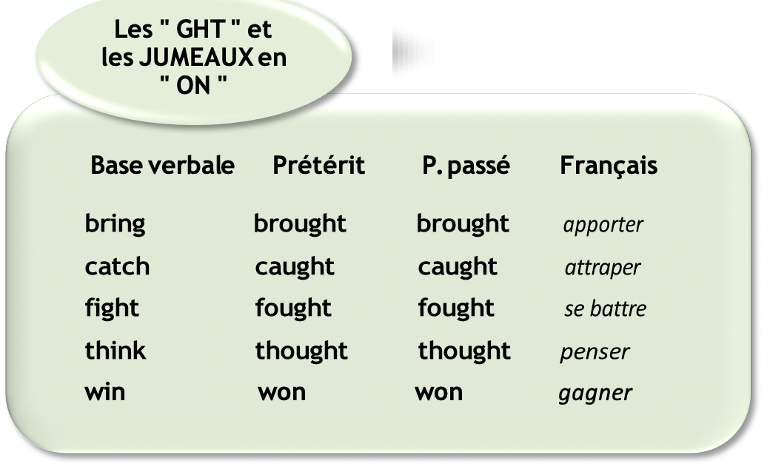

***COURSE 2 - CORRECTION***

**1. Look at the pictures from course 1 (p.80 of your English book) and the definition of art and say, for each of them, if you think that it is art or not.**

*🡪 Regarde à nouveau les œuvres du cours 1 (p.80 de ton manuel) et lis la définition de l’art et dis, pour chaque œuvre, si tu penses que c’est de l’art ou non*

***Art****:* ***definition*** *🡪 The creation of things whose purpose is to be beautiful or full of meaning.*

*\*a purpose = a goal*

*\*a meaning = a sense*

|  |  |
| --- | --- |
| **Picture 1** | I believe this piece is a work of art because I find it beautiful and it has a lot of meaning to me. |
| **Picture 2** | I am not sure this is a piece of art even if it is beautiful. It looks more like a political poster to support a politician. |
| **Picture 3** | It looks like a piece of art to me, even if I don’t think it is very beautiful. Indeed, it has a  lot of meaning and denounces the consuming society. |
| **Picture 4** | I don’t think this is a piece of art. I don’t find it beautiful and I don’t really see any meaning. |
| **Picture 5** | To me, this is a piece of art as I find it beautiful. However, it does not really have a meaning. |

**2. Match each expression with its French translation then use them to express your opinion on your favorite piece of art**

*🡪 Associe chaque expression à sa traduction en français et utilise-les pour formuler ton opinion sur ton œuvre préférée (parmi les œuvres du cours 1 – p.80 du manuel)*

1. **I think / believe / feel / assume / consider / find that... =** Je pense, je crois, je sens, je présume, je considère, je trouve que
2. **To my mind... In my opinion... From my point of view... To me... =** Selon moi, à mon avis, de mon point de vue, pour moi…
3. **As far as I’m concerned,… =** En ce qui me concerne…
4. **What I mean is... =** Ce que je veux dire c’est…
5. **I am convinced that... I am sure that... =** Je suis convaincu(e) que… / Je suis sûr(e) que…
6. **I tend to think that... =** J’ai tendance à penser que…
7. **I’d like to point out that... =** je voudrais souligner que…
8. **It seems to me that... =** Il me semble que…
9. **No matter what you say, I still think that... =** Peu importe ce que tu penses, je crois toujours que..
10. **Some may believe / state / argue that..., but I think... =** Certains pensent/disent/défendent que…, mais je pense…

|  |  |
| --- | --- |
| **Your favorite piece of art** *(ton oeuvre préférée)* | 3. The sculpture |
| **Your opinion on this piece of art** *(ton opinion sur cette oeuvre, en utilisant les expressions vues juste au-dessus)* | **From my point of view**, this piece of work is the best because **I find that** is really means something.  **To my mind**, it denounces society and **I tend to think** that this is a crucial issue.  **Some may say** that it is creepy, but **I think** it is necessary. |

**3. Listen to the audio and take notes of how the person nuances his/her opinion**

*🡪 Ecoute l’audio et prend des notes de comment la personne nuance ses propos*

*\*Nuancer ses propos = exprimer quelque-chose de manière plus polie*

*Ex : je déteste cette œuvre car elle est laide 🡪 cette œuvre n’est pas à mon goût mais j’imagine que certaines personnes doivent l’aimer.*

|  |  |
| --- | --- |
| **Your notes on the audio** | The picture that I like the most…  I don’t actually like the way the sculpture looks  I don’t find it that appealing to look at  It could be interpreted in two ways…  Maybe it means that…  Perhaps it is to make people think…  I think it is interesting because…  Art doesn’t necessarily have to look nice… |

**4. Listen to the audio a second time and take notes of the gapfillers**

*🡪 Ecoute l’audio une deuxième fois et prend des notes des gapfillers utilisés*

*\*Gapfilliers = Mots ou expression utilisées pour faire des transitions entre ses idées, notamment quand on cherche ce qu’on va dire*

*Ex : Well... So... Err... I mean...  
What I mean is... Let me think... Let’s see... Anyway, what I’m trying to say is...*

|  |  |
| --- | --- |
| **Your notes on the audio** | So, uuum (many times)  But what I mean… |

***COURSE 3: Shepard Fairey***

**1. Read the recap about the street art artist Shepard Fairey and imagine 4 questions you could ask him**

*🡪 Lis ce résumé sur l’artiste de street art Shepard Fairey et imagine 4 questions que tu pourrais lui poser*

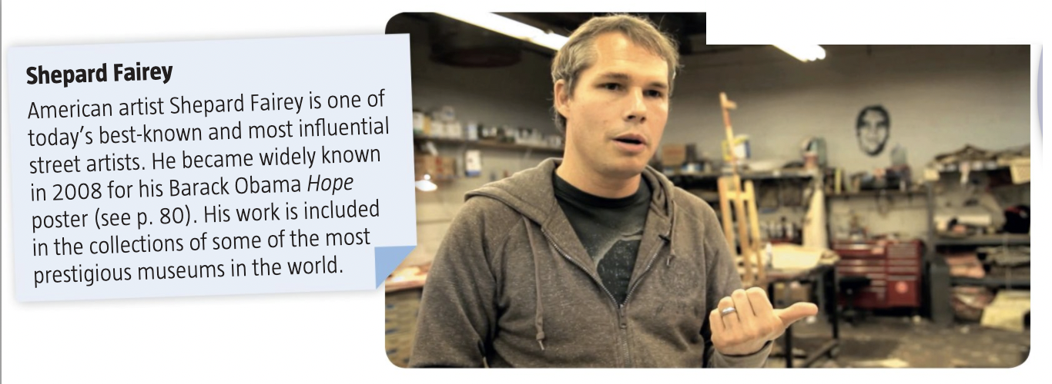

**1.**

**2.**

**3.**

**4.**

**2. Watch the first minute of the video with the sound off, and then the whole video with the sound on and take notes of what you understand**

*🡪 Regarde la première minute de la vidéo sans le son puis toute la vidéo avec le son et prend des notes de ce que tu comprends*

|  |  |
| --- | --- |
| **SOUND OFF: 1st MINUTE** | **SOUND ON: THE WHOLE VIDEO** |
|  |  |

**3. Use what you have learned to explain what played a key role in Shepard Fairey’s carrer**

*🡪 Utilise ce que tu as appris pour expliquer ce qui a joué un rôle important dans la carrière de Shepard Fairey. A chaque fois, utilise les captures d’écrans de la vidéo qui t’indiquent ces moments clés.*

|  |  |
| --- | --- |
| **Image of the moment** | **Your explanation of that moment** |
|  |  |
|  |  |
|  |  |
|  |  |

***HOMEWORK :***

**\*Voici les nouveaux verbes à apprendre : les jumeaux en T**

**Le lien Quizlet pour ce groupe de verbes :** <https://quizlet.com/fr/502718384/les-jumeaux-en-t-flash-cards/>

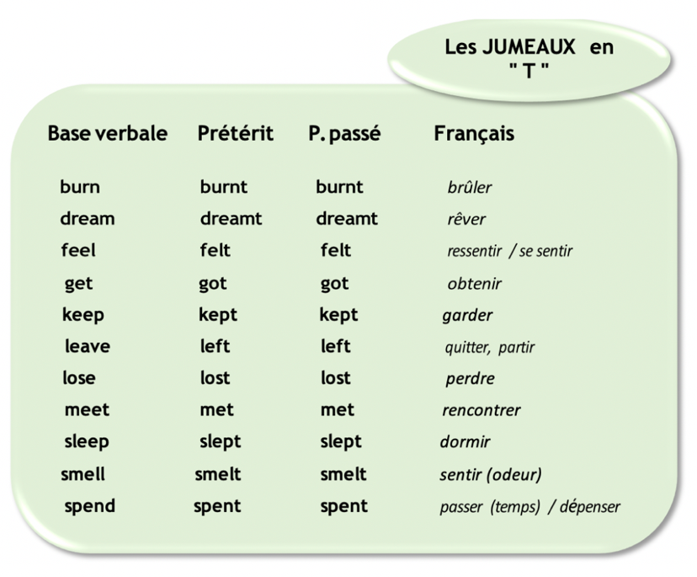

***COURSE 3 - CORRECTION***

**1. Read the recap about the street art artist Shepard Fairey and imagine 4 questions you could ask him**

1. Why did you decide to become a street artist?

2. Do you understand people who say that street art is not art?

3. Who are the best street artists, according to you?

4. Do you think a simple graffiti is art?

**2. Watch the first minute of the video with the sound off, and then the whole video with the sound on and take notes of what you understand**

|  |  |
| --- | --- |
| **SOUND OFF: 1st MINUTE** | **SOUND ON: THE WHOLE VIDEO** |
| Obey / The rise / People gluing posters on walls in the streets.  A person talking (probably Shepard Fairey)  Skaters  A workshop/an artist studio | He never did graffiti with aerosol because he grew up in South Carolina where there wasn’t a graffiti scene  He went to a design school, an art school  He was into skateboarding and punk-rock  Stickers, stencils logo, flyers  He went to NY in 1988 with a school group 🡪 he saw all the graffiti  To him, street art is about expressing yourself in public space, something pure about graffiti  He started making stickers, stencils and posters |

**3. Use what you have learned to explain what played a key role in Shepard Fairey’s carrer**

|  |  |
| --- | --- |
| **Image of the moment** | **Your explanation of that moment** |
|  | When he was young, Shepard Fairey loved skateboard and punk rock. |
|  | Shepard Fairey was into skateboarding and punk rock. He started making homemade stickers and stencils. |
|  | S. Fairey discovered street art during a school trip to New York. They went to a museum but he was more interested in the graffiti he saw outside the city. After that trip he decided that he wanted to express himself in public spaces. |
|  | He decided to use stencils, stickers and posters (rather than aerosols / bombing). |