page3image15852544***COURSE 9 : Meet your future self!***

**1. Look at the picture (screenshot from the video)🡪 Imagine:**

*🡪Regarde la photo (capture d’écran de la vidéo) et imagine :*

1. ***What the video is about***

*🡪 Quel est le sujet de la vidéo*

The video is about…

1. ***Who the two characters are***

*🡪 Qui sont les deux personnes que tu vois sur l’image*

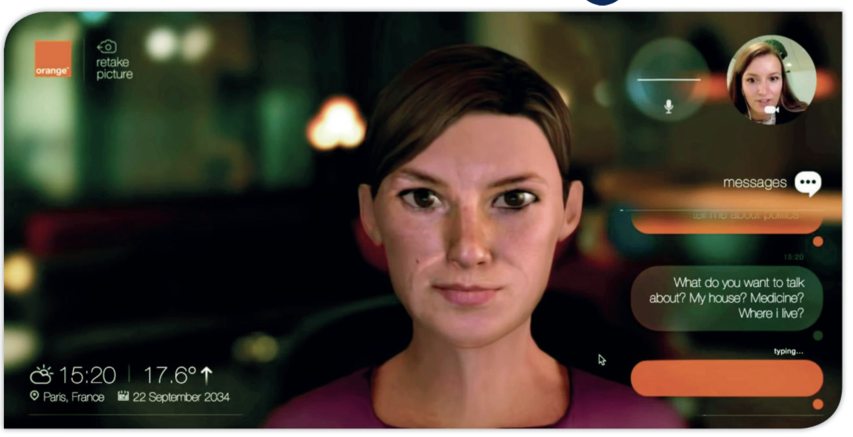

**2. The video: watch the video and take notes of what you understand**

1. ***Take notes of what you understand***

*🡪 Prend des notes de ce que tu comprends (ce que tu vois et ce que tu entends)*

1. ***Write a small summary to explain what the application is***

*🡪 Ecris un court résumé pour expliquer ce qu’est cette application*

**3. The audio: Annie used the app and had a conversation with her future self. Listen to the audio and complete the table**

*🡪Annie a utilisé l’application et a eu une conversation avec sa future ‘elle’. Ecoute à présent l’audio dans lequel elle raconte cela et complète le tableau*

|  |
| --- |
| ***Things that have changed*** *- les choses qui ont changé* |
|  |
|  |
|  |
|  |
|  |
|  |

***HOMEWORK :***

Voici les verbes irréguliers à apprendre pour ce cours !

Voici le lien quizlet pour les apprendre et pour t’entraîner : <https://quizlet.com/fr/505230176/de-go-a-ride-flash-cards/?new>

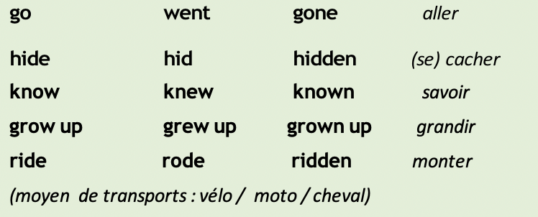

***COURSE 9 : CORRECTION***

**. Look at the picture (screenshot from the video)🡪 Imagine:**

*🡪Regarde la photo (capture d’écran de la vidéo) et imagine :*

1. ***What the video is about***

*🡪 Quel est le sujet de la vidéo*

**The video is about a video chat.**

1. ***Who the two characters are***

*🡪 Qui sont les deux personnes que tu vois sur l’image*

**I think they are the same person 🡪 I think she is talking to her future self.**

**2. The video: watch the video and take notes of what you understand**

1. ***Take notes of what you understand***

*🡪 Prend des notes de ce que tu comprends (ce que tu vois et ce que tu entends)*

**The future / yourself / in 20 years / travel through time / faces / look like a robot / sport / house / communicate / dog / orange.com**

1. ***Write a small summary to explain what the application is***

*🡪 Ecris un court résumé pour expliquer ce qu’est cette application*

**The people in the video are talking to their future selves.  
They are asking questions about the future.**

**3. The audio: Annie used the app and had a conversation with her future self. Listen to the audio and complete the table**

|  |
| --- |
| ***Things that have changed*** *- les choses qui ont changé* |
| **Houses have changed because they are digital in the future.** |
| **They have created robots to help at home and to be friends with.** |
| **Cinema has improved because it is immersive in the future.** |
| **Culture has changed because books are all online** |
| **Transport has changed because they have invented cars that drive themselves.** |