***COURSE 9 : Article about Banksy***

**1.Before reading the article about Banksy, answer the questions**

*🡪Avant de lire l’article, réponds aux questions ci-dessous*

1. ***Write down the key information of the first paragraph***

*🡪Ecris les informations clés (les plus importantes), du premier paragraphe*

1. ***The first sentence of each paragraph introduces a new idea. Underline and read them to have a clear idea of the whole article***

*🡪La première ligne de chaque paragraphe présente une nouvelle idée. Souligne et lis toutes les premières pages de l’article pour avoir une idée claire de ce qu’il y a dans l’article*

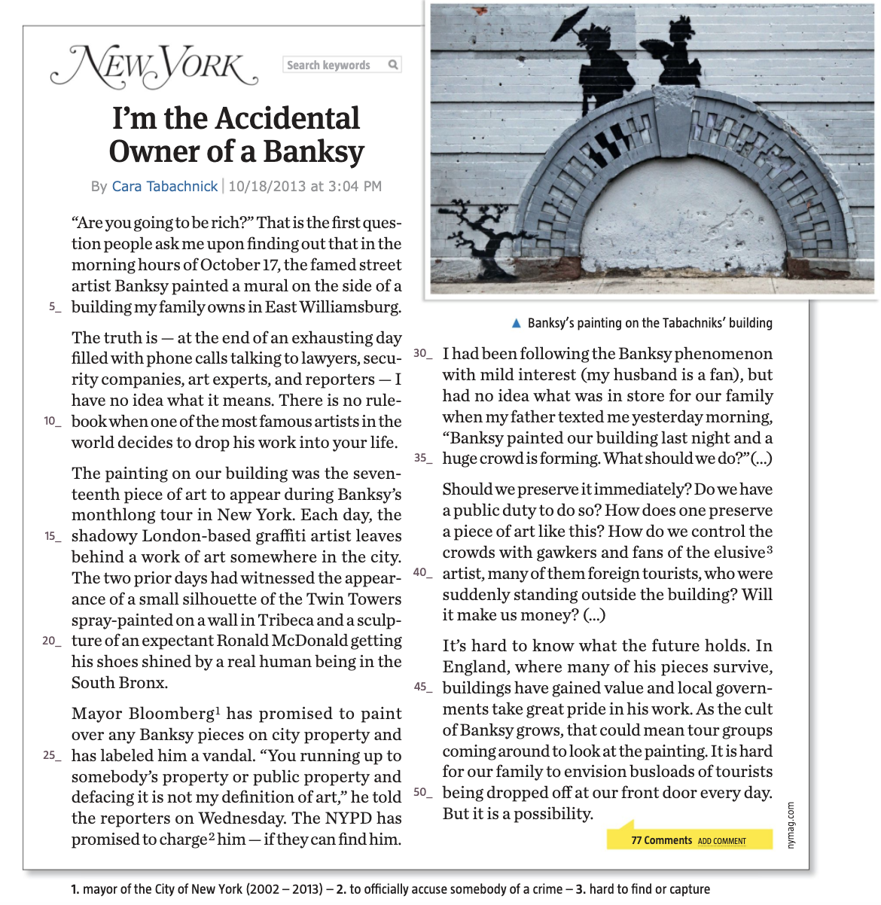

**2.Now read the article and pick out the following information**

*🡪Maintenant lis l’article en entier et note les différentes informations dans les cases correspondantes (tu ne pourras pas remplir toutes les cases, notamment ‘facts’)*

|  |  |  |
| --- | --- | --- |
| ***The people involved***  *Les gens impliqués* | ***The facts***  *Les faits* | ***Their reactions***  *Leurs réactions* |
|  |  |  |
|  |  |  |
|  |  |  |
|  |  |  |
|  |  |  |

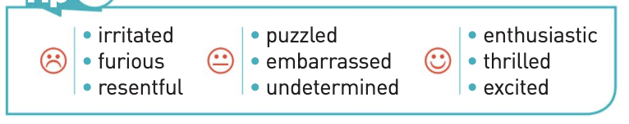 **🡨 pour t’aider à remplir les cases**

***HOMEWORK :***

Voici les verbes irréguliers à apprendre pour ce cours !

Voici le lien quizlet pour les apprendre et pour t’entraîner : <https://quizlet.com/fr/505230176/de-go-a-ride-flash-cards/?new>

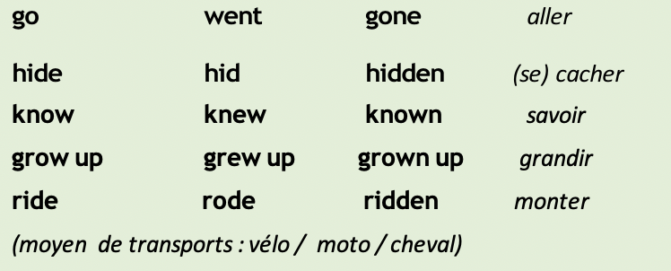

***CORRECTION: COURSE 9***

**1.Before reading the article about Banksy, answer the questions**

*🡪Avant de lire l’article, réponds aux questions ci-dessous*

1. ***Write down the key information of the first paragraph***

*🡪Ecris les informations clés (les plus importantes), du premier paragraphe*

**Money – October 17 – a mural painted by Banksy – East Williamsburg – a private building**

* ***Banksy painted a mural on a private building. The owner says that people think she will be rich thanks to that mural.***

1. ***The first sentence of each paragraph introduces a new idea. Underline and read a clear idea of the whole article***

*🡪La première ligne de chaque paragraphe présente une nouvelle idée. Souligne et lis toutes les premières pages de l’article pour avoir une idée claire de ce qu’il y a dans l’article*

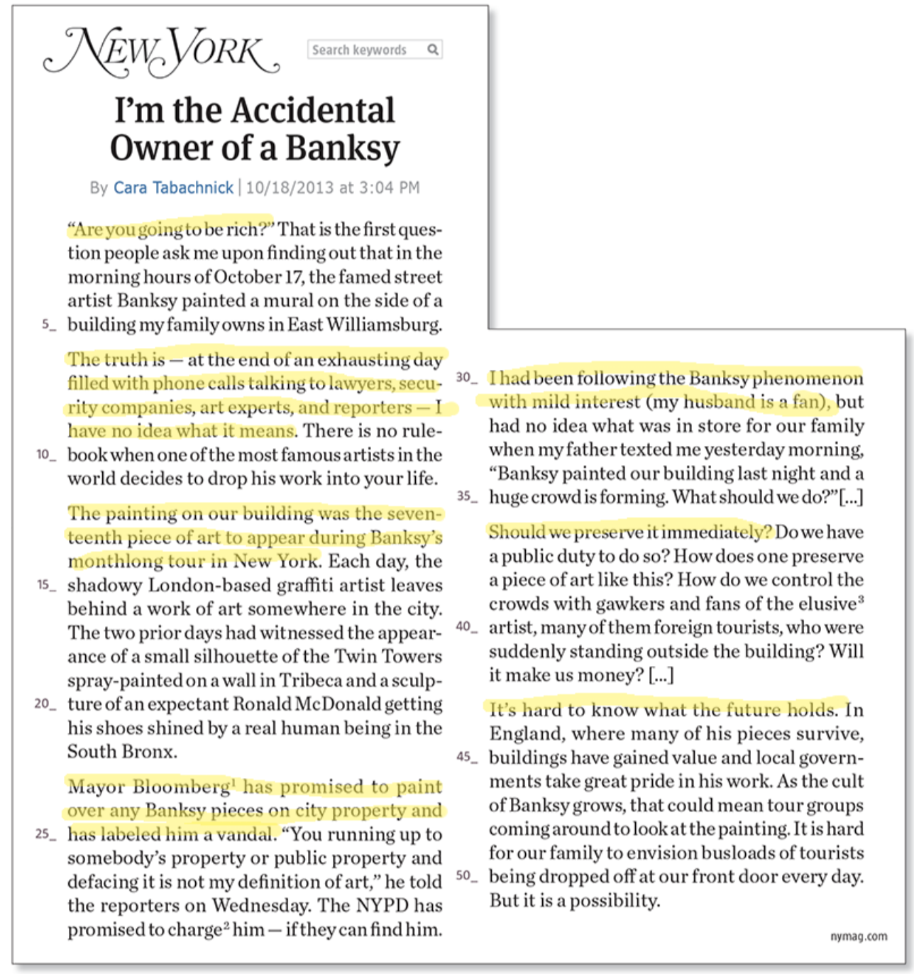

**2.Now read the article and pick out the following information**

*🡪Maintenant lis l’article en entier et note les différentes informations dans les cases correspondantes*

|  |  |  |
| --- | --- | --- |
| ***The people involved***  *Les gens impliqués* | ***The facts***  *Les faits* | ***Their reactions***  *Leurs réactions* |
| **Cara Tabachnik** | “in the morning hours of October 17, the famed street artist Banksy painted a mural on the side of a building my family owns in East Williamsburg” (l. 2-5) | **→ she is surprised and does not know what to do.** |
| **Banksy** | **→ Banksy has painted a mural on cara tabachnik’s building**  “The painting on our building was the seventeenth piece of art to appear during Banksy’s monthlong tour in New York” (l. 12-14)  **→ Banksy is staying in new-York for a month. Cara’s tag is the 17th the artist has painted in NYC**  “Each day, the shadowy London-based graffiti artist leaves behind a work of art somewhere in city” (l. 14-16)  **→ Banksy, who comes from lon- don, makes one graffiti a day**  “The two prior days had witnessed the appearance of a small silhouette of the Twin Towers spray-painted on a wall in Tribeca and a sculpture” (l. 17-22)  **→ Banksy painted two tags over the past two days.** |  |
| **Michael Bloomberg, Mayor of New York** |  | “Mayor Bloomberg has promised to paint over any Banksy pieces on city property and has labeled him a vandal.” (l. 23)  **→ He is angry and considers Banksy a vandal.** |
| **The NYPD** |  | “The NYPD has promised to charge him — if they can find him” (l. 28)  **→ the police will arrest Banksy if they can find him.** |
| **Cara’s father** |  | “my father texted me yesterday morning, “Banksy painted our building last night and a huge crowd is forming. What should we do?” (l. 33)  **→ Her father tells Cara what happened and asks her what they should do / for advice.** |