***COURSE 3***

**1. Watch the video: A first time with the sound off to take notes of everything you see, and a second time with the sound on to complete your notes**

🡪 *Regarde la vidéo : Une première fois sans le son pour prendre des notes de tout ce que tu vois, et une seconde fois avec le son pour compléter tes notes*

|  |  |  |
| --- | --- | --- |
|  | **Sound off (*sans le son*)** | **Sound on (*avec le son*)** |
| **Place (*endroit*)** |  |  |
| **Burial date (*date d’enterrement*)** |  |  |
| **Opening date (*date d’ouverture*)** |  |  |
| **Contents (*contenu*)** |  |  |

**2. Time to write: use what you have learnt to write a paragraph about this time capsule**

🡪 *C’est le moment d’écrire : utilise les informations du tableau pour écrire un paragraphe sur cette capsule temporelle*

*In 19… : the ……………………………………………… time capsule.*

*Event : ………………………………………………………………………………………………*

Contents : *…………………………………………………………………………………………*

*Place of burial : ………………………………………………………………………………….*

*Opening date : ……………………………………………………………………………………*

***HOMEWORK :***

**\*Voici donc les nouveaux verbes à apprendre : les jumeaux en T**

**Le lien Quizlet pour ce groupe de verbes :** <https://quizlet.com/fr/502718384/les-jumeaux-en-t-flash-cards/>

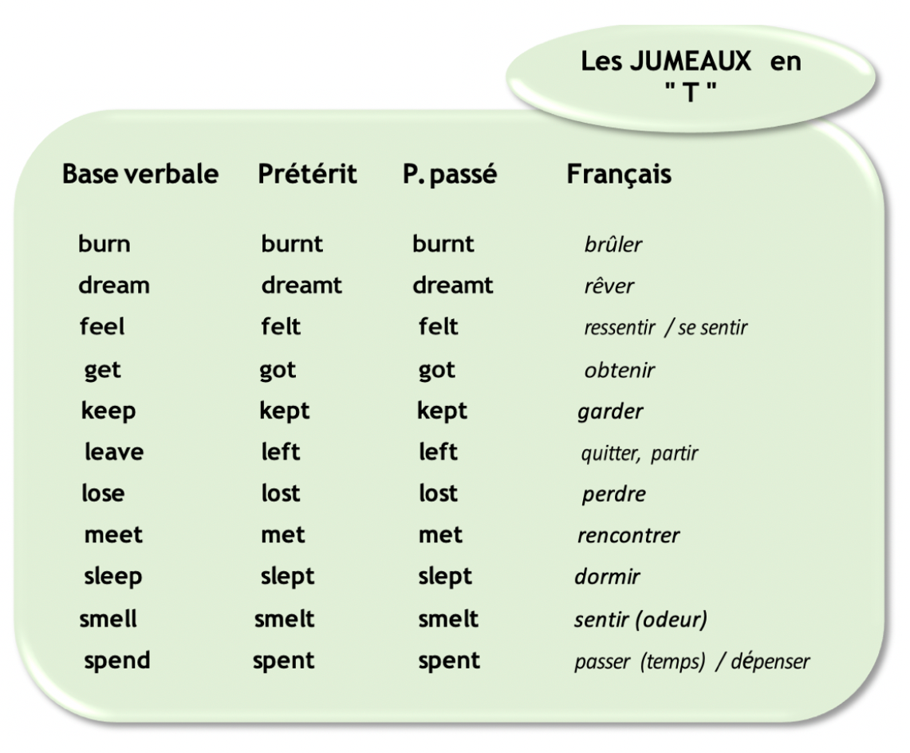

***CORRECTION – COURSE 3***

**1. Watch the video: A first time with the sound off to take notes of everything you see, and a second time with the sound on to complete your notes**

|  |  |  |
| --- | --- | --- |
|  | **Sound off (*sans le son*)** | **Sound on (*avec le son*)** |
| **Place (*endroit*)** | Oklahoma (it’s written on the newspaper) | Oklahoma, USA. |
| **Burial date (*date d’enterrement*)** | Maybe in the XIXth century? | April 22nd, 1913 |
| **Opening date (*date d’ouverture*)** | Nowadays. | April 22nd, 2013 |
| **Contents (*contenu*)** | A big box that looks like a coffin.  There are many documents inside: papers, a newspaper, books with images inside…  Some objects: a hat, shoes, a fountain-pen, a jar… | A bow, a plate, a pen used by a President to sign the Free Homes Act for Oklahoma in 1900.  A phonograph 🡪 with speeches from 1913.  A book of pictures and poems  A 1913 telephone  A lady’s hat, a boy suit, a pair of women’s shoes  The first state flag of Oklahoma |

**2. Time to write: use what you have learnt to write a paragraph about this time capsule**

🡪 *C’est le moment d’écrire : utilise les informations du tableau pour écrire un paragraphe sur cette capsule temporelle*

**1913: The Oklahoma Time Capsule  
Event**: The opening of the Oklahoma Time Capsule

**Contents**: a bow made by a Choctaw Indian, a plate painted by a Chickasaw Indian, Indian pottery, a pen used by President McKinley, a phonograph, a book of pictures and poems, a 1913 telephone, a ladies’ hat, a boys’ suit, a pair of shoes and the first state flag of Oklahoma.

**Place of burial**: The basement of the First Lutheran Church of Oklahoma City  
**Opening Date**: April, 2013

***Vocabulary:***

**A fountain-pen:** un stylo plume

**A coffin :** un cercueil

**A speech :** un discours

**Nowadays :** de nos jours