***COURSE 3: Shepard Fairey***

**1. Read the recap about the street art artist Shepard Fairey and imagine 4 questions you could ask him**

*🡪 Lis ce résumé sur l’artiste de street art Shepard Fairey et imagine 4 questions que tu pourrais lui poser*

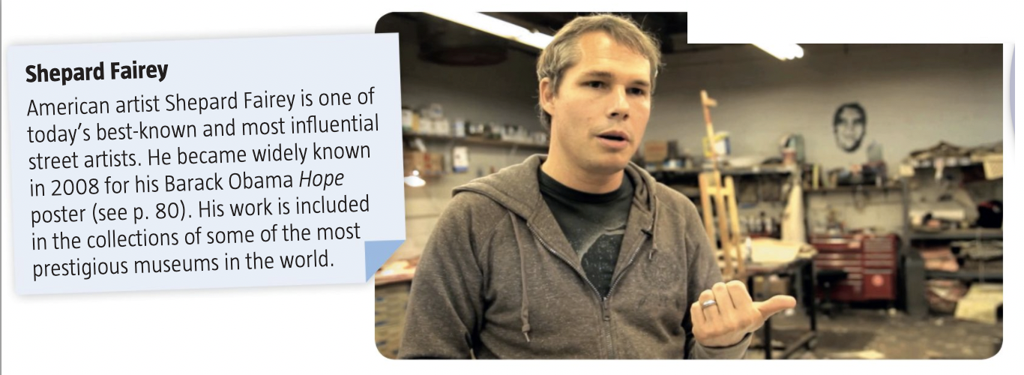

**1.**

**2.**

**3.**

**4.**

**2. Watch the first minute of the video with the sound off, and then the whole video with the sound on and take notes of what you understand**

*🡪 Regarde la première minute de la vidéo sans le son puis toute la vidéo avec le son et prend des notes de ce que tu comprends*

|  |  |
| --- | --- |
| **SOUND OFF: 1st MINUTE** | **SOUND ON: THE WHOLE VIDEO** |
|  |  |

**3. Use what you have learned to explain what played a key role in Shepard Fairey’s carrer**

*🡪 Utilise ce que tu as appris pour expliquer ce qui a joué un rôle important dans la carrière de Shepard Fairey. A chaque fois, utilise les captures d’écrans de la vidéo qui t’indiquent ces moments clés.*

|  |  |
| --- | --- |
| **Image of the moment** | **Your explanation of that moment** |
|  |  |
|  |  |
|  |  |
|  |  |

***HOMEWORK :***

**\*Voici les nouveaux verbes à apprendre : les jumeaux en T**

**Le lien Quizlet pour ce groupe de verbes :** <https://quizlet.com/fr/502718384/les-jumeaux-en-t-flash-cards/>

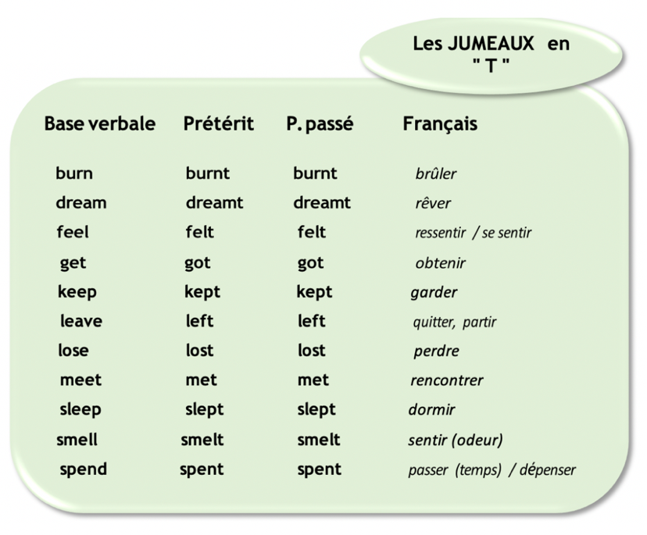

***COURSE 3 - CORRECTION***

**1. Read the recap about the street art artist Shepard Fairey and imagine 4 questions you could ask him**

1. Why did you decide to become a street artist?

2. Do you understand people who say that street art is not art?

3. Who are the best street artists, according to you?

4. Do you think a simple graffiti is art?

**2. Watch the first minute of the video with the sound off, and then the whole video with the sound on and take notes of what you understand**

|  |  |
| --- | --- |
| **SOUND OFF: 1st MINUTE** | **SOUND ON: THE WHOLE VIDEO** |
| Obey / The rise / People gluing posters on walls in the streets.  A person talking (probably Shepard Fairey)  Skaters  A workshop/an artist studio | He never did graffiti with aerosol because he grew up in South Carolina where there wasn’t a graffiti scene  He went to a design school, an art school  He was into skateboarding and punk-rock  Stickers, stencils logo, flyers  He went to NY in 1988 with a school group 🡪 he saw all the graffiti  To him, street art is about expressing yourself in public space, something pure about graffiti  He started making stickers, stencils and posters |

**3. Use what you have learned to explain what played a key role in Shepard Fairey’s carrer**

|  |  |
| --- | --- |
| **Image of the moment** | **Your explanation of that moment** |
|  | When he was young, Shepard Fairey loved skateboard and punk rock. |
|  | Shepard Fairey was into skateboarding and punk rock. He started making homemade stickers and stencils. |
|  | S. Fairey discovered street art during a school trip to New York. They went to a museum but he was more interested in the graffiti he saw outside the city. After that trip he decided that he wanted to express himself in public spaces. |
|  | He decided to use stencils, stickers and posters (rather than aerosols / bombing). |