Bloody Mary…
Read the text carefully and fill in the gaps with the right verb in the right tense.
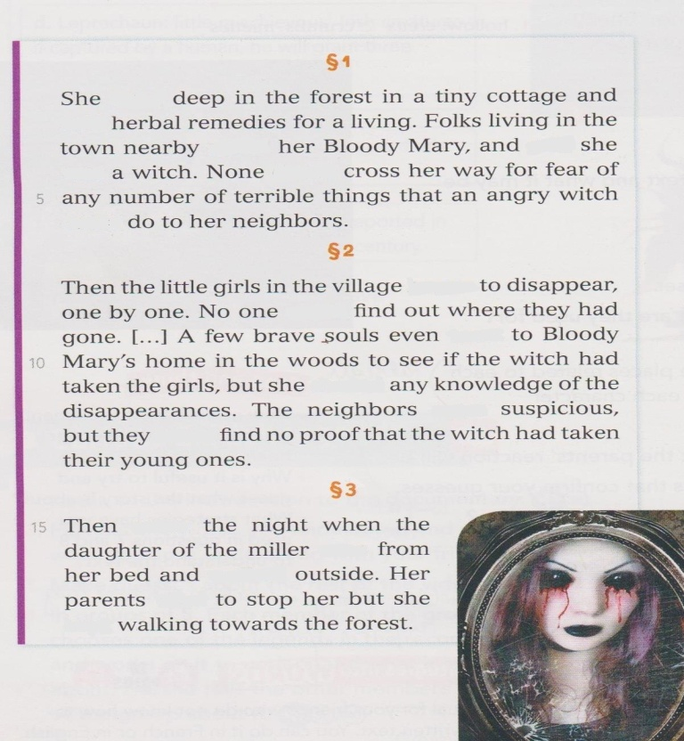  § 3  § 1  § 2 |  | live, sell, can, be, call, dare, say  go, can, deny, be, can, begin  walk, rise, come, try, keep
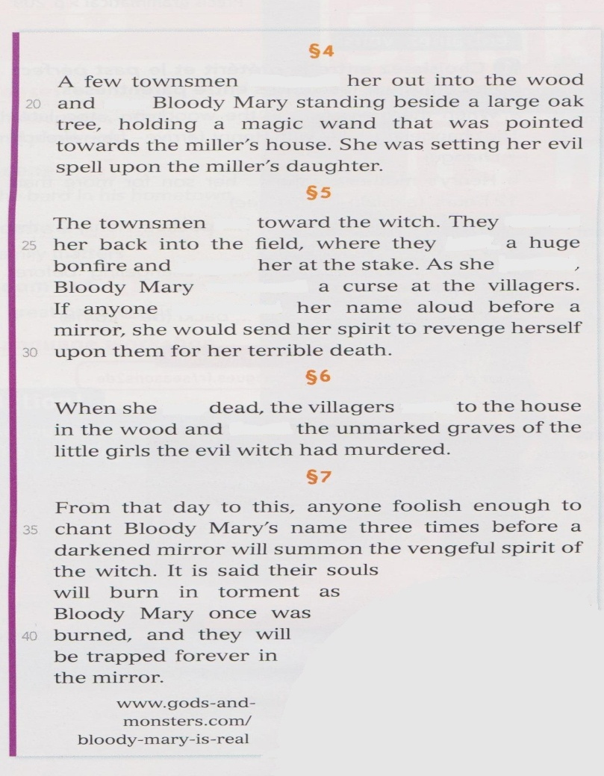  § 6  § 5  § 4 |  | see, follow  build, burn, burn, scream, mention, carry, run  go, be  

