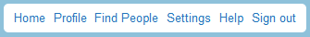

 | PROFILE  PICTURE ? | Username ? |  | Name:
 | PROFILE  PICTURE ? |  |  | Age:  Birthday:  Family:  Pets:  Languages spoken:  Location / Town:
 | PROFILE  PICTURE ? |  |  | Profile / Personality:  -  -  -  -  -  -  -
 | Introduce yourself using all the information on the right-hand side of your Facebook page! You can also include other information not mentioned here! Be as creative and original as you can!  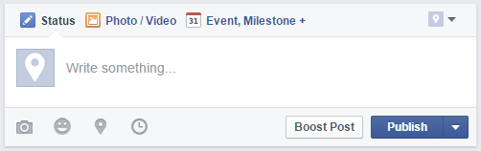 |  |  | 234 | 12
 |  |  |  | followers |  | following
Post / Write something about what you’re doing / your mood
About 5 minutes ago from web
 |  |  |  | Likes 
Favourite sport / hobby:

Favourite food:

Favourite subject at school:

 | Post / Write something about what you’re doing / your mood  About 2 hours ago from web |  |  | Dislikes 
Least favourite activity:

Least favourite food:

Least favourite subject at school:

Post / Write something about what you’re doing / your mood

About 5 days ago from web
Post / Write something about what you’re doing / your mood

About 2 weeks ago from web

