Finger family  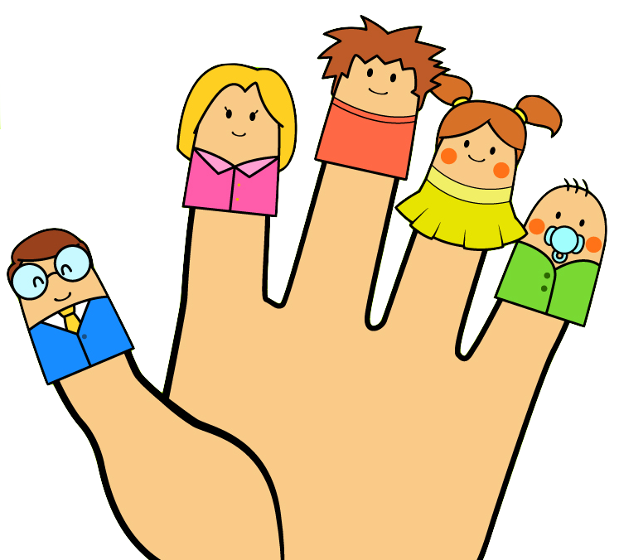 | Daddy finger, daddy finger,  Where are you?  Here I am, here I am  How do you do?  Mummy finger, mummy finger  Where are you?  Here I am, here I am  How do you do?  Brother finger ….  Sister finger…  Baby finger….

Head, shoulders, knees and toes

Head, shoulders, knees and toes, knees and toes.
Head, shoulders, knees and toes, knees and toes.
And eyes and ears and mouth and nose.
Head, shoulders, knees and toes, knees and toes, knees and toes.

