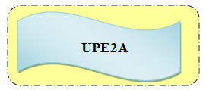 **Tables d'addition**

<https://learningapps.org/1148390>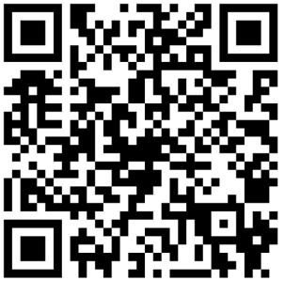

<https://learningapps.org/1725115>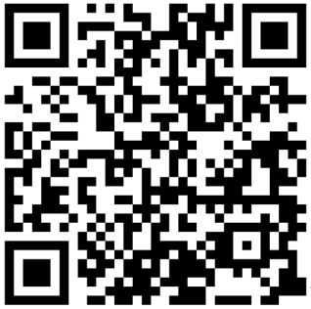

<https://learningapps.org/9761049>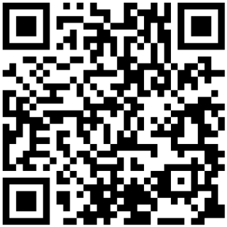

<https://learningapps.org/7735385>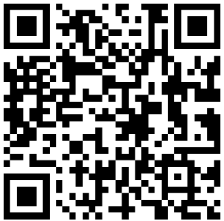

Révision sur les nombres :

<https://learningapps.org/14637411>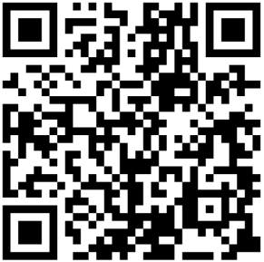

<https://learningapps.org/1010369> 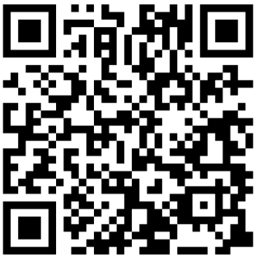

<https://learningapps.org/3001126> 