TIMES UP

A faire avant la tâche finale

Objectifs vocabulaire

Objectifs culturels

Objectifs grammaire

Objectif méthodologique : savoir décrire quelque chose

**Règle du jeu :**

5/6 players.

**Tour 1**

Player 1 makes player 2 guess what is on a card. Player 2 has to guess as many cards as possible in a short amount of time. Player 1 can use as many words as he wants.

At the end of the timer, Player 2 makes player 3 guess what is on a card.

Etc. etc.

At the end of the tour, each player counts his points he made with the players before and after him.

**Tour 2**

Same as Tour 1, but only one word is allowed.

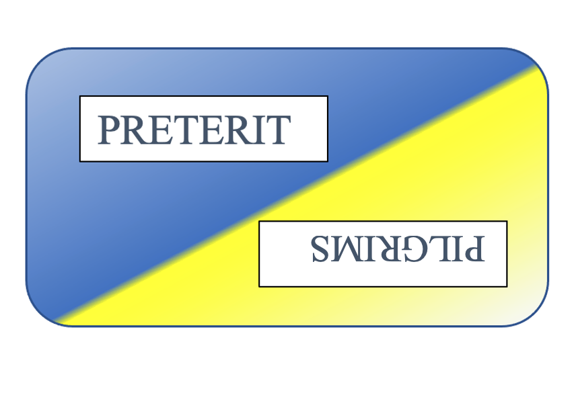

Pour faire votre propre carte, prenez celle de l’exemple et collez vos mots en insérant une