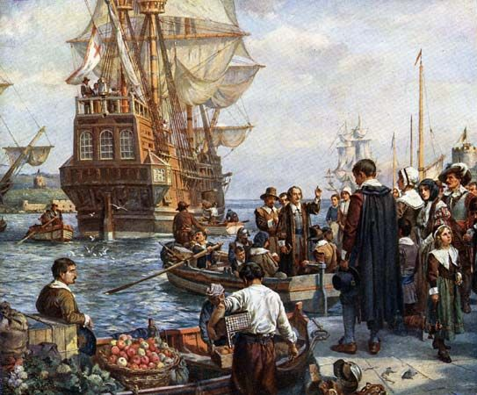
© Photos.com/Getty Images
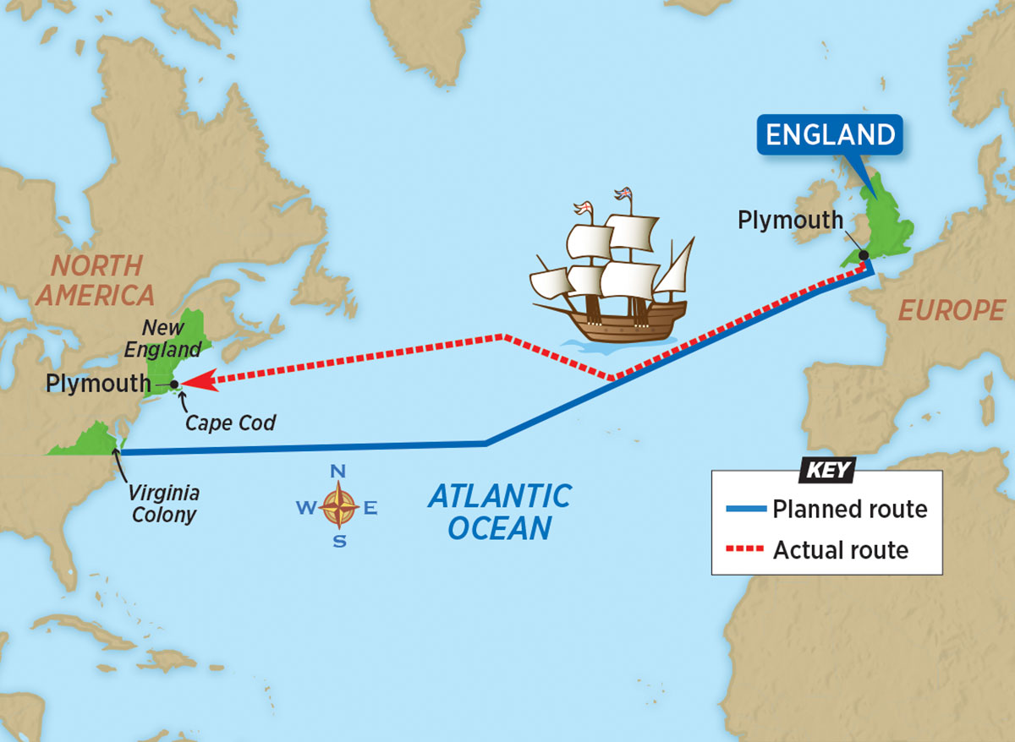
A pilgrim is a person who makes a long journey to a foreign land, sometimes for religious reasons. In U.S. history, the Pilgrims were the founders of the Plymouth Colony, in what is now Massachusetts, in 1620. (…)
The Pilgrims included just over 100 men, women, and children. About a third of them were Separatist Puritans. Puritans were English Christians who wanted to “purify,” or simplify, the Church of England. The Separatist Puritans were a radical faction of Puritans who broke away from that official church. Because of this, they were persecuted in England. Afraid of being forced to rejoin the church, a group of Separatists fled from England to Leiden, Netherlands, in 1608. But soon they decided to settle in North America.
Seeking a more prosperous life along with religious freedom, they negotiated with a company of investors from London, England, to finance a journey to North America aboard the Mayflower. (…). (…) The Mayflower set sail in September 1620 and reached what is now Massachusetts in November. The Pilgrims founded Plymouth the following month.
The colonists who established Plymouth were not known as Pilgrims during their lifetimes. https://kids.britannica.com/students/article/Pilgrims/624088

