JOB EXPERIENCES ABROAD –

GROUP 1 – WWOOFING

WHAT IS WWOOFING?

WWOOFing stands for ‘World Wide Opportunities on Organic Farms.’ The volunteer or ‘WWOOFer,’ gets the opportunity to spend time in an organic farm, learn what it’s like, how it works and what sustainable agriculture is all about. During your stay in the farm, you don’t have to pay for board or lodging. It is not a monetary exchange program.
WWOOF is an educational program and it offers the visitors / WWOOFers the chance to learn what WWOOFing is about. It is all about learning how to farm, taking part in the organic agriculture program and learning the culture. WWOOFing is a worldwide movement, and WWOOF-USA® Host Farm Directory has more than 2,000 organic farms all over the nation. Agritourism is rising in popularity.
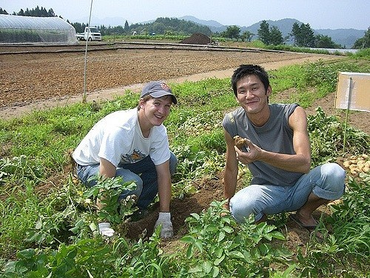

WHO CAN WWOOF?
Any garden project, community or farm can participate in the program. Anyone can be WWOOFer as long as they are at least 18 years old regardless whether you have experience or not. In some countries, those under 18 can participate when accompanied by any adult parent or legal guardian.
WWOOFing gives you the chance to learn all about organic farming and do real, physical work. Among the things you will discover while WWOOFing are making wine, beekeeping, creating straw houses, growing vegetables, or assisting with animal care, weeding and helping with harvesting.

HOW WWOOFING WORKS
There are no hard and fast rules when it comes to the number of hours you have to work, but usually it is 4 to 6 hours a day helping around the farm, and in exchange you will get a full day’s worth of accommodation and food.
The time you stay in the farm will have been negotiated prior to your arrival and will be between you and your host. The average stay length is 2 to 3 weeks, but it can be as short as 2 days or as long as 6 months; it all depends on your negotiations with your host.

Adapted from an article written by Wwoofer Rodrigo Rocha, 07/03/2017

JOB EXPERIENCES ABROAD –

GROUP 2 – F.L.A. IN A SECONDARY

SCHOOL IN THE U.K.

Become a language assistant in the UK
Would you like to spend a year living and working in the UK, helping students to improve their knowledge and understanding of your language and culture? By becoming a language assistant in a UK school, you can do just that.

What will I be doing?
Language assistants in UK schools work in the classroom with teachers or on their own with small groups. They spend up to a year helping students improve their confidence with foreign languages and increase their cultural awareness.
You will get the chance to experience teaching in the UK, develop your English language skills and gain important transferable skills to help you in your career, whatever industry you choose to work in.
You will also get the opportunity to live in the UK and visit England, Scotland, Wales and Northern Ireland.

How do I apply?
To become a language assistant in French, German, Italian, Mandarin Chinese or Spanish in the UK, please apply to the relevant partner agency in your home country.
The British Council’s French Partner Agency is called CIEP: Centre International d’Etudes Pedagogiques – however you must be registered as a student at a French university to apply to the CIEP).

Keep in mind that FLA positions are not exclusive to the United Kingdom – you can work as a language assistant in many countries around the world; however the British Council will not be the agency in charge of your posting into a school located outside the United Kingdom.

Adapted from an article found on the British Council website

JOB EXPERIENCES ABROAD –

GROUP 3 – HOUSE SITTING ABROAD

What is house sitting abroad?

Housesitters who travel abroad
If you have property and pet care experience, with or without previous housesitting references you may consider the opportunity to housesit abroad away from your home country.
All you need to consider is do you have home care and pet care experience you can offer in exchange for free accommodation.
Most of us in our lives have cared for a home and garden, and been involved in pet care of some description. You can prepare for pet sitting perhaps by taking a pet first aid course, or volunteering at a pet rescue shelter to gain experience of a wider range of animals.
Housesitting membership networks like HouseSitMatch exist to serve house sitters and petsitters wanting to find suitable assignments at home and housesitting abroad. However, at HouseSitMatch we can also help new sitters get started on their journey.
We offer advice, top tips, contacts in the housesitting community such as Housesittingworld.com there you will find full time housesitters who can advise based on a wealth of community knowledge and years of experience in housesitting and petsitting activities.
Learning from the community can help you prepare to become a highly rated housesitter. This community specialises in supporting and nurturing reliable housesitters.
It is easy to register as a housesitter, to get ID and police checked online as part of the registration process through your HouseSitMatch membership. Once registered you can build a housesitter profile and specify the countries in which you would prefer to housesit.
Adapted from an article found on housesitmatch.com

JOB EXPERIENCES ABROAD –

GROUP 4 – HOSTEL EMPLOYEE

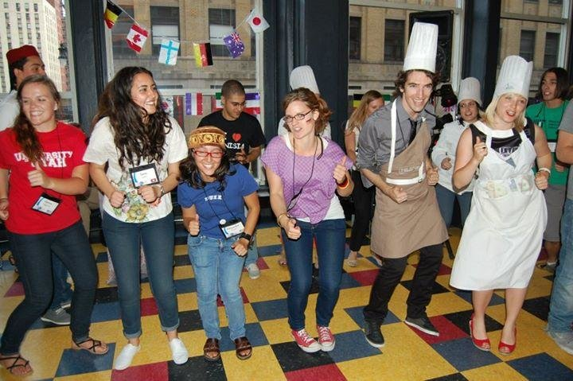

Fostering Tourism as a Hostel Employee
Working at a hostel is a classic choice for a job abroad. This type of work is often seasonal. During peak travel periods, hostels in popular destinations often need extra employees to help with smooth operations. As an English speaker, your communication skills will be valuable in helping with guests who come from Australia, New Zealand, the United Kingdom, United States and more, as English is often a bridge language for many different nations.
Working at a hostel will likely involve receptionist work as you man the front desk and assist with reservations, check-ins, giving guests recommendations and directions and check out. Other typical duties for seasonal hostel employees include cleaning rooms, washing linens, cooking meals and running errands.
If you are the type of traveler who likes to stay in hostels, you may be the type of person who will find working in one to be particularly awesome. In such a social environment it is often quite easy to make friends. In an open atmosphere, you’ll get to meet people from all over the world and increase your understanding not only of your chosen locale but of the wide range of destinations where guests come from. You’ll also gain real-world experience in the hospitality industry and surely go home with many stories to tell about how you used cross-cultural communication skills to solve problems.
Adapted from an article found on gooverseas.com

JOB EXPERIENCES ABROAD –
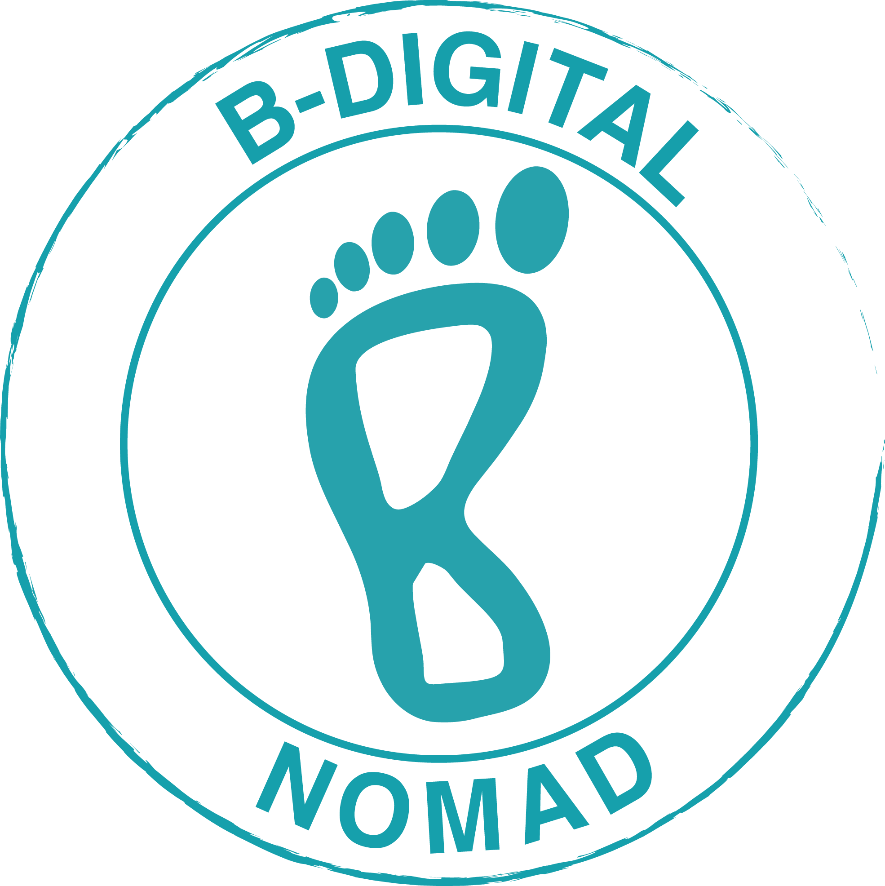

GROUP 5 – DIGITAL NOMAD

Do you dream of hiking Machu Picchu in Peru? Or maybe you’d rather relax on a Colombian beach or walk through huge Chinese cities. These are all nice ideas, but let’s be real. How would you even begin to pay for all these trips? Wouldn’t it be nice to get paid to travel? Is that even possible?
Well, sort of. Maybe no one will pay you to travel. But they’ll certainly pay you to work while you travel! There are people who travel around the world and do all their work on the Internet. They don’t have to secure a job teaching English or giving guided tours in foreign countries. They just take their computer and keep moving.
These people are called digital nomads, and it’s surprisingly easy to take on this lifestyle.

Work as You Travel! 8 Examples of Jobs for Digital Nomads:

- Programmers write the computing code for various things, the most popular being software, websites and apps.
- Web developers build, maintain and fix websites. They either work using code with some sort of coding language or via a more intuitive content management system like WordPress.
- App developers build the layout, functions and features of an application. They test it, analyze its flaws and fix any bugs that could hamper its usability.
- Social media marketers help create and maintain a brand’s public face. They’re instrumental in getting everyday consumers interested in and engaged with that brand via social media.
- Digital entrepreneurs are usually business owners who’ve built a website or online service that provides value to an online community. They constantly push the boundaries of what it means to do business in the digital age.
- Language teachers: thanks to the magic of the Internet, two people from across the globe can instantly communicate with each other. This allows for things like language learning to flourish. Luckily, there are many online companies that have taken this idea and created platforms for teachers and students to come together.
- Specific to the digital age, companies need designers to build and maintain a brand’s identity, be it a logo, social media advertisement or overall look and feel of a company’s website
- Bloggers are digital entrepreneurs, but they’re a very specific kind of digital entrepreneur. Whereas most offer a service or product, bloggers offer content. They commonly make money with affiliate marketing, direct advertisements and sponsored posts. They also sell valuable content, such as e-books, courses and seminars created themselves.

Adapted from an article found on fluentu.com
TOOLBOX GROUP 1: WWOOFING
sustainable (adj): Conserving an ecological balance/equilibrium by avoiding depletion/running out of natural resources
agritourism (noun) : work made out of agriculture + tourism = tourism in which tourists stay with local people in rural areas abroad.
weeding (noun): when you pull up unwanted plants
harvesting (noun) : collecting crops of vegetables, cereals, grapes, fruit…
accommodation (noun): a room or group of rooms in which someone may live or stay.
TOOLBOX GROUP 2: FLA IN THE UK
a skill (noun)= a competence
apply to (verb)= send a request to obtain a job
posting (noun) = an appointment to a job, especially one abroad.

TOOLBOX GROUP 3: HOUSE SITTING ABROAD
home care / property care (noun) = taking care of the house / property
accommodation (noun) = a room or group of rooms in which someone may live or stay.
a shelter (noun) = a refuge
an assignment (noun) = an appointment to a job
nurture (verb) = care for, raise, educate
reliable (adj)= worthy of trust, that you can trust

TOOLBOX GROUP 4: HOSTEL EMPLOYEE
foster (verb)= promote, encourage
peak (adj) = maximum, at the highest point
a skill (noun)= a competence
a check-in (noun) = registration process in a hotel
run errands (verb) = go out to do chores such as shopping for work etc…

TOOLBOX GROUP 5: DIGITAL NOMAD
fix (verb) = repair
the content (noun) = what is contained (on the Internet, it is data, information, text…)
the layout (noun) = the graphic design
hamper (verb) = be an obstacle to
a boundary (noun) = a limit, a frontier
advertisement (noun) = an announcement in a public medium promoting a product, service, or event or publicizing a job vacancy.

