The first “Paralympics” – Written Comprehension Worksheet

1 – What is the nature of the document?

………………………………………………………………………………………………………………………………………………………………………
………………………………………………………………………………………………………………………………………………………………………

2 –What do the following numbers refer to in the text? Answer in your own words.

29  29 | …………………………………………………………………………………………………………………………………………………….  ………………………………………………………………………………………………………………………………………………………..  …………………………………………………………………………………………………………………………………………………….  ………………………………………………………………………………………………………………………………………………………..
70 | …………………………………………………………………………………………………………………………………………………….  ………………………………………………………………………………………………………………………………………………………..
16 | …………………………………………………………………………………………………………………………………………………….  ………………………………………………………………………………………………………………………………………………………..
2 | …………………………………………………………………………………………………………………………………………………….  ………………………………………………………………………………………………………………………………………………………..
6 | …………………………………………………………………………………………………………………………………………………….  ………………………………………………………………………………………………………………………………………………………..
1939 | …………………………………………………………………………………………………………………………………………………….  ………………………………………………………………………………………………………………………………………………………..
1944 | …………………………………………………………………………………………………………………………………………………….  ………………………………………………………………………………………………………………………………………………………..
1945 | …………………………………………………………………………………………………………………………………………………….  ………………………………………………………………………………………………………………………………………………………..
130 | …………………………………………………………………………………………………………………………………………………….  ………………………………………………………………………………………………………………………………………………………..
1956 | …………………………………………………………………………………………………………………………………………………….  ………………………………………………………………………………………………………………………………………………………..
2012  2012 | …………………………………………………………………………………………………………………………………………………….  ………………………………………………………………………………………………………………………………………………………..  …………………………………………………………………………………………………………………………………………………….  ………………………………………………………………………………………………………………………………………………………..
9 | …………………………………………………………………………………………………………………………………………………….  ………………………………………………………………………………………………………………………………………………………..
1976 | …………………………………………………………………………………………………………………………………………………….  ………………………………………………………………………………………………………………………………………………………..
2018 | …………………………………………………………………………………………………………………………………………………….

3 – Who were the athletes?
………………………………………………………………………………………………………………………………………………………………………
………………………………………………………………………………………………………………………………………………………………………

4 – True or False? Justify by quoting the text.
a/ The Stoke Mandeville Games were named after a health institute.

………………………………………………………………………………………………………………………………………………………………………
………………………………………………………………………………………………………………………………………………………………………

b/ Guttman was a Nazi German neurosurgeon.

………………………………………………………………………………………………………………………………………………………………………
………………………………………………………………………………………………………………………………………………………………………

c/ The Stoke Mandeville Games happened every four years, just like the Olympic Games.

………………………………………………………………………………………………………………………………………………………………………
………………………………………………………………………………………………………………………………………………………………………

5 – According to what you understood from the text, which photograph seems to best illustrate the document? Justify your answer.
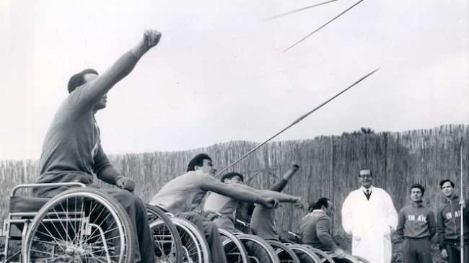 | 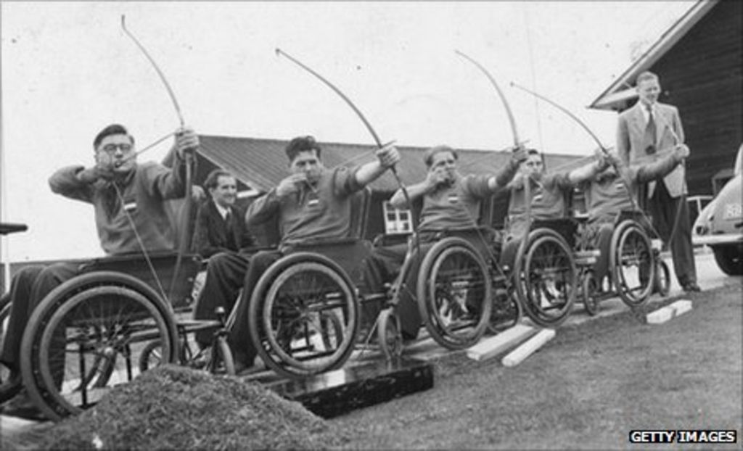
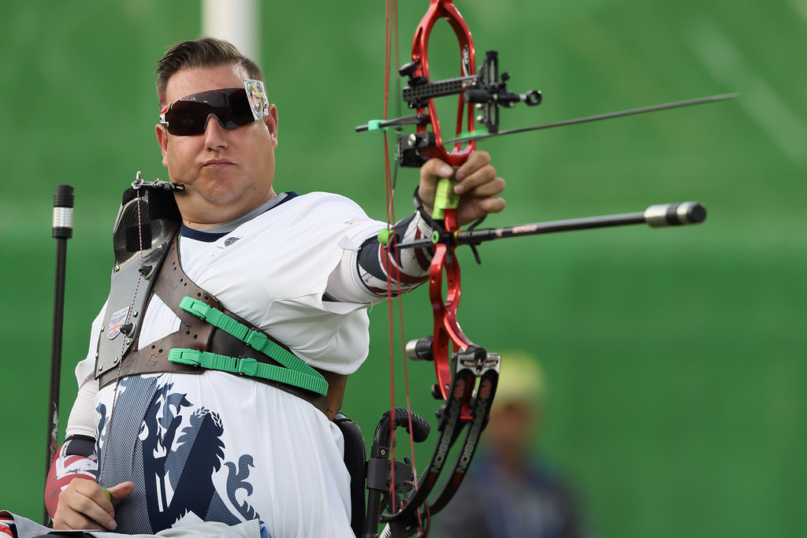 | 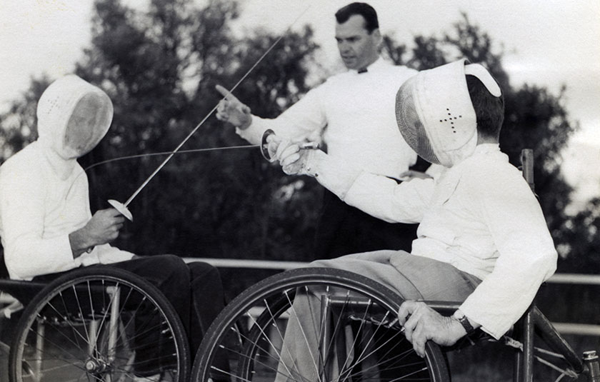

………………………………………………………………………………………………………………………………………………………………………
………………………………………………………………………………………………………………………………………………………………………
Middle Task – Written Production

As a columnist for the newspaper SPORTS TODAY, you must answer the question of a teenage reader and fan of your columns.

“What are the advantages of sporting events – such as the Stoke Mandeville Games or Paralympics – on the society?”
Evan Spencer, 14, Birmingham, UK

Answer him in 70 words minimum.

Middle Task – Written Production

As a columnist for the newspaper SPORTS TODAY, you must answer the question of a teenage reader and fan of your columns.

“What are the advantages of sporting events – such as the Stoke Mandeville Games or Paralympics – on the society?”
Evan Spencer, 14, Birmingham, UK

Answer him in 70 words minimum.

Middle Task – Written Production

As a columnist for the newspaper SPORTS TODAY, you must answer the question of a teenage reader and fan of your columns.

“What are the advantages of sporting events – such as the Stoke Mandeville Games or Paralympics – on the society?”
Evan Spencer, 14, Birmingham, UK

Answer him in 70 words minimum.

Middle Task – Written Production

As a columnist for the newspaper SPORTS TODAY, you must answer the question of a teenage reader and fan of your columns.

“What are the advantages of sporting events – such as the Stoke Mandeville Games or Paralympics – on the society?”
Evan Spencer, 14, Birmingham, UK

Answer him in 70 words minimum.

Middle Task – Written Production
As a columnist for the newspaper SPORTS TODAY, you must answer the question of a teenage reader and fan of your columns.

“What are the advantages of sporting events – such as the Stoke Mandeville Games or Paralympics – on the society?”
Evan Spencer, 14, Birmingham, UK
Answer him in 70 words minimum.
Bonus + 1 = mise en page, respect des codes de la chronique/ réponse au courrier des lecteurs…

5 / 4 – 3 / 2 / 1 - 0

Réalisation de la tâche
La production est satisfaisante et compte des arguments pertinents et suffisamment développés.
La production est satisfaisante et compte des arguments pertinents qui manquent parfois de développement)

La production ne compte qu’un argument peu clair et/ou insuffisamment développé.
La production est trop concise et / ou (partiellement) hors-sujet.

Construction du discours

Les propos sont cohérents et témoignent d’une organisation logique et chronologique.

Les propos sont cohérents et témoignent d’un effort de structuration logique et/ou chronologique.

Les propos sont cohérents bien que l’agencement des propos relève de la juxtaposition et non de l’organisation.

Incohérence dans certains propos.

Richesse lexicale

Le vocabulaire utilisé est bien approprié à l’intention de communication, malgré quelques imprécisions, répétitions ou maladresses.

Le vocabulaire employé est correct et suffit à exprimer les propos, malgré plusieurs incorrections, imprécisions ou répétitions.
Le vocabulaire est pauvre, attestant d’un manque de moyens lexicaux pour véhiculer les idées.

Un vocabulaire peu voire (in-)compréhensible au regard de barbarismes et d’erreurs récurrentes.

Correction grammaticale

Assez bonne maîtrise des structures simples et courantes, malgré quelques erreurs sur des structures simples qui ne nuisent pas à la compréhension.

Production immédiatement compréhensible, malgré une fréquence des erreurs sur des structures simples et courantes.
Production globalement compréhensible mais très réduite ; les erreurs se multiplient au point de rendre la lecture peu aisée.

Production pratiquement inintelligible ; les erreurs sont très nombreuses : il ne s’agit plus de compréhension mais de déchiffrage.

