What were the Stoke Mandeville Games? Celebrating 70 years since the first 'Paralympics'
The forerunner of the modern Paralympic Games first took place in a Buckinghamshire hospital 70 years ago.
By Chas Early
Last updated: 26 June 2018 - 4.42pm

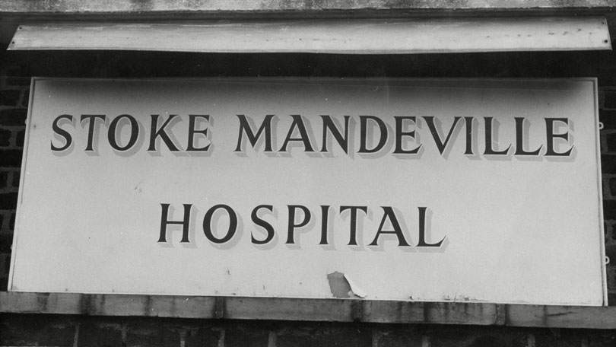
Seventy years ago this year, on July 29, 1948, the first Stoke Mandeville games were held. The games - an archery competition for wheelchair athletes - went on to become an annual event and eventually inspired the Paralympic Games. (…).

What were the Stoke Mandeville Games?
On July 29, 1948, the day of the Opening Ceremony of the London 1948 Olympic Games, a competition for wheelchair athletes took place at Stoke Mandeville. 16 patients (14 men and two women) from Stoke Mandeville and the Star and Garter Home took part in an archery tournament.
The competition became an annual event which was named the Stoke Mandeville Games. More teams and sports were added as years went by; in 1949 six teams competed and ‘wheelchair netball’ – which later became wheelchair basketball - was introduced.

Whose idea were the Stoke Mandeville Games?
Dr Ludwig Guttman was a respected Jewish neurosurgeon who had been forced to flee his homeland of Germany in 1939 to escape Nazi persecution. Five years later, he was asked by the British government to open a Spinal Injuries Unit at Stoke Mandeville, intended to treat soldiers and civilians injured during the war.
As part of his treatment for the injured veterans, Guttmann promoted sport as a means of physical and mental rehabilitation. The first sport played by patients was a hybrid form of wheelchair polo and hockey, initially played informally on the ward against the physiotherapists, before it was developed into a proper team game.
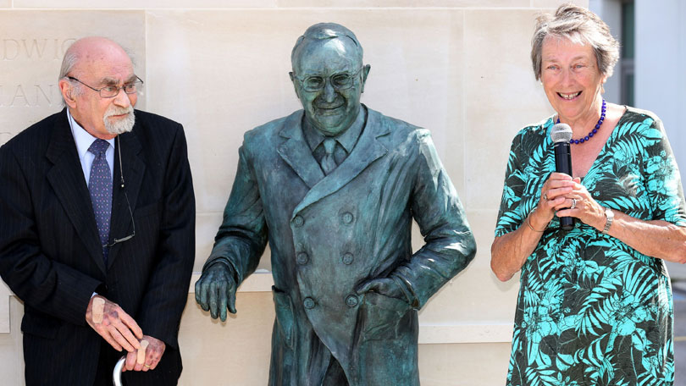
Guttman became a naturalised British citizen in 1945. The Games he created grew in size and stature; by 1952, more than 130 international competitors had taken part. This attracted the support and appreciation of the wider sporting community, and in 1956 Guttmann was awarded the Sir Thomas Fearnley Cup by the International Olympic Committee (IOC) for his achievement.
In 2012, a television film about Guttman's early years at Stoke Mandeville, called The Best of Men, was shown by the BBC, starring British actor Eddie Marsan as Guttman.

How are the Stoke Mandeville Games linked to the modern Paralympic Games?
The Stoke Mandeville Games became officially linked to the Olympics in 1960, when the 9th Annual Stoke Mandeville Games was run alongside the Olympic Games in Rome. This event, featuring 400 athletes from 23 countries, is now recognised as the first Paralympic Games (the 'para' in the name being the Greek preposition for 'alongside' and reflecting how the events run side by side).
Like the Olympics, they take place every four years. In 1976 the first Winter Paralympic Games were held in Sweden and like the Summer Games, they have taken place every four years, and include an opening and closing ceremony.
Since the 1988 Olympics in Seoul, Korea and the Winter Games in Albertville, France in 1992 the Games have also taken part in the same cities and venues as the Olympics thanks to an agreement between the IOC and the International Paralympic Committee.
The mascot of the London 2012 Paralympic Games was named Mandeville, after the hospital.
Adapted from an article found on http://home.bt.com

