The Civil Rights Movement in the 1960s
A few landmarks of civil progress before the 1960s:
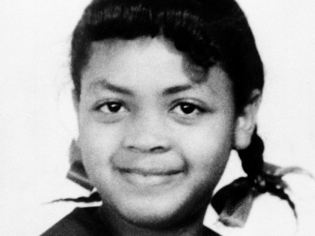 | Linda Brown v. Board of Education of Topeka – 1954  Linda Brown wanted to attend an all-white school that was closer to her house instead of being forced to go to an all-black school.  The Supreme Court overruled the 1896 Plessy v. Ferguson decision which promoted “separate but equal” facilities, resulting in Linda being admitted to the all-white school.
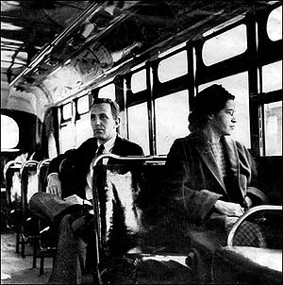 | Montgomery Bus Boycott – 1955  Rosa Parks was arrested for refusing to give up her bus seat to a white man.  Martin Luther King, emerged as a nationally-recognised leader, organized the Montgomery Bus Boycott, black residents agreed not to use the buses, a move which would deprive the bus company of 65% of its income.
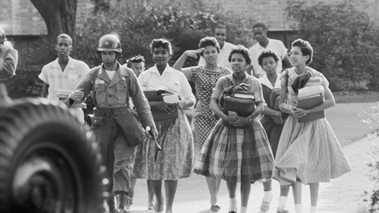 | Desegregation at Little Rock High School – 1957  On 3rd September 1957, after schools were desegregated nine blacks students tried to enter Little Rock High School, yet they were prevented from doing so by National Guardsmen acting on the orders of Arkansas state governor.  On 23th September, the nine students returned to the high school but were prevented from attending school by a mob of 1,000 townspeople.  Finally, President Eisenhower ordered 1,000 troopers and 10,000 National Guardsmen to grant access to school to the Little Rock nine , therefore the school got desegregated.

Find in the three short texts equivalents for:
to reject (a law): | a crowd:
equipments: | citizens:
revenue: | to command:
_______________________________________________________________________________________________
Social actions for the Black Civil Rights Movement
1/ The sit-in Campaigns in 1960s:
Watch the video and describe what happens.
……………………………………………………………………………………………………………………………………………………………………………………………………………………………………………………………………………………………………………………………………………………………………………………………………………………………………………………………………………………………………………………………………………………………………………………………………………………………………………………………………………………………………………………………………………………………………………………………………………………………………………………………………………………………………………………………………………………………………………………………………………………………………………………………………………………………………………………………………………………………………………………………………………………………………………………………………………………………………………………

Sit-in Campaigns – 1960
After having been refused service at a lunch counter of a Woolsworth’s in Greensboro, North Carolina, Joseph McNeill, a black college student, returned the next day with three classmates to sit at a counter until they were served.
They were not served. The four students returned to the lunch counter every single day. More and more students joined the protest, and students across the nation were inspired to launch similar protests, after an article in the New York Times drew attention to the four students’ action.

Freedom Riders – Oral Comprehension
Watch the film trailer three times, take notes and be ready to explain what the freedom riders’ actions are.
(Relevés possibles:
- board a bus to travel through the borders of deep South
- like soldiers in a non-violent army (non-violent repeated)
- simple but daring plan to put blacks and whites on commercial buses, they would deliberately violate segregation laws
- Blacks and whites going from town to town, get off the bus to provoke blacks’ survival
- Going to Mississippi and Alabama and challenging segregation so frontally it alarmed those who opposed the Civil Rights but also those within the Civil Rights community)

