THE LIMITS OF THE HARLEM RENAISSANCE
FILE n°1: The 1929 Stock Market Crash

The stock market crash of 1929 was one of the worst stock market crashes in the history of the United States. The value of stocks fell dramatically over the course of several days at the end of October. Many people lost all of their savings and ended up losing their homes. Businesses had to layoff employees or go bankrupt.
Before, during and after the Crash
The 1920s (also called the Roaring Twenties) were a time of economic boom and business speculation. New industries such as automobiles and radios were changing the landscape and culture of America. People thought everyone was going to be rich and that the economy would never stop growing. This optimism caused wild speculation in the stock market. Between 1921 and 1929 the stock market had grown by 600% with the Dow Jones Industrial Average increasing from 63 points to 381 points.
The crazy growth in the stock market wasn't based on reality, however. The economy could not continue to grow at such a rapid rate forever. In 1929 the economy began to slow down. At the end of October, panic gripped the stock market and people began to sell massive amounts of stock. The worst days were October 28th and 29th when values fell a total of 23%. These days became known as "Black Monday" and "Black Tuesday", and signalled the beginning of the Great Depression that would last for ten years until 1939.
Although the market tried to rally, it couldn't recover. Over the course of a few months, the stock market fell around 40%. Many investors lost everything. It didn't reach the bottom until the summer of 1932 when it had dropped 89% from its peak. Billions of dollars of wealth had been erased and the country entered into a deep economic depression.
The Great Depression
During this period, unemployment rose to around 25%, banks failed across the country, and hundreds of thousands of businesses went bankrupt. While the stock market crash was not the only cause of the Great Depression, it did have a major impact.
The end of Harlem’s creative boom began with this 1929 stock market crash and wavered until Prohibition ended in 1933, which meant white patrons no longer sought out illegal alcohol in uptown clubs.
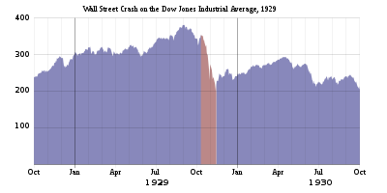

*stock market = la bourse, le marché boursier
**Dow Jones Industrial Average – or simply Dow Jones – is an index of figures indicating the relative price of shares on the New York Stock Exchange, based on the average price of selected stocks.

THE LIMITS OF THE HARLEM RENAISSANCE
FILE n°1: The 1929 Stock Market Crash

In order to anticipate the sharing of information with the other groups, make sure you are able to answer these questions:

1. What year did the stock market crash discussed in the article occur?
a. 1865
b. 1902
c. 1929
d. 1945
e. 1981
2. Around how long did the Great Depression last?
a. 2 years
b. 5 years
c. 10 years
d. 40 years
e. 100 years
3. During what month did the stock market begin to crash?
a. October
b. January
c. March
d. April
e. December
4. Which of the following caused the stock market to crash?
a. Wild speculation
b. People buying stock on credit
c. Slow economy
d. All of the above
e. None of the above
5. True or False: The stock market crash is generally considered the start of the Great Depression.
a. TRUE
b. FALSE
6. What was the result of the stock market crash?
a. The economy recovered
b. Many people lost their savings
c. Business improved
d. New jobs were created
e. All of the above
7. True or False: Before the crash, the stock market continued to rise even though the economy had slowed.
a. TRUE
b. FALSE
8. Why did the stock market have an impact on the Harlem Renaissance? Explain precisely.

THE LIMITS OF THE HARLEM RENAISSANCE
FILE n°2: Civil unrest

Once home to a number of New York’s prominent families, Harlem by the early 1900s had become a major centre of African American culture. It provided the backdrop against which the Harlem Renaissance was set. Indeed, the race riot of 1935 – precipitated by a teenager’s theft of a penknife from a store and fuelled by economic hardship, racial injustice, and community mistrust of the police – is considered the terminating event of that cultural flowering.

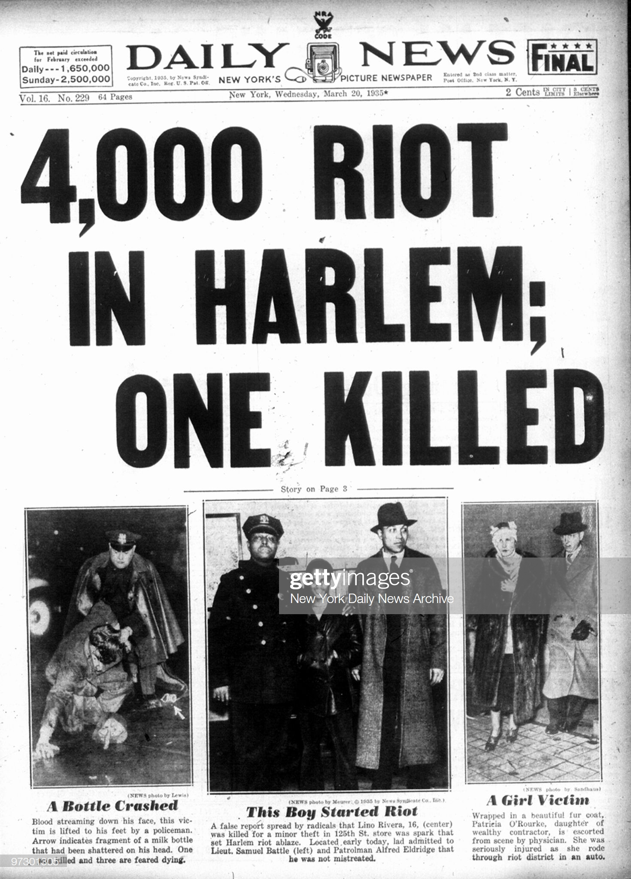
THE LIMITS OF THE HARLEM RENAISSANCE
FILE n°2: Civil unrest

In order to anticipate the sharing of information with the other groups, make sure you are able to answer these questions:

1. What kind of document is it?
2. What does it deal with? When and where did it happen?
3. What did the young boy do before it happened?
4. Why did it happen? Explain in your own words.
5. Which of the following statements is true? Correct those which are wrong
a. Alfred Eldridge is a policeman.
b. The victim on the third picture is from a lower-class background.
c. The young criminal insisted on how brutal the police was towards him.
6. What does the number “4,000” refer to in the headline?
7. Deduce why such an event served as a marker of the end of the Harlem Renaissance.

THE LIMITS OF THE HARLEM RENAISSANCE
FILE n°2: Civil unrest

In order to anticipate the sharing of information with the other groups, make sure you are able to answer these questions:

1. What kind of document is it?
2. What does it deal with? When and where did it happen?
3. What did the young boy do before it happened?
4. Why did it happen? Explain in your own words.
5. Which of the following statements is true? Correct those which are wrong
a. Alfred Eldridge is a policeman.
b. The victim on the third picture is from a lower-class background.
c. The young criminal insisted on how brutal the police was towards him.
6. What does the number “4,000” refer to in the headline?
7. Deduce why such an event served as a marker of the end of the Harlem Renaissance.

THE LIMITS OF THE HARLEM RENAISSANCE
FILE n°3: Harlem nightlife
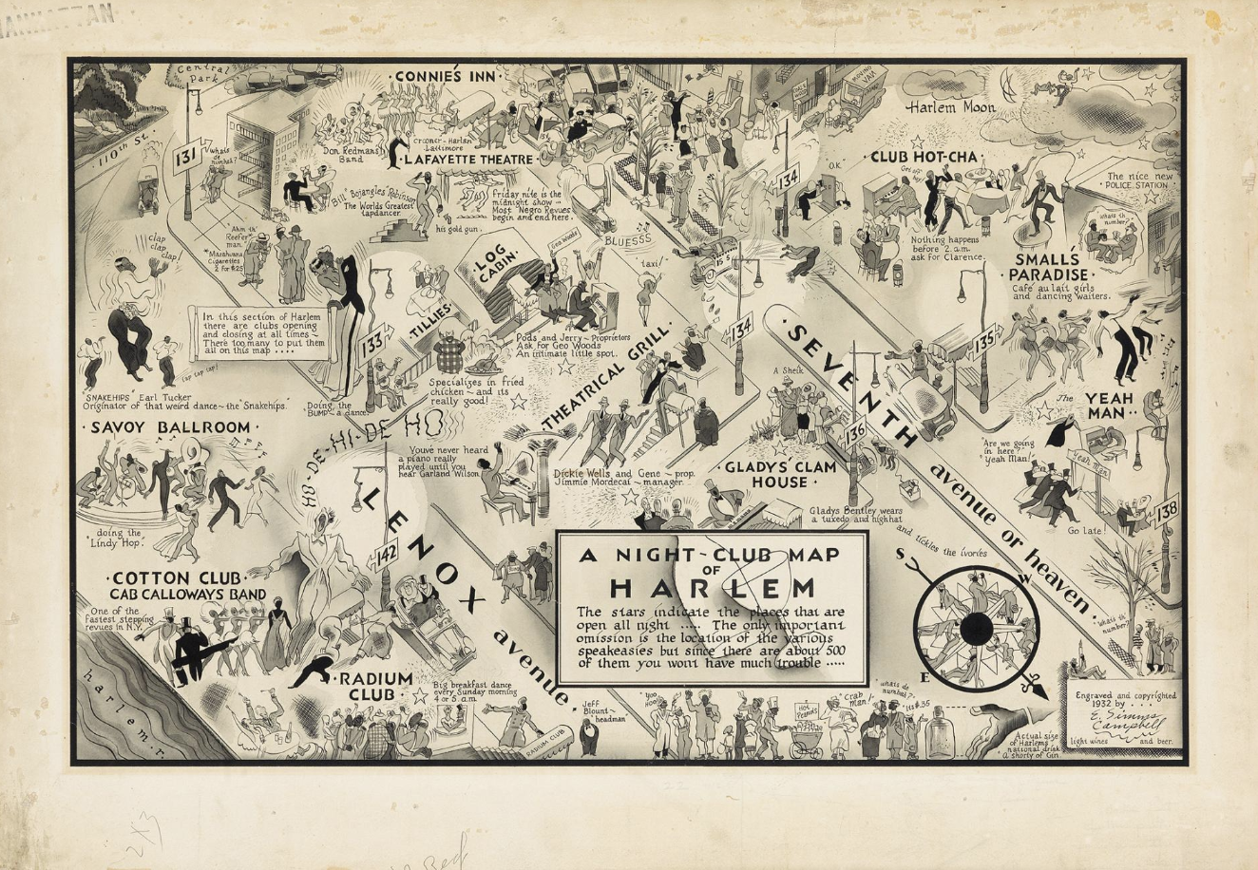

A 1932 map showing where to find famous musicians, gambling policemen, and a guy selling marijuana in Harlem.

A map showing where to find famous musicians, gambling policemen, and a guy selling marijuana in Harlem.

Cotton Club
With the ground-breaking new music came a vibrant nightlife. The Savoy opened in 1927, an integrated ballroom with two bandstands that featured continuous jazz and dancing well past midnight, sometimes in the form of battling bands helmed by Fletcher Henderson, Jimmie Lunceford and King Oliver.
While it was fashionable to frequent Harlem nightlife, entrepreneurs realized that some white people wanted to experience black culture without having to socialize with African Americans and created clubs to cater to them.
The most successful of these was the Cotton Club, which featured frequent performances by Ellington and Calloway. Some in the community derided the existence of such clubs, while others believed they were a sign that black culture was moving towards greater acceptance.
Adapted from an article found on www.history.org
THE LIMITS OF THE HARLEM RENAISSANCE
FILE n°3: Harlem nightlife

In order to anticipate the sharing of information with the other groups, make sure you are able to answer these questions:

1. What year is the map from?

2. Take an overall look at the map. Is it an official document?
3. Read the frame inside the map. “The only important omission is the location of the various speakeasies”. Why do you think speakeasies were “omitted” on the map?
4. What element appearing on the map constitutes the obstacle to speakeasies? Justify.
5. Read the text. What argument appears as a limit to the development of the Harlem Renaissance?

THE LIMITS OF THE HARLEM RENAISSANCE
FILE n°3: Harlem nightlife

In order to anticipate the sharing of information with the other groups, make sure you are able to answer these questions:

1. What year is the map from?

2. Take an overall look at the map. Is it an official document?
3. Read the frame inside the map. “The only important omission is the location of the various speakeasies”. Why do you think speakeasies were “omitted” on the map?
4. What element appearing on the map constitutes the obstacle to speakeasies? Justify.
5. Read the text. What argument appears as a limit to the development of the Harlem Renaissance?

THE LIMITS OF THE HARLEM RENAISSANCE
FILE n°3: Harlem nightlife

In order to anticipate the sharing of information with the other groups, make sure you are able to answer these questions:

1. What year is the map from?

2. Take an overall look at the map. Is it an official document?
3. Read the frame inside the map. “The only important omission is the location of the various speakeasies”. Why do you think speakeasies were “omitted” on the map?
4. What element appearing on the map constitutes the obstacle to speakeasies? Justify.
5. Read the text. What argument appears as a limit to the development of the Harlem Renaissance?

