HAR(T)LEM – HARLEM RENAISSANCE
FILE 1: POETRY
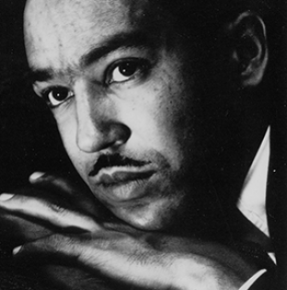

A poet, novelist, fiction writer, and playwright, Langston Hughes (1902-1967) is known for his insightful, colourful portrayals of black life in America from the twenties through the sixties and was important in shaping the artistic contributions of the Harlem Renaissance. Hughes not only made his mark in this artistic movement by breaking boundaries with his poetry, he drew on international experiences, found kindred spirits amongst his fellow artists, took a stand for the possibilities of black art, and influenced how the Harlem Renaissance would be remembered.

Question 1
Who is the persona in the poem? (to put it differently, who seems to be the talking voice in the poem?)

Question 2
Focus on the second stanza. “They send me to eat in the kitchen
When company comes”
What does that mean? What does it refer to?

Question 3
Pay attention to the last three stanzas. What is the tone of the poem?

I, too, sing America (1926) by Langston Hughes
I, too, sing America.
I am the darker brother.
They send me to eat in the kitchen
When company comes,
But I laugh,
And eat well,
And grow strong.
Tomorrow,
I'll be at the table
When company comes.
Nobody'll dare
Say to me,
“Eat in the kitchen,”
Then.
Besides,
They'll see how beautiful I am
And be ashamed—
I, too, am America.

HAR(T)LEM – HARLEM RENAISSANCE
FILE 2: NOVELS
Question 1
What was Tea Cake’s reaction after Mrs Turner’s brother met Janie? Why did he react that way?

Question 2
Explain why Sop-de-Bottom’s words are so disturbing.

Question 3
To what extent could this extract have contributed to improve society during the Harlem Renaissance?
Writer and anthropologist Zora Neale Hurston was a fixture of the Harlem Renaissance and author of the masterwork 'Their Eyes Were Watching God.' Her most famous work: Their Eyes Were Watching God (1937) is a novel telling the story of Janie Mae Crawford, who learns the value of self-reliance through multiple marriages and tragedy. Hurston moved to New York City's Harlem neighborhood in the 1920s. She became a fixture in the area's thriving art scene, with her apartment reportedly becoming a popular spot for social gatherings. Hurston befriended the likes of Langston Hughes and Countee Cullen, among several others, with whom she launched a short-lived literary magazine, Fire!!

Their Eyes Were Watching God
Mrs Turner, a friend of Janie’s (of mixed heritage, just like her) brought her brother to meet Janie. Janie’s husband, nicknamed ‘Tea Cake’ reacted.

When Mrs. Turner’s brother came and she brought him over to be introduced, Tea Cake had a brainstorm. Before the week was over he had whipped Janie. Not because her behavior justified his jealousy, but it relieved that awful fear inside him. Being able to whip her reassured him in possession. No brutal beating at all. He just slapped her around a bit to show he was boss.

"Tea Cake, you sho is a lucky man," Sop-de-Bottom told him. "Uh person can see every place you hit her [Janie]. Ah bet she never raised her hand tuh hit yuh back, neither. Take some uh dese ol’ rusty black women and dey would fight yuh all night long and next day nobody couldn’t tell you ever hit ‘em. Dat’s de reason Ah done quit beatin’ mah woman. You can’t make no mark on ‘em at all. Lawd! Wouldn’t Ah love tuh whip uh tender woman lak Janie. Ah bet she don’t even holler. She jus’ cries, eh, Tea Cake?"

Zora Neale HURSTON, Their Eyes Were Watching God, Chapter XVII, 1937

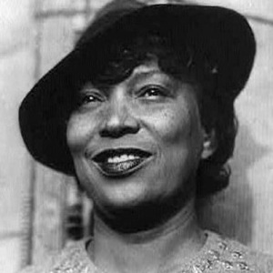

HAR(T)LEM – HARLEM RENAISSANCE
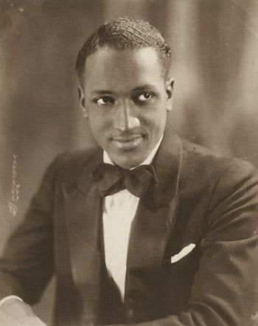
FILE 3: PHOTOGRAPHY
Question 1
Judging by his artworks above, guess the type of photographs that made James Van Der Zee the best-known Harlem photographer during the Harlem Renaissance movement.

Question 2
Comment upon the appearances of the subjects on the photographs (the way they look).

Question 3
According to what you know of the Harlem Renaissance, can you deduce Van Der Zee’s intentions in taking such photographs of the black community?
Marcus Garvey with George O. Marke and Prince Kojo Tovalou-Houénou, 1924
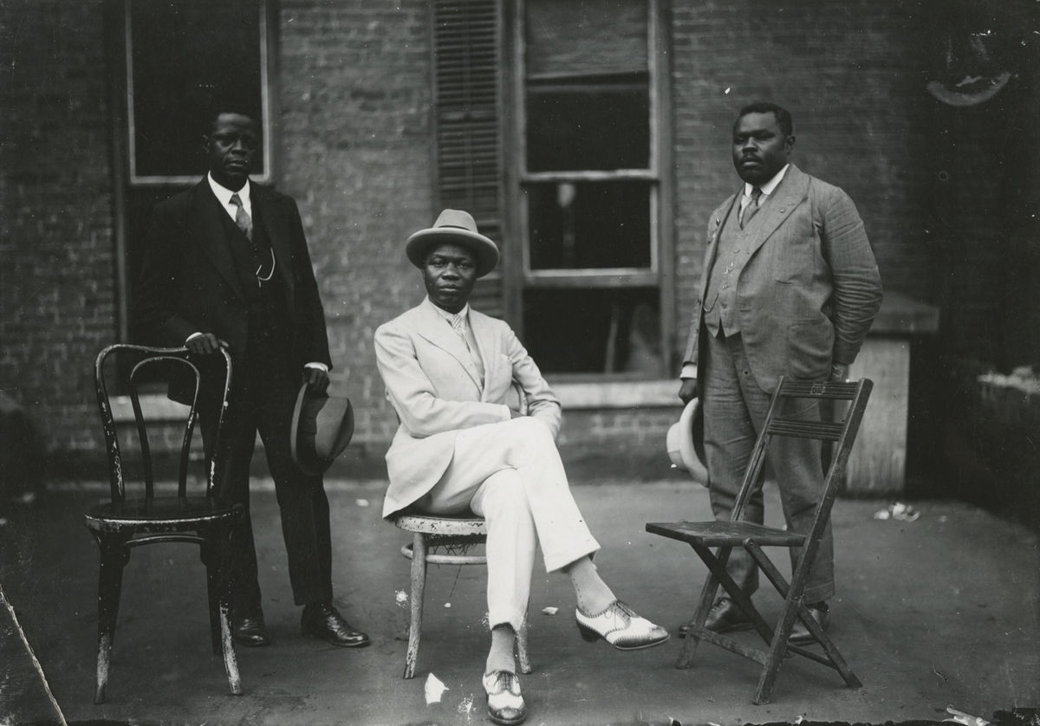
Evening Attire, 1922
Lady with Fur Jacket, 1935
A Member of Garvey’s African Legion with his Family Lady with Fur Jacket, 1924
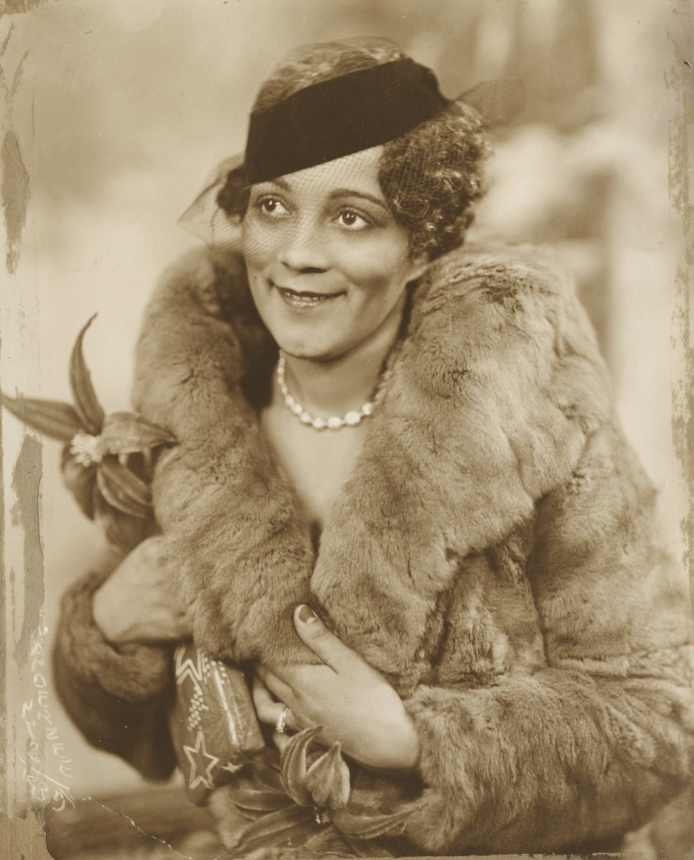

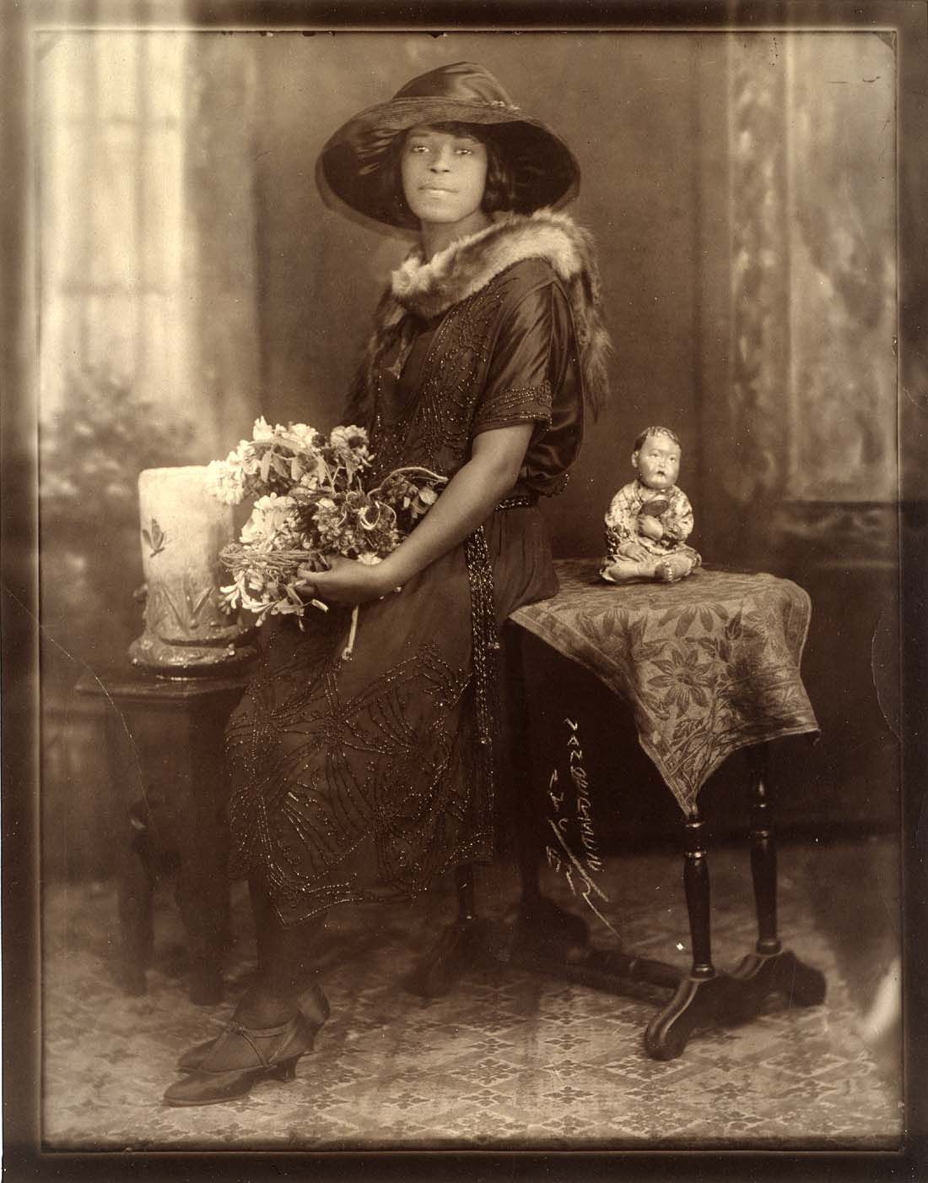
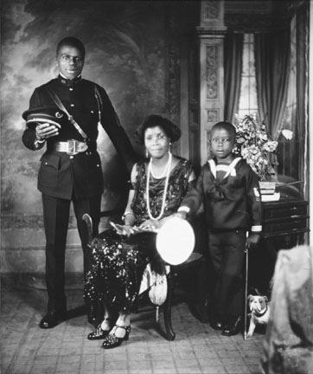
James Van Der Zee (1886 – 1983) was a renowned, Harlem-based photographer known for his posed, storied pictures capturing African-American citizenry and celebrity. James Van Der Zee developed a passion for photography as a youth, and opened up his own Harlem studio in 1916. Van Der Zee became known for his detailed imagery of African-American life, and for capturing celebrities such as Florence Mills and Adam Clayton Powell Jr. Following hard financial times, Van Der Zee enjoyed a resurge in his career during his later years.

HAR(T)LEM – HARLEM RENAISSANCE
FILE 4: PAINTING
Question 1
What does this painting feature from left to right?

Question 2
The painting could be divided into four historical parts representing different “aspects of Negro life”, as the title of the painting reads. What are they?

Question 3
Can you guess the sequel of the title of the painting? Justify your choice.
a – an Idyll of the Deep South
b – the Negro in an African Setting
c – Let my People Go
d – from Slavery through Reconstruction
Aaron Douglas, Aspects of Negro Life: ………………………………………………………………………………………………., 1934
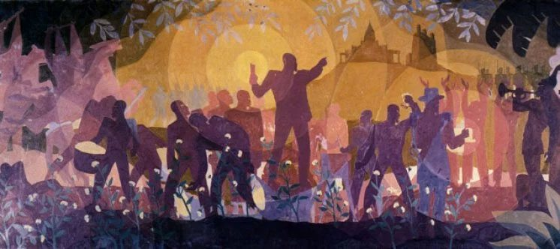

Aaron Douglas (1899 – 1879) was an African-American painter and graphic artist who played a leading role in the Harlem Renaissance of the 1920s and 1930s. His first major commission, to illustrate Alain LeRoy Locke's book, The New Negro, prompted requests for graphics from other Harlem Renaissance writers. By 1939, Douglas started teaching at Fisk University, where he remained for the next 27 years. Douglas created powerful images of African-American life and struggles, and won awards for the work he created for these publications. Douglas had a unique artistic style that fused his interests in modernism and African art.

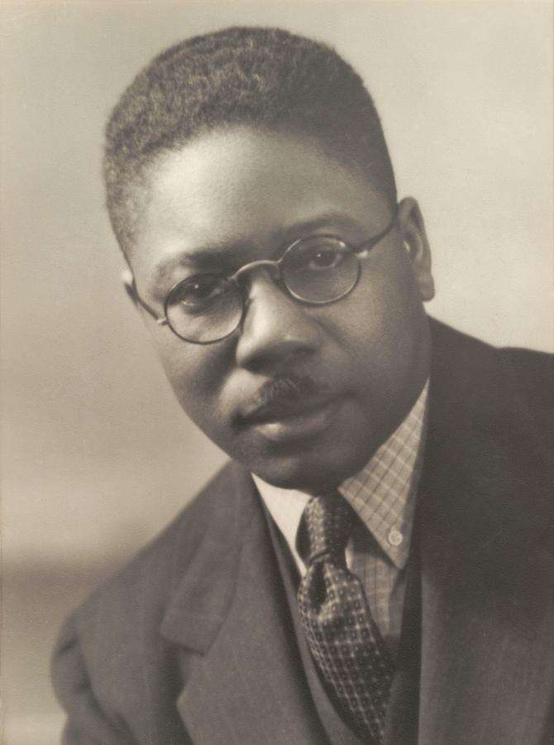

HAR(T)LEM – HARLEM RENAISSANCE
FILE 5: CINEMA & STAGE PERFORMANCE
Paul Robeson (1898 – 1976) moved to Harlem in 1919 while studying law at Columbia University. He was famous for being a civil rights activist, actor, athlete, and singer. Robeson also spoke out against racism.
Robeson played the lead role in many productions such as All God’s Chillun Got Wings, and The Emperor Jones. In 1925 he starred In Body and Soul, escalating his career and becoming a star throughout London. During the 1920’s, his singing and film career arose and from then on he was played the lead role in many movies, dramas, musicals and much more.

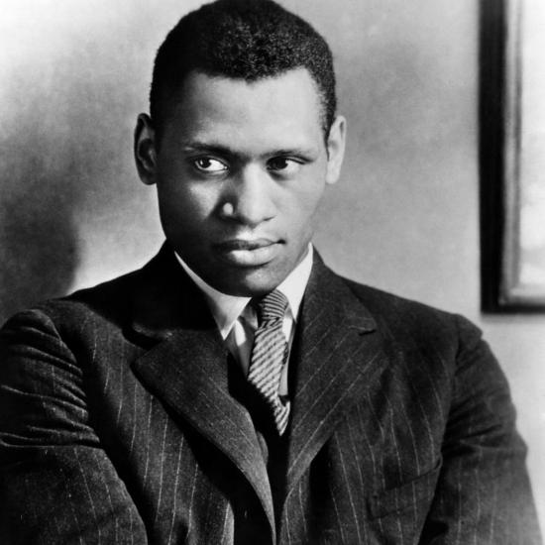

“As an artist I come to sing, but as a citizen, I will always speak for peace, and no one can silence me in this” - Paul Robeson
Born Freda Josephine McDonald in St. Louis, Missouri, Josephine Baker (1906 – 1975) spent her youth in poverty before learning to dance and finding success on Broadway. In the 1920s she moved to France and soon became one of Europe's most popular and highest-paid performers to headline the revues of the Folies Bergère in Paris. She worked for the French Resistance during World War II, and during the 1950s and '60s devoted herself to fighting segregation and racism in the United States.

In August 1922 Baker joined the chorus line of the touring show "Shuffle Along" in Boston, Massachusetts, before moving to New York to perform with the "Chocolate Dandies" at the Cotton Club and with the floor show at the Plantation Club in Harlem. Audiences loved her clowning, mugging, improvising comic style, foreshadowing her style as an entertainer.

Question 1
Why did Paul Robeson break with the past tradition with black performers at the time?

Question 2
Take a look at Paul Robeson’s famous quote. After reading the paragraphs concerning him, can you explain his quote in a more explicit way?

Question 3
a/ What kind of stage performance was Josephine Baker well-known for?
b/ How did she manage to bolster the Harlem Renaissance movement?
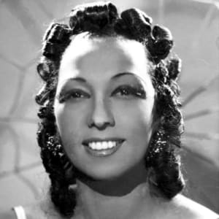
The Harlem Renaissance movement gave black actors opportunities for stage work that had previously been withheld. Traditionally, if black actors appeared onstage, it was in a minstrel show musical and rarely in a serious drama with non-stereotypical roles.
Robeson firmly believed that arts and culture were the best paths forward for black Americans to overcome racism and make advances in a white-dominated culture.
Paul Robeson was the epitome of the 20th-century Renaissance man. He was an exceptional athlete, actor, singer, cultural scholar, author and political activist. His talents made him a revered man of his time, and his beliefs all but erased him from popular history.

