Document 1 – The dark legacy of sex selection
Watch the video on the blog and take notes to make sure you can answer the following questions as precisely as possible.

1/ Identify the issue tackled in the video and locate it.
2/ Explain why this issue takes place?
3/ What happens sometimes when pregnant women get their ultrasounds?

Toolbox:

gender ratio = the sex rate
to deter someone from + V-ING = to dissuade someone from + V-ING
a curse = a cause of harm or misery (contrary for blessing)
abortion = pregnancy termination

Document 2 - The major critical arguments
Many critics who argue against non-medical sex selection do so because they believe that it is a sexist, and therefore wholly unethical, practice. Biomedical ethics experts Jonathan M. Berkowitz and Jack Snyder argue that non-medical sex selection exemplifies sexism in its purest most blatant form, and that because of this, it has the potential to cause widespread social harm. They believe that, because of the harms that are likely to be caused, legislative authorities are justified in curbing reproductive rights and liberties in this case. This is firstly because wider, more important social goals such as the eradication of sexism and the promotion of gender equality are at risk. Berkowitz and Snyder base their reasoning here upon the belief that male and female children are equally valuable and capable: they believe that social roles ought not be dictated by sex or gender. By encouraging parents to found their decision-making upon socially contingent, stereotypical concepts of sex, gender and gendered social roles, non-medical sex selection promotes and perpetuates sexism. Berkowitz and Snyder also believe that non-medical sex selection directly threatens the psychological welfare and future liberties of the resulting child, and this is their second core reason for rejecting the practice. Non-medical sex selection forces gendered social stereotypes upon children from the moment of their creation. Berkowitz and Snyder believe that there is a significant risk that heightened the levels of parental expectation (to conform to gendered roles), will psychologically harm children who wish to express their sex or gender in an unexpected manner. Berkowitz and Snyder clearly demonstrate that, as a practice that threatens harm to both society and individuals, non-medical sex selection is an ethically inappropriate exercise in parental choice.
Adapted from the British Medical Bulletin, Volume 94, Issue 1

Read the article. Take notes to make sure you can answer the following questions as precisely as possible.

1/ Are Berkowitz and Snyder in favour or against non-medical sex selection? Justify their opinion.
2/ Justify their point of view: list the consequences of non-medical sex selection according to them.

Toolbox:

gender ratio = the sex rate
to deter someone from + V-ING = to dissuade someone from + V-ING
a curse = a cause of harm or misery (contrary for blessing)
abortion = pregnancy termination

Document 3
A/ 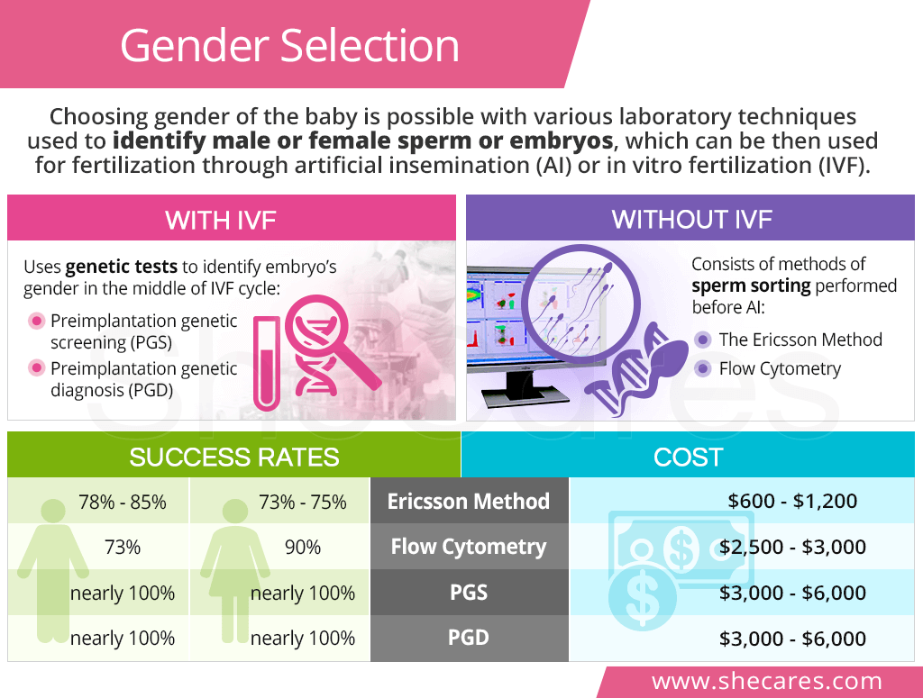
B/ Sex Ratio, Children under 15 Years of Age, by Country
(CIA World Factbooks)
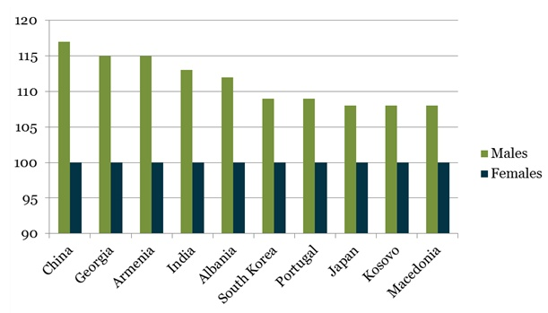

Take a look at the documents above and make sure you can answer the following questions as precisely as possible.

1/ What is the nature of these documents?
2/ What does each document deal with?
3/ What whole-new information does Document A reveal about sex selection interventions?
4/ What conclusion can you draw from Document B?

