Twitter activism and youth in South Africa: the case of #RhodesMustFall
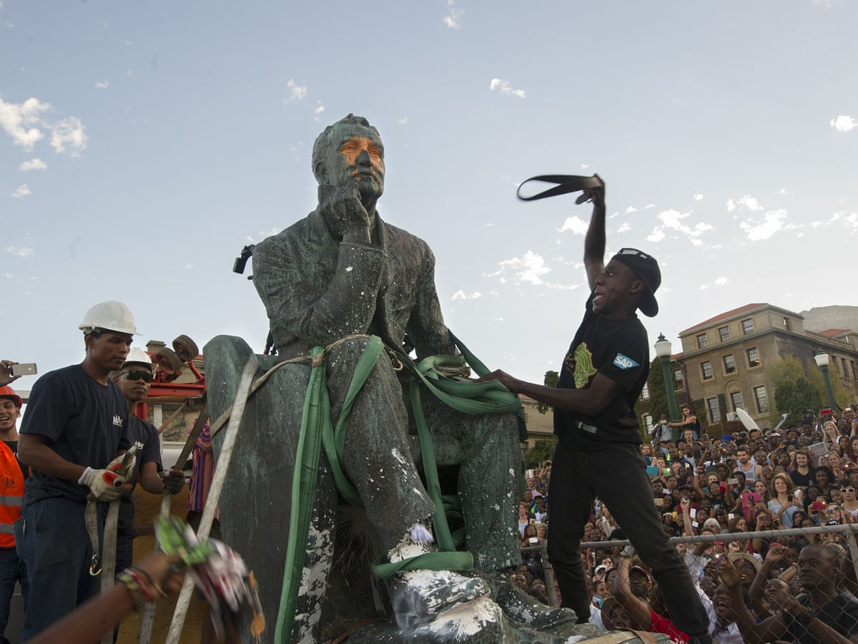

The South African student-led campaign known as #RhodesMustFall, commonly referred to simply as #RMF, illustrates youth activism and counter-memory via social networking site Twitter. The RMF campaign took place at the University of Cape Town and comprised student-led protests, which campaigned to remove the statue of British colonialist Cecil John Rhodes, as activists argued that it promoted institutionalized racism and promoted a culture of exclusion particularly for black students. […] Despite the digital divide in South Africa, and limited access to the Internet by the majority of citizens, Twitter was central to youth participation during the RMF campaign, reflecting the politics and practices of counter-memory but also setting mainstream news agendas and shaping the public debate. […] Youth are increasingly using social-networking sites to develop a new biography of citizenship which is characterized by more individualized forms of activism. In the present case, Twitter affords youth an opportunity to participate in political discussions, as well as discussions of broader socio-political issues of relevance in contemporary South African society, reflecting a form of subactivism.

Adapted from an article found on researchgate.net, March 2016

To answer the key question for the synthesis, you should be able to answer these questions:

1/ Explain what the protest movement is about.
2/ Find information about digital access in South Africa.
3/ According to the article, how does the internet enable young South Africans to take a stand?

