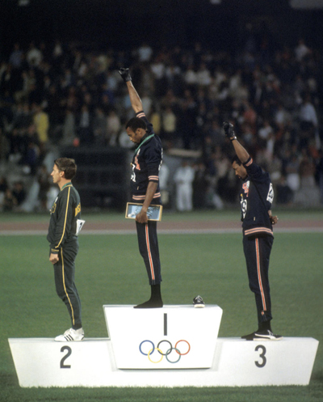

“Black Power”

The context

🡪 Until the end of the 1960s, the United States knew an era of **racial segregation**, which involved the physical separation and provision of separate facilities (such as restaurants, schools, hospitals, transport…) and included other forms of racial discrimination, such as unfair treatment in relation to obtaining jobs and education, on the basis of prejudice.

African Americans did not enjoy the same rights as whites.

🡪 The struggle for social justice (and to put an end to racial inequality) that many took place during the 1950s and 60s was called **the Civil Rights Movement**.

🡪 Championed by preacher Malcolm X and heavyweight boxer Muhammad Ali, **the Black Power Movement** emerged out of this fight as an important group that fought for black independence and black pride.

Tommie Smith and John Carlos

U.S. sprinters Tommie Smith and John Carlos finished first and third respectively in the 200-metre dash at the 1968 Mexico Olympics. As they received their medals, both sprinters were shoeless and wore black socks, symbolizing black poverty. Sprinter Tommie Smith wore a black scarf to symbolize black pride. During the national anthem, Smith and Carlos lowered their heads and gave a black power salute. Smith and Carlos were booed by the crowd and were ostracized by many athletes in America due to their actions. However, history remembers them as bold heroes who took a stand against injustice.

Peter Norman

The Australian athlete who ended in second position in the 200-metre dash at the 1968 Olympic Games in Mexico went by the name of Peter Norman, and is commonly referred to as the “Forgotten Black Power hero**” because of a visible detail** on his vest which cost him his career.

Indeed, on his left breast he wore a small badge that read: "Olympic Project for Human Rights" -- an organization set up a year previously opposed to racism in sport. But while Smith and Carlos are now feted as human rights pioneers, the badge was enough to effectively end Norman's career. He returned home to Australia a pariah, suffering unofficial sanction and ridicule as the Black Power salute's forgotten man. He never ran in the Olympics again.