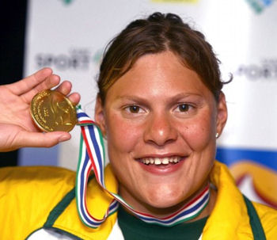

**Natalie du Toit**

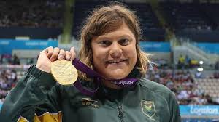 Born 29 January 1984, Natalie du Toit is a South African swimmer, best known for the gold medals she won at the 2004 Paralympic Games as well as the Commonwealth Games (an international multi-sport event involving athletes from the Commonwealth of Nations). She was one of two Paralympians to compete at the 2008 Summer Olympics in Beijing. Du Toit became the third amputee ever to qualify for the Olympics. The young woman from Cape Town had her left leg amputated after she was hit by a car while riding her scooter back to school in 2001.

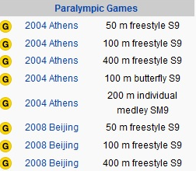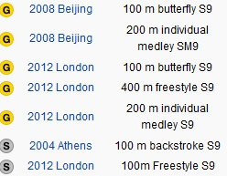



**Lee Pearson**

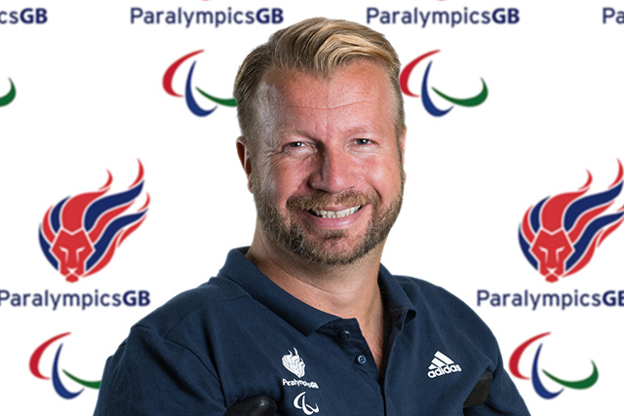Sir David Lee Pearson, born 4 February 1974 in Staffordshire, England is an undisputed star having represented British para-equestrianism in Sydney, Athens, Beijing, London and Rio. Over the course of his career he has won 30 gold medals at European, World and Paralympic level. Pearson was born with arthrogryposis multiplex congenita, that is a congenital joint contracture in two or more areas of the body.

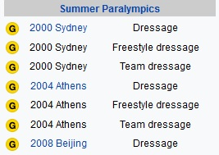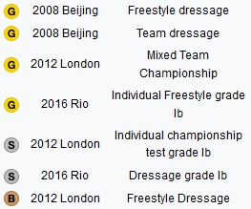

**Trischa Zorn**



Trischa Zorn (born June 1, 1964 in Orange, California) is a US swimmer. Blind from birth, she competes in Paralympic swimming in many disability categories. She competed in the 1980, 1984, 1988, 1992, 1996 2000 and 2004 Paralympic Games, and is the most successful athlete in the history of the Paralympic Games, having won 55 medals (41 gold, 9 silver and 5 bronze) and was inducted into the Paralympic Hall of Fame in 2012.

**Chantal Petitclerc**

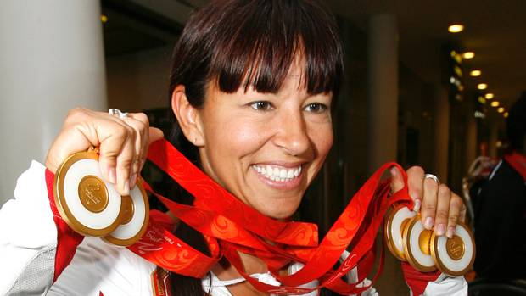 Chantal Petitclerc was born December 15, 1965 in Saint-Marc-des-Carrières, Quebec and is famous for being a Canadian wheelracer and a Senator from Quebec. At the age of 13, Petitclerc lost the use of both legs in an accident when at a friend’s farm, a heavy barn door fell on her, fracturing her spine. She raised profound interest in wheelchair racing, developed athletic skills and participated in several Olympic Games where she won a whole lot of medals.

