MURALS IN BELFAST

Match the following murals with the corresponding descriptions.

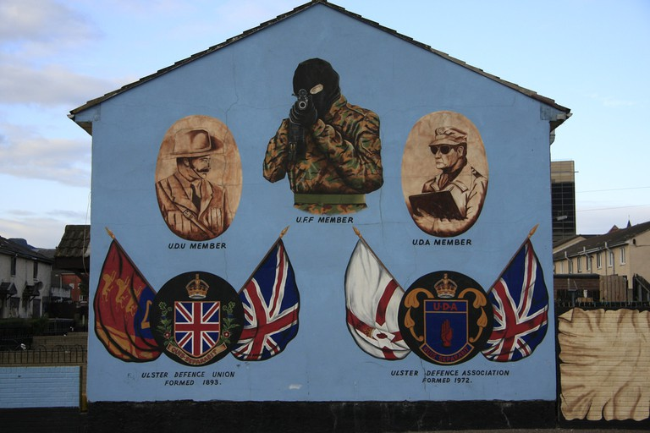

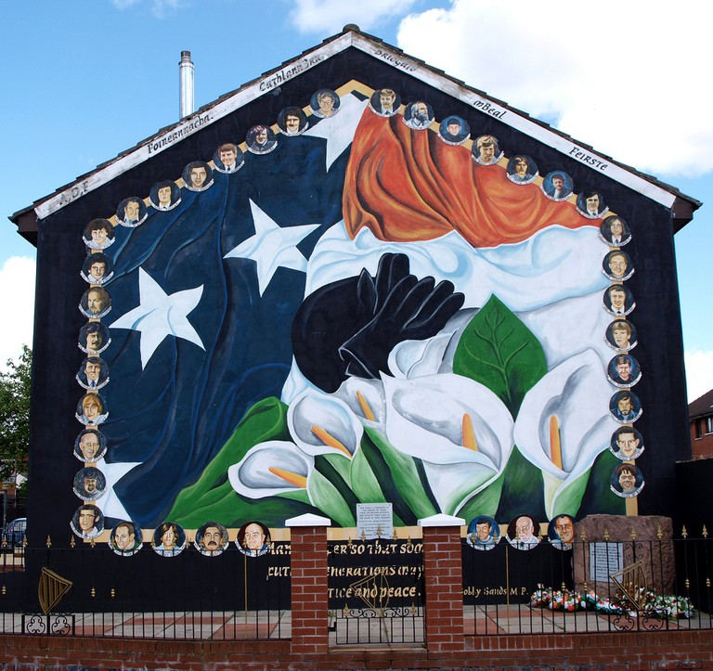

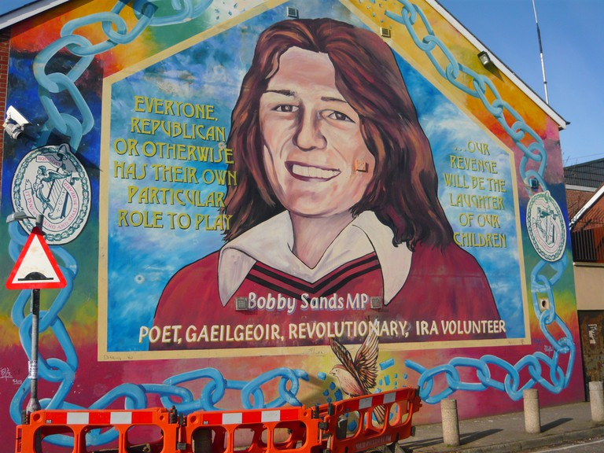

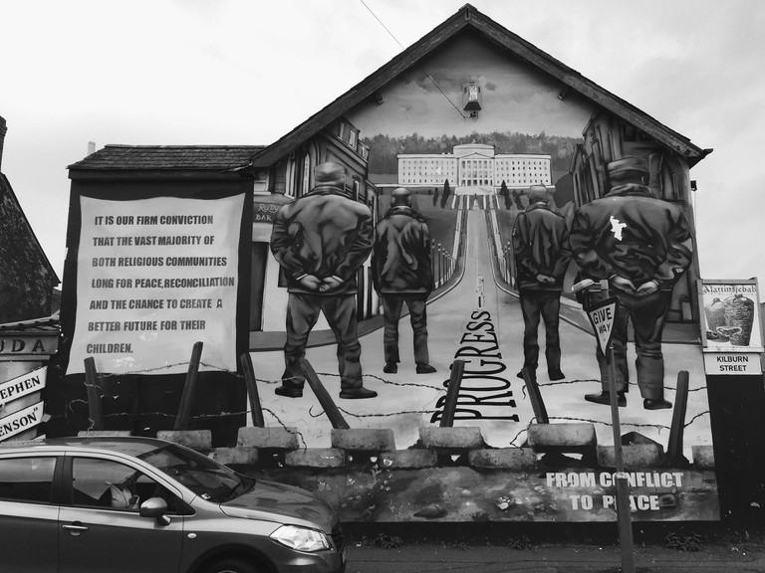

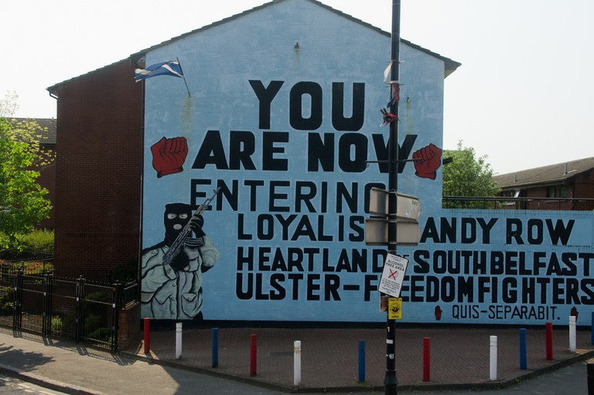

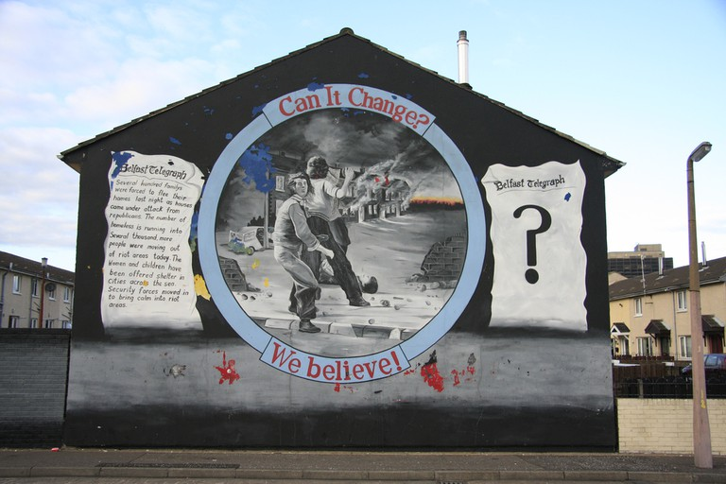



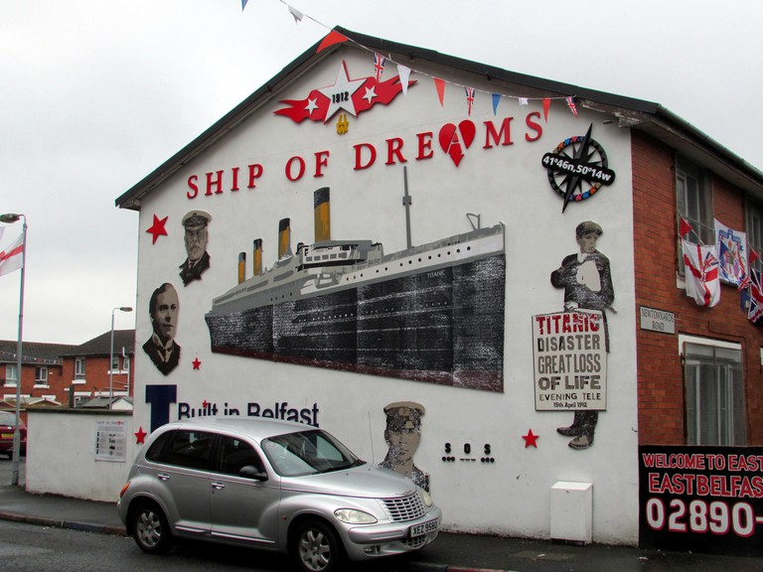

## ‘Can It Change?’ Mural

This Unionist mural depicts a family being evacuated from their home by Republican paramilitary groups, with the news report on the left. The right hand side shows an empty newspaper symbolising an unknown future for Northern Ireland.

Ulster Loyalist Tribute Mural

A tribute to all branches of loyalist communities, including the UDA and [UVF](https://en.wikipedia.org/wiki/Ulster_Volunteer_Force), together with their coat of arms.

**After matching each mural with its corresponding description, are you able to determine the category they belong to?**

|  |  |  |
| --- | --- | --- |
| **Unionist murals** | **Republican murals** | **Non-sectarian murals** |
|  |  |  |

## Tribute to RMS Titanic

This collage in East Belfast pays tribute to the [RMS Titanic](https://theculturetrip.com/europe/united-kingdom/northern-ireland/articles/the-pride-of-belfast-visit-the-titanic-exhibition/). Built in Belfast Harbour, it set sail in 1912 on its only voyage. The ‘Ship of Dreams’ made Belfast’s dock the major trading post that it is today, improving infrastructure and the workforce in the region now named Belfast’s Titanic Quarter.

## Tribute to Bobby Sands

Bobby Sands was a member of the paramilitary group the [Irish Republican Army](https://en.wikipedia.org/wiki/Irish_Republican_Army) and a member of the UK parliament. He led the 1981 hunger strike and died in Prison Maze while on strike.

## Irish Nationalism Mural

A tribute that reads: ‘This mural is dedicated to the memory of those local Republican activists who devoted their lives to the cause of Irish freedom.’ The portraits of [Hunger Strikers](https://en.wikipedia.org/wiki/1981_Irish_hunger_strike) create a border around an American and Irish flag, with lilies used to symbolise the 1916 Rising in Dublin.

## Progress Mural

A solidarity mural which shows all groups within the Northern Irish community looking toward the parliament building, Stormbound, which operates on Home Rule in Northern Ireland. The word ‘progress’ is used to symbolise a journey towards peace.

## Loyalist Entry Mural

A mural which marks the beginning of Sandy Row, a predominantly Unionist residence area in Belfast.