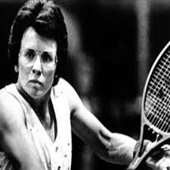
Muhammad Ali
1942 – 2016
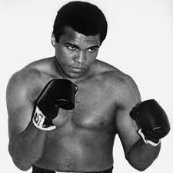
Arguably the greatest boxer ever. He was an Olympic gold medal winner and three-time world heavyweight champion.
During the 1960s, America was at war with with communists in Vietnam and Muhammad Ali was called up to fight in the Vietnam war. He famously replied “I ain’t got no quarrel with no Viet Cong”. Ali was not prepared to give his life, or kill Vietnamese, on behalf of a society that barely valued his life or that of his fellow-black men and women. His refusal to fight led to him being suspended from boxing. Muhammad Ali was also one of the first athletes to make a public political statement about the fight for racial equality in America.
Billie Jean King
1943 –
Number one female tennis player in the world in the 1970s. She won 12 Grand Slam titles and is one of the greatest players of all time.
In 1973 an ageing tennis star, Bobby Riggs, challenged Billie Jean King to the “Battle of the Sexes”, worldwide watched by 90 million people. He believed that even at 59 he could beat any woman tennis player, but he was defeated by King – 6-4, 6-3, 6-3.At the time, she said “If I didn’t win that match it would set us (women) back 50 years”.No other sporting event has played a more significant role in developing greater respect and recognition for women athletes. King is still highly active on Twitter, championing a variety of feminist causes.

LeBron James
1984 –
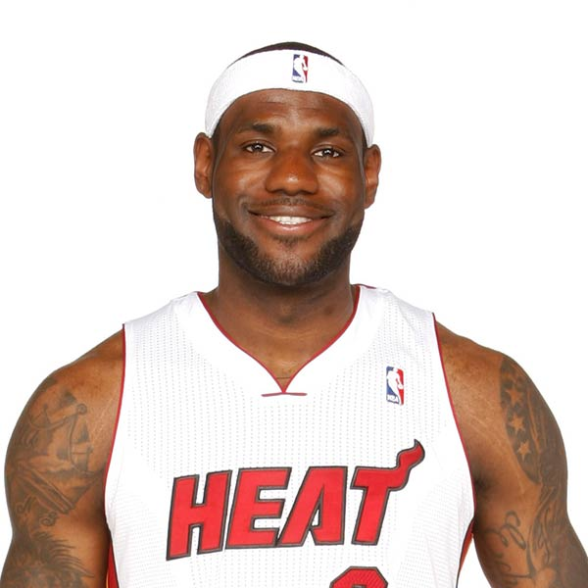
Possibly the greatest basketball player of all time – he is a four-time MVP (Most Valuable Player, that is the best player in the league, in the American NBA.
LeBron James is a huge figure in the fight for racial equality in America. In 2016, Laura Ingraham, a TV news host was not impressed by his activism and tried to silence the Cleveland Cavalier, saying “Shut up and dribble”, seeking to rebuke him for “talking politics”.That inspired him to become an even more active campaigner. Recently he has also established a charity – the LeBron James Family Foundation – in order to help young black people in disadvantaged areas to access education and training.
Colin Kaepernick
1987 –
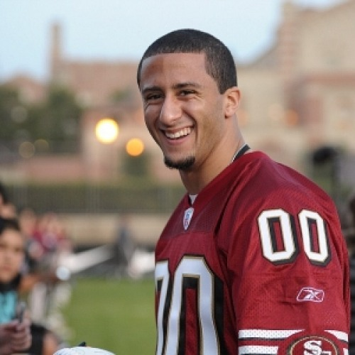
Colin Kaepernick is an American football player (quarterback) who is currently a free agent.
He attracted international attention when he decided to kneel during the American national anthem while playing for the San Francisco 49ers.
He was making a statement about the poor treatment of racial minorities in America and managed to revive a discussion about police conduct, racial injustice and oppression – an action which has won him several medals and awards for civil rights campaigning, though resulting in a wider protest movement, which intensified in September 2017 after President Trump said that NFL owners should “fire” players who protest the national anthem.
Simone Biles
1987 –
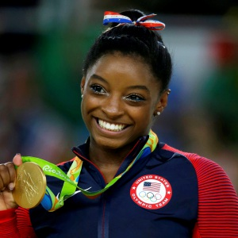
Simone Biles burst onto the scene in the 2016 Rio Olympic Games where she won four medals. Her unique style and unbeatable energy has led to her becoming the most successful US gymnast in history.
In 2018 she took a stand against Larry Nassar, a US gymnastics team doctor who was accused of sexual misconduct with hundreds of his patients. She twitted that she herself had been abused by him and said that she was “not afraid to tell her story”. As a consequence, Nassar was sentenced to 40 to 175 years in prison for sexually abusing dozens of young female gymnasts, including Simone Biles, under the guise of medical treatment.

Vocabulary battle :

Take a stand = state or express your opinion clearly

Under the guise of = by acting as if something is other than what it really is; under the pretence/pretext of…

Misconduct = bad behaviour / illegal actions in workplace

A free agent = a player not bound by contract to rebuke = to reprimand, to criticize

An owner = a proprietor a campaigner = an activist

Barely = very weakly To kneel = bend the knee

A quarrel = an argument, a clash In order to + V / So as to + V = with the objective to + V

To champion (a cause) = to defend, to support

An anthem = official song of a country

Significant = important A charity = an organization founded in order to fight for a charitable cause.

A statement = a written or oral declaration

