Unit 1 – Working Abroad – Clouds of words

Now that you have printed versions of your clouds of words, your job will be to update them with the new vocabulary words you will learn during the unit.

GROUP 1 – Adjectives describing qualities required for a job:

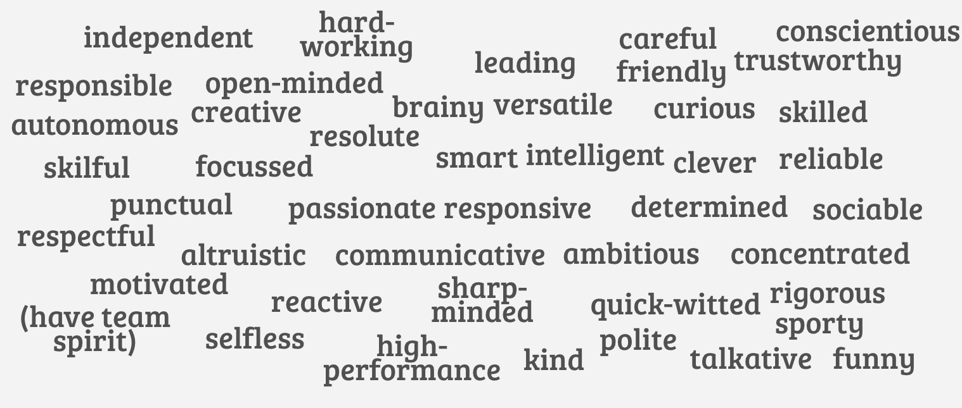

GROUP 2 – Verbs describing actions related to work:

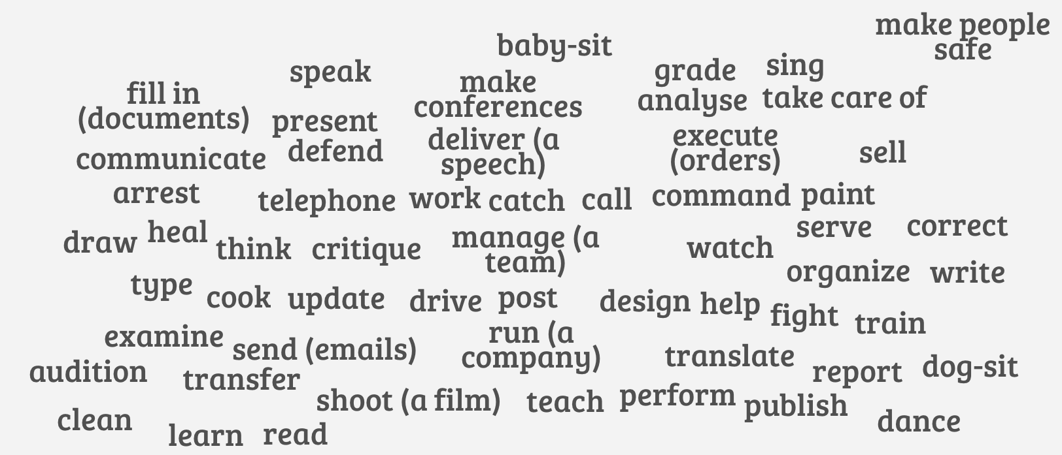

GROUP 3 – Nouns describing jobs, professional activities:

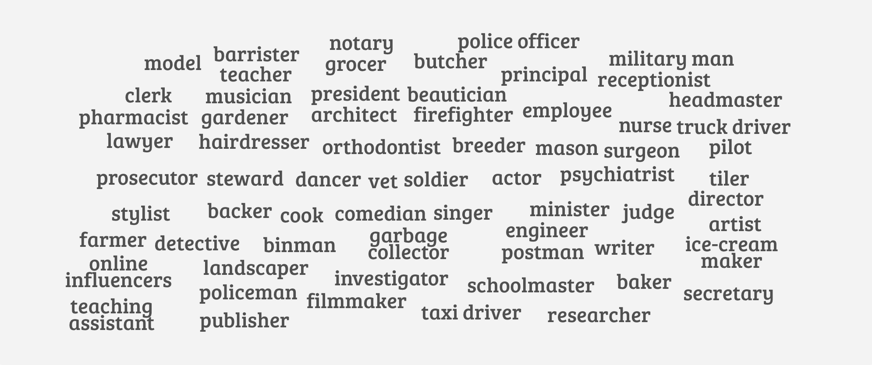

GROUP 4 – Nouns describing qualities required for a job:

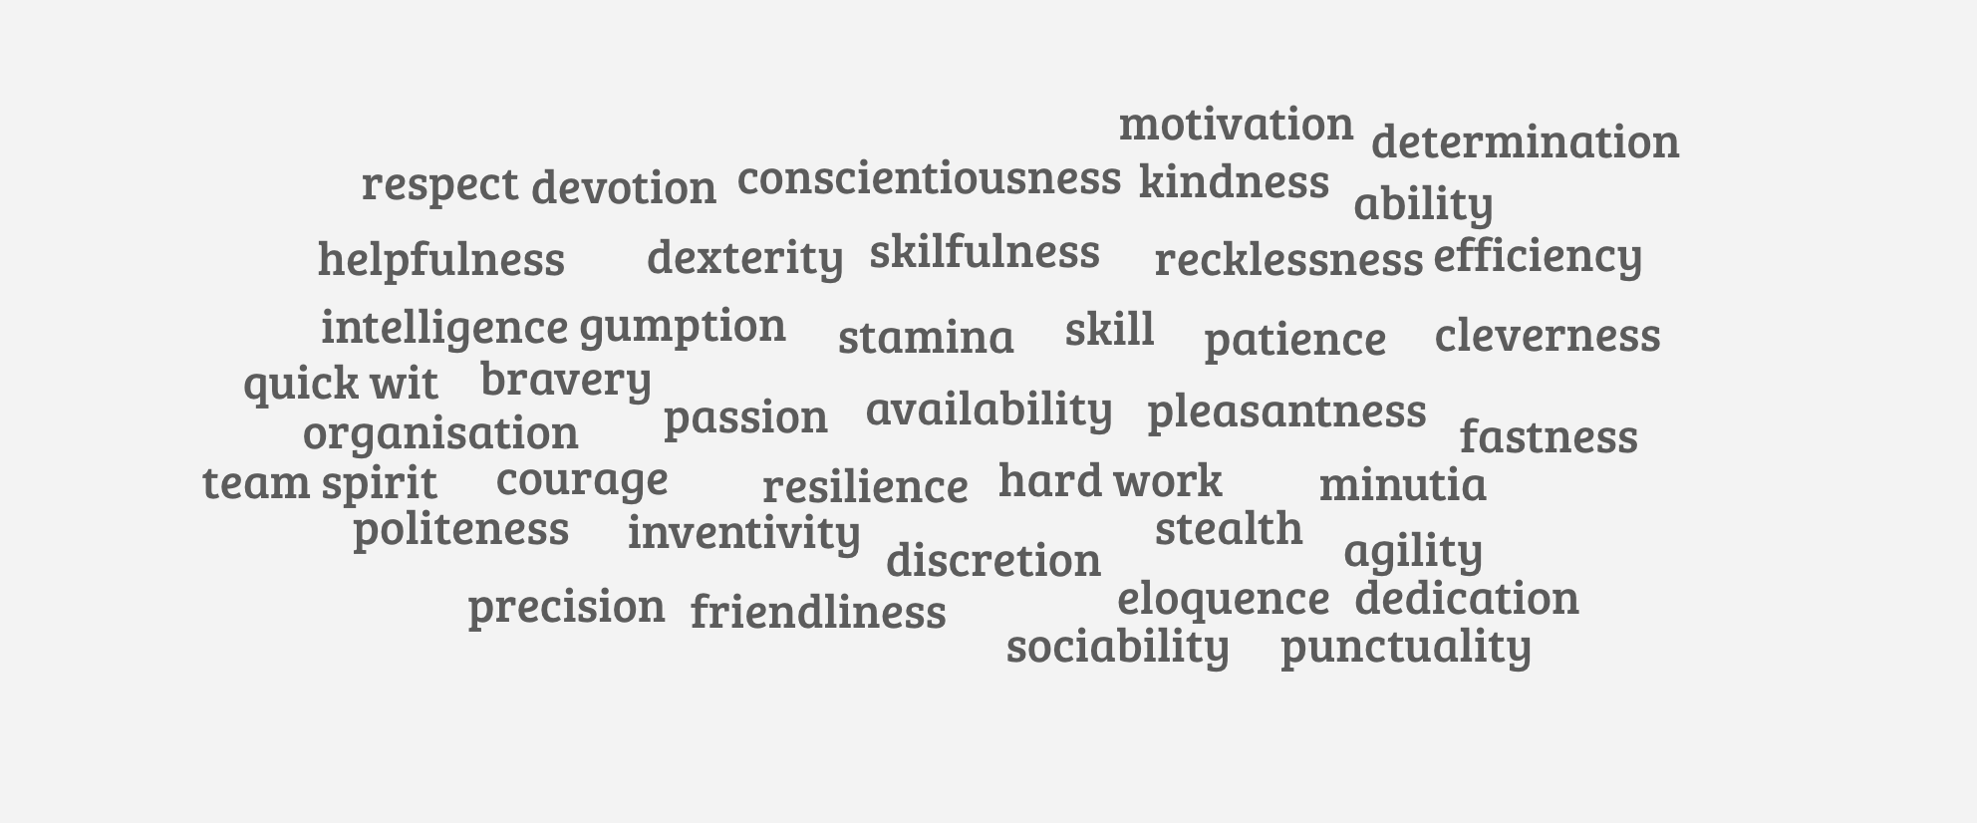

GROUP 5 – Nouns describing useful things to bring forward when you apply for a job:

Extra cloud: what are the different job experiences abroad you know about? Create your own personal cloud of words.

