Unit 1 – Obesity – Clouds of words

Now that you have printed versions of your clouds of words, your job will be to update them with the new vocabulary words you will learn during the unit.

GROUP 1 – Names describing junk food (brands are forgotten):

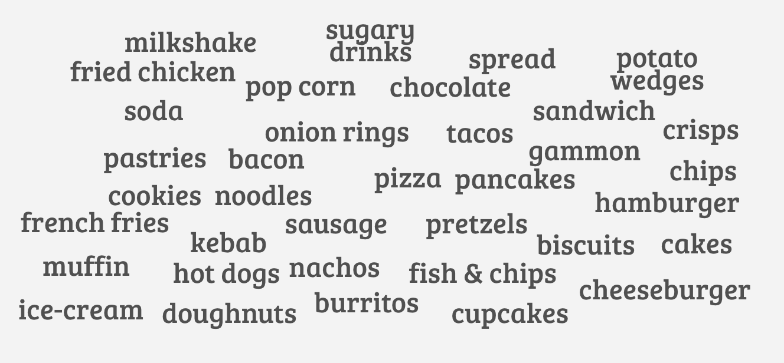

GROUP 2 – Adjectives related to weight & physical condition:

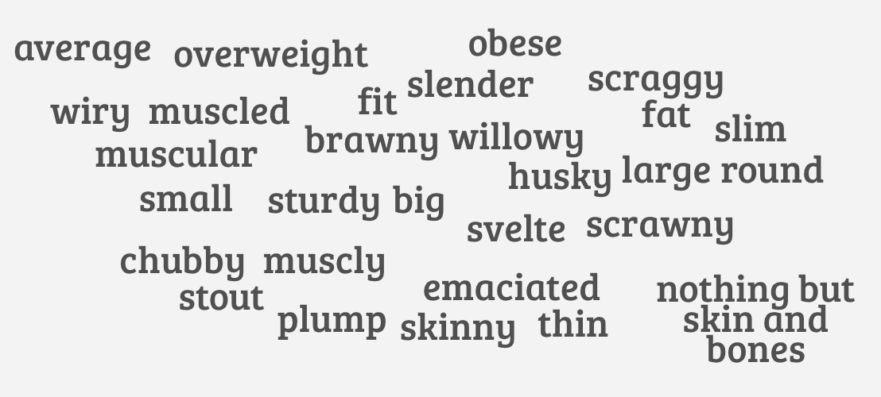

GROUP 3 – Nouns describing diseases and other consequences of overweight and obesity:
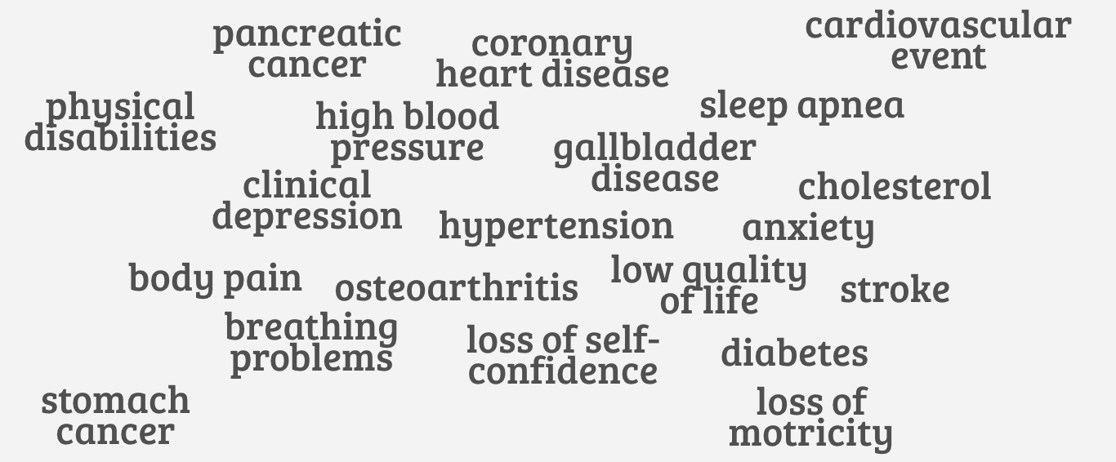

GROUP 4 – Causes & factors for obesity and obesity:
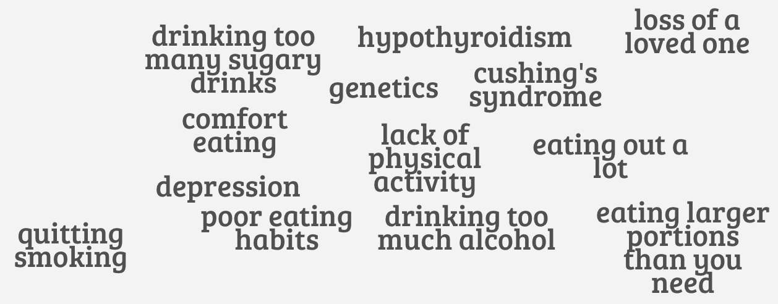
GROUP 5 – Solutions to avoid an increase in obesity rate:
