Washington DC the most famous city in the country.
If you go to Washington DC, you should visit the US capitol wich is one of the most popular building in the USA.
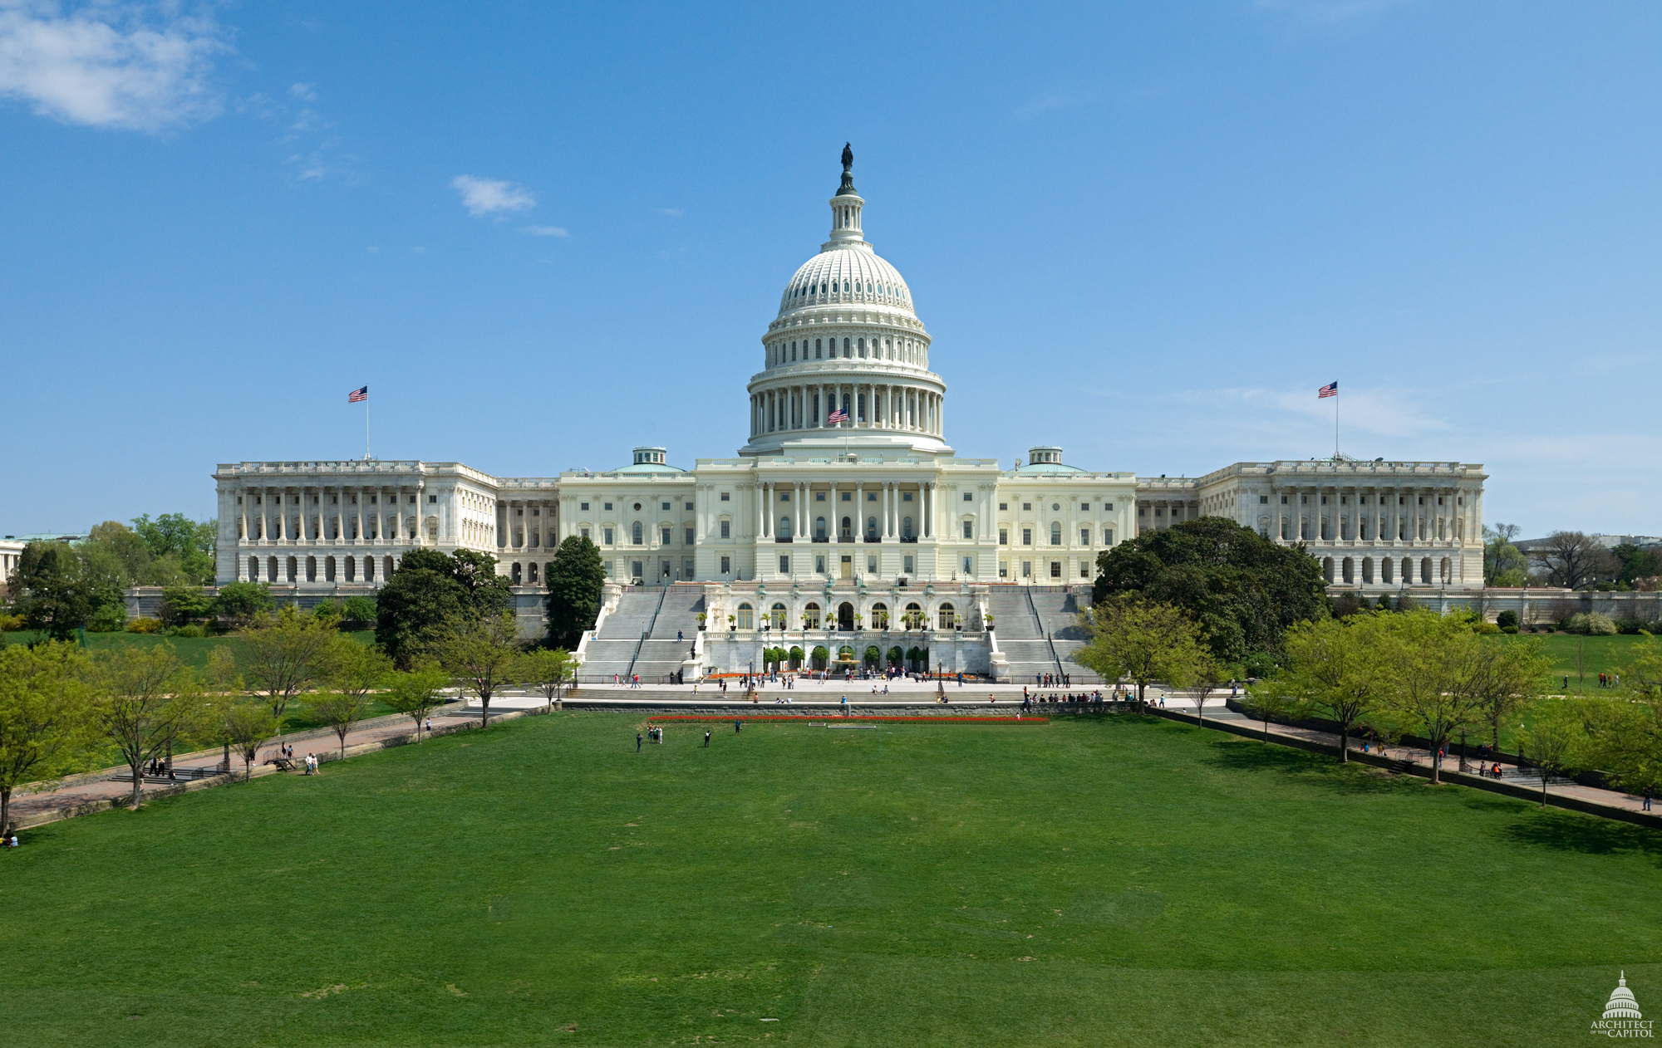

If you are romantic, you will be able to see the Potomac river. The Potomac river is such a wonderful wiew !
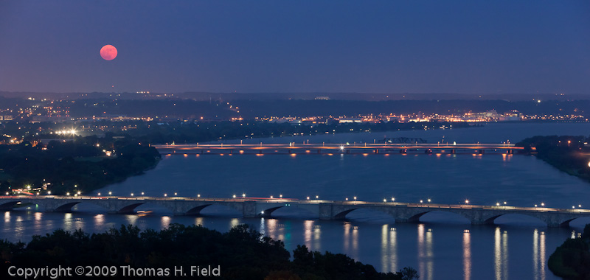

If you come to Washington DC, you will be able to relax next to the Tidal Basin. After you will go and visit the Jefferson Memorial.
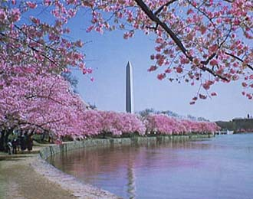
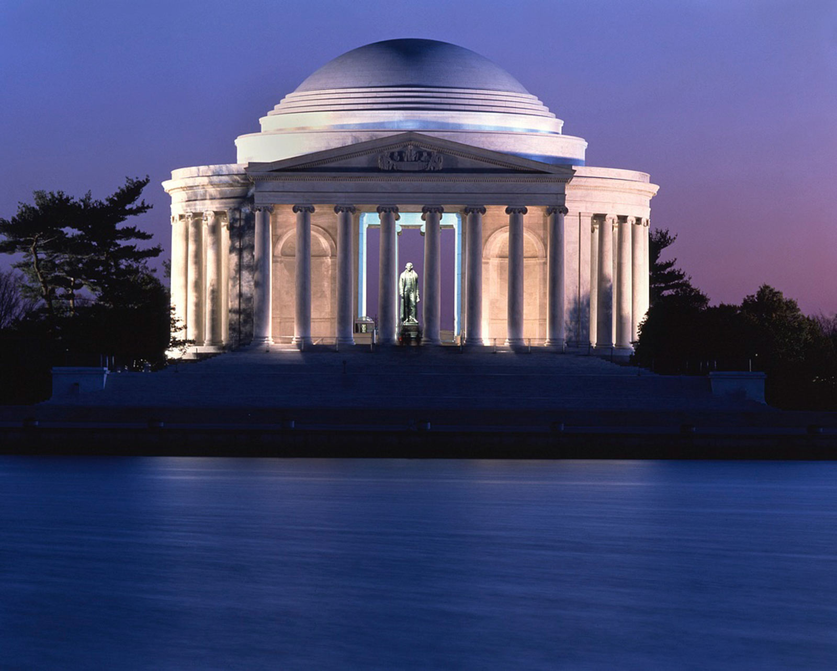

If you like famous buildings you should visit the White House wich is the most photographed building in Washigton DC.
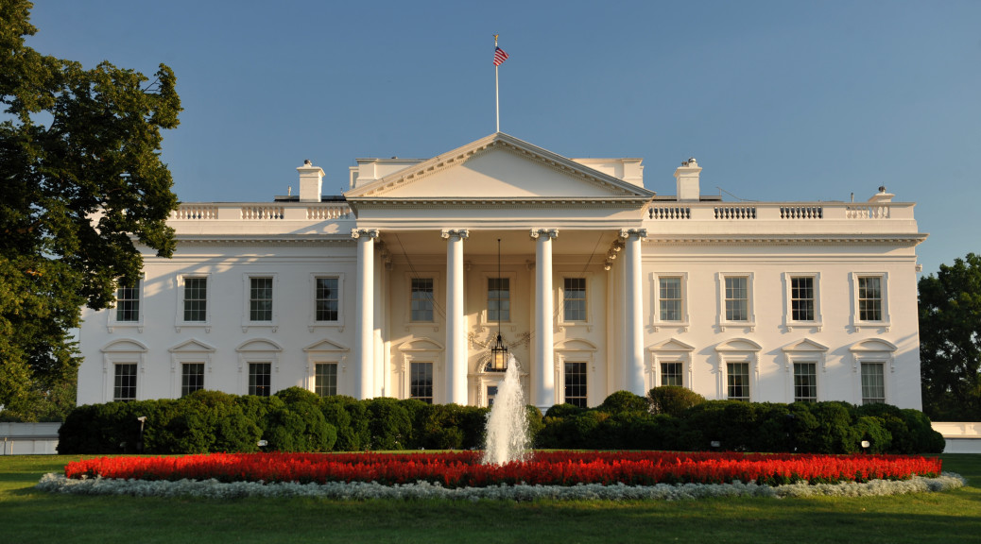

For more information you can write an E-mail at : washingtondc@enc92.com

