**Making people vote thanks to inspirational quotes**

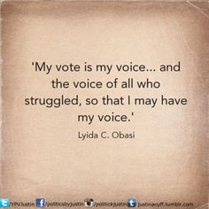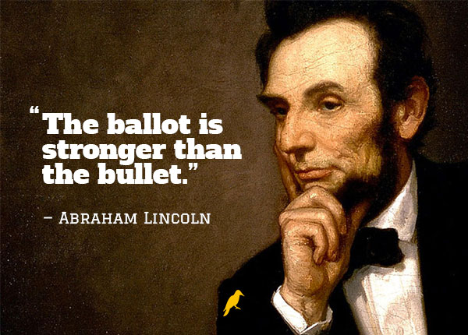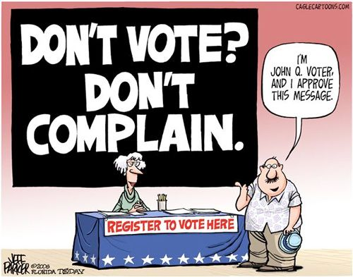

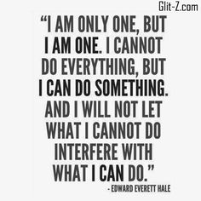

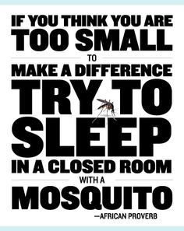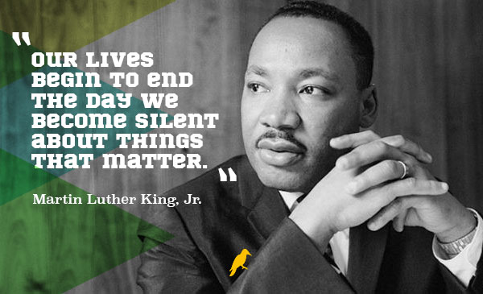

☞ Read these quotes.

☞ What is the message for each?

☞ Do you think a quote from a famous person can have an influence on people?

☞ Search the web for more inspirational quotes and pick your favourite to illustrate your quiz on US elections.