An apple crumble

I – Anticipation

1 – Match the ingredients and two domestic appliances (appareils) with the pictures:

apples / butter / flour / dark brown sugar / oven / ice-cream / dish / mixed fruit / granulated sugar /.
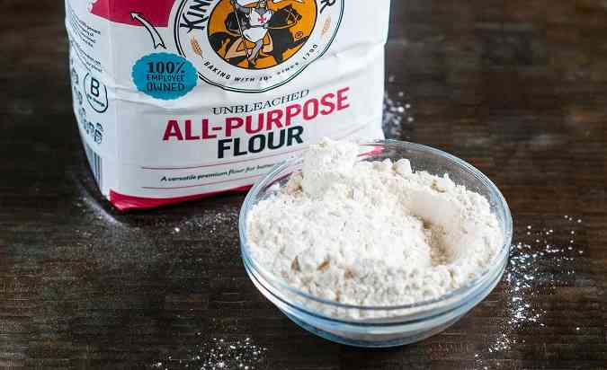
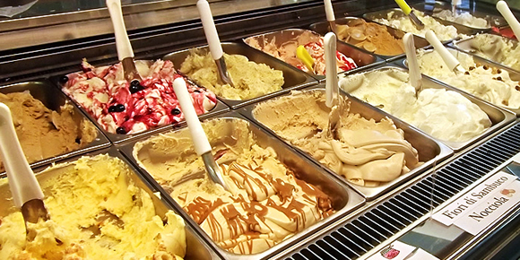
…..................................... ….........................................

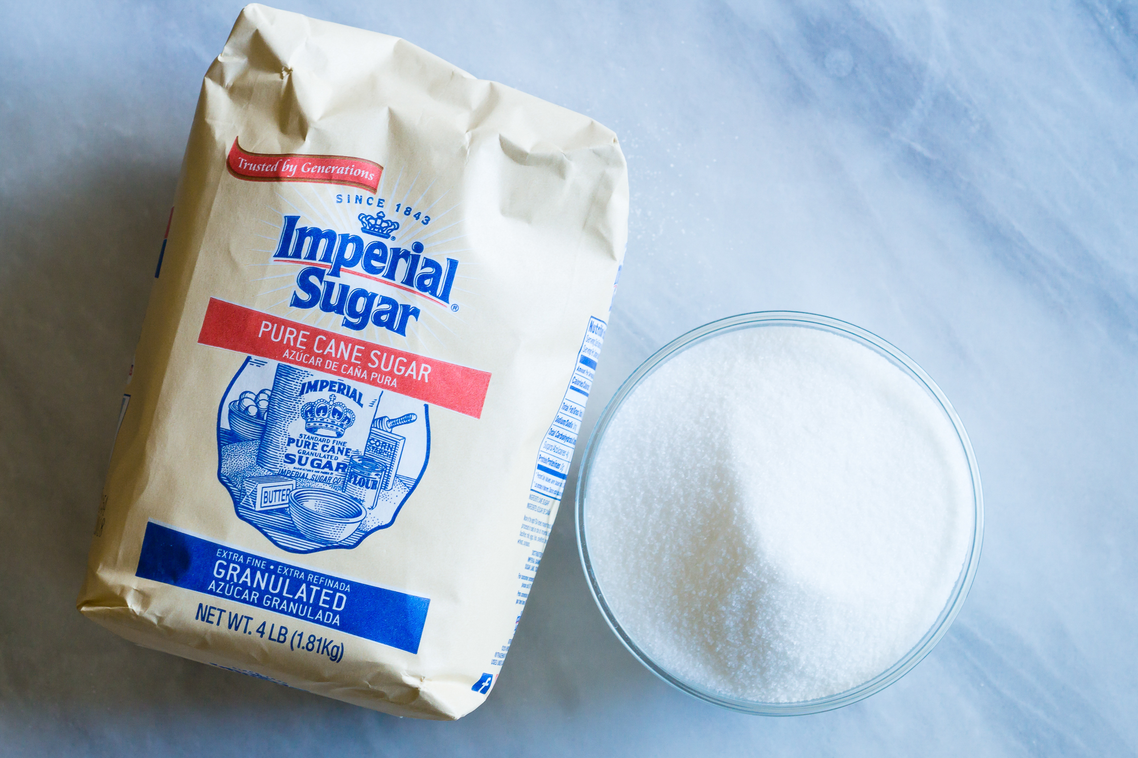
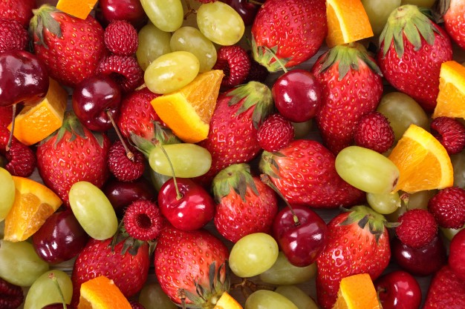

…....................................... …....................................
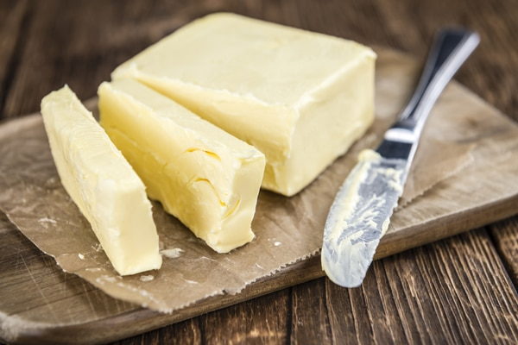
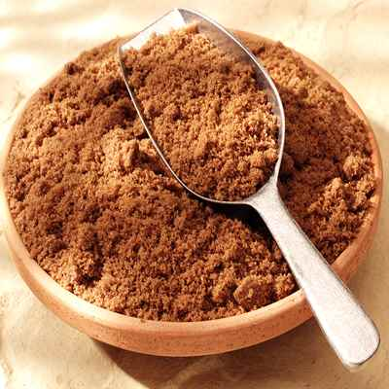
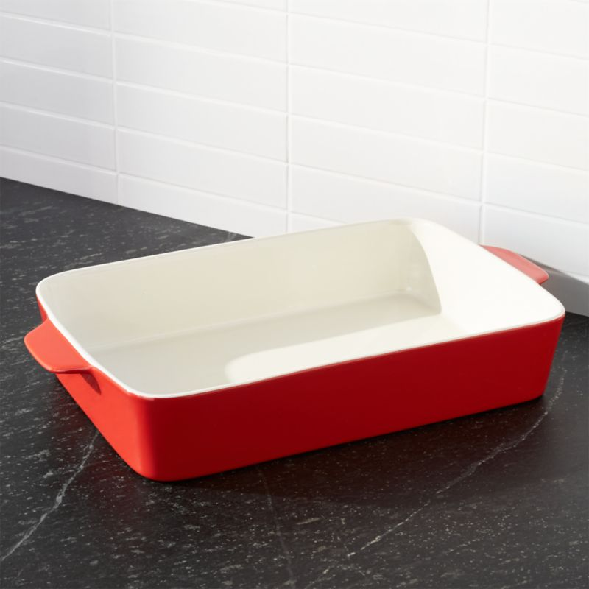
…....................................... …....................... ….........................
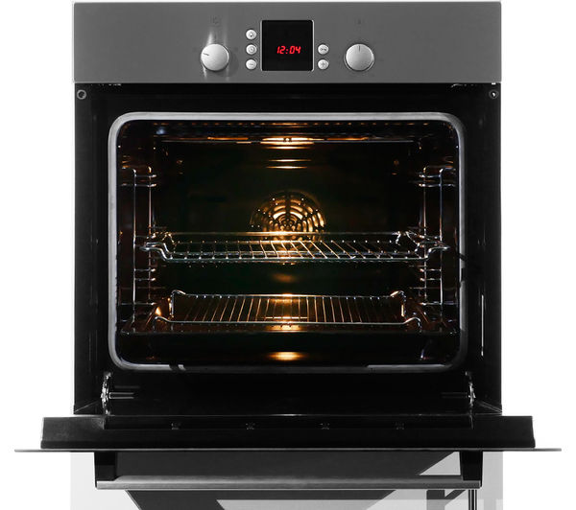
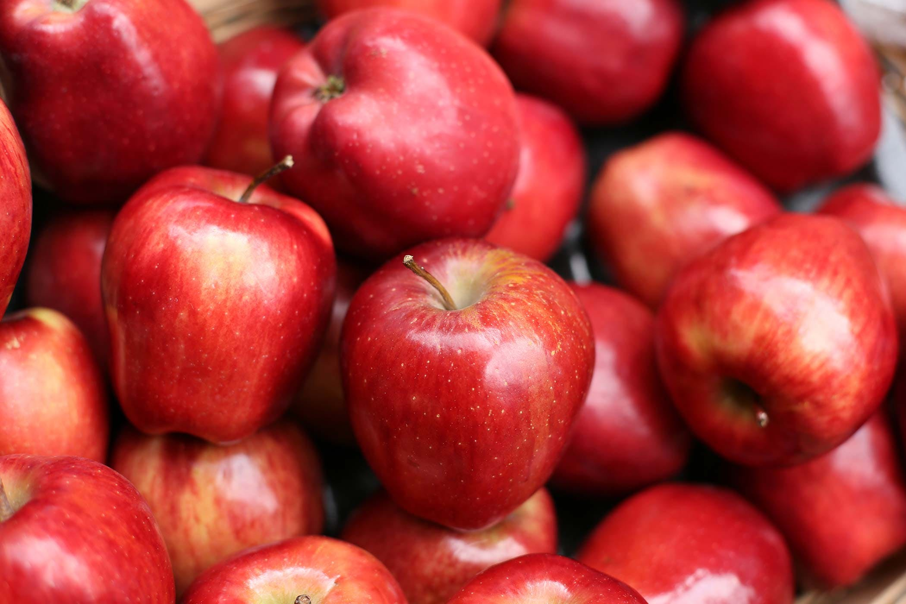

…........................................... ….............................................

2 – a – Find the verbs of action corresponding to the pictures:

chop / mix / put in an oven / sprinkle / rub / peel

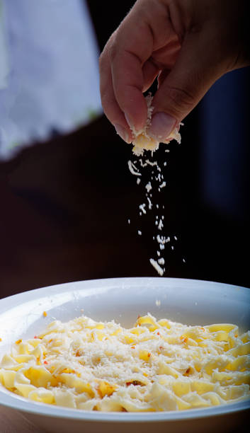
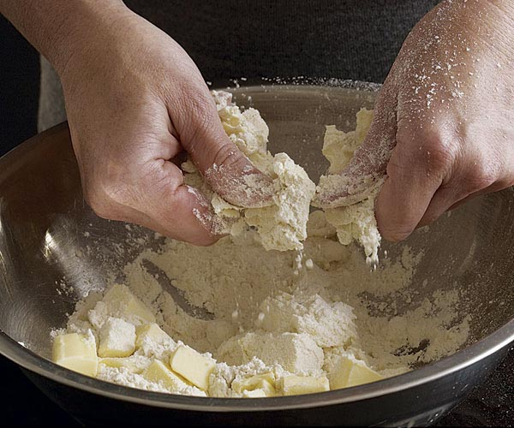
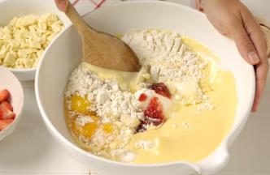

…................................ …...................................... …............................................

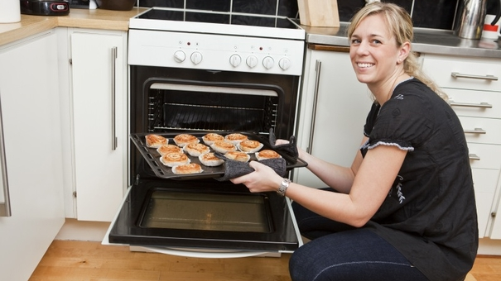
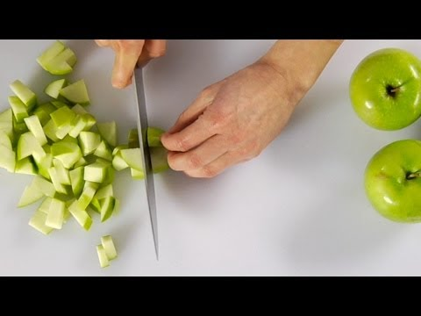
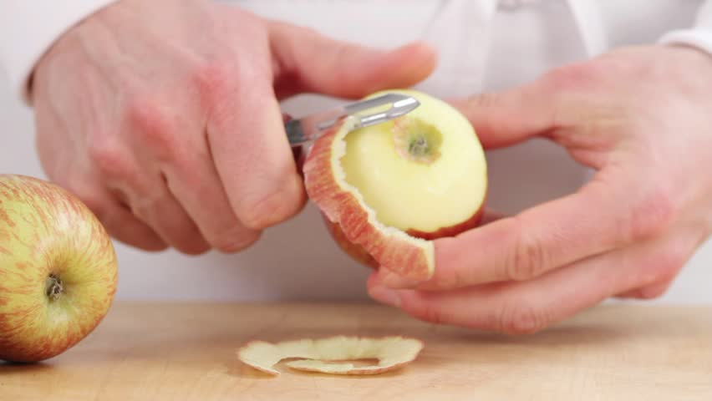

….............................................. …...................................... …........................................

2 – b – Write 6 sentences about the actions (use IS + V-ING)

photo 1: The woman ................................................................................................. .

photo 2: The woman ................................................................................................. .

photo 3: The woman ................................................................................................. .

photo 4: The woman ................................................................................................. .

photo 5: The woman ................................................................................................. .

photo 6: The man ...................................................................................................... .

