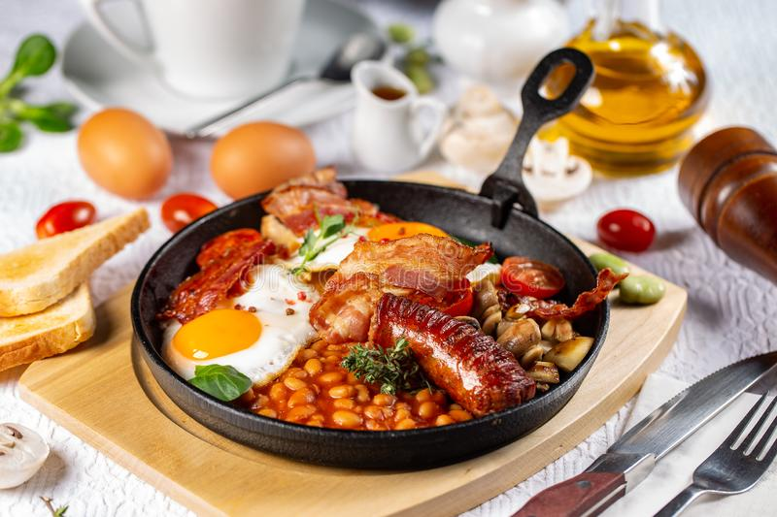

Chef d’oeuvre

English The brunch

I – Choose 1 recipe among the 4 (traditional English breakfast or carrot cake or apple and blueberry porridge or scones) :

My recipe is ……………………………………………………………………… .

II – Complete or highlight the different pieces of information about the recipe you have chosen :

1 – Serves : …………………………………………………………………………... .

2 – Preparation : ……………………………………………………………………. .

3 – Cooking : ………………………………………………………………………… .

4 – skill : easy medium difficult

III – Translate into English :

1 – The ingredients you need for your recipe :

………………………………………………………………………………………...
…………………………………………………………………………………………
…………………………………………………………………………………………
…………………………………………………………………………………………
…………………………………………………………………………………………

2 – The utensils you need for your recipe :

………………………………………………………………………………………..
…………………………………………………………………………………………
…………………………………………………………………………………………
…………………………………………………………………………………………
…………………………………………………………………………………………

3 – The verbs of action in the recipe :

…………………………………………………………………………………………
…………………………………………………………………………………………
…………………………………………………………………………………………
…………………………………………………………………………………………
…………………………………………………………………………………………
…………………………………………………………………………………………



