BE or HAVE ? ETRE ou AVOIR ?
Look, write, practise , memorize ! (forme pleine, forme contractée, forme négative)
I have got/ I’ve got/ I haven’t got
You have got/ You’ve got/ You haven’t got
He has got/ He’s got/ He hasn’t got
She has got/ She’s got/ She hasn’t got
It has got/ It’s got/ It hasn’t got
We have got/We’ve got/ We haven’t got
You have got/ You’ve got/ You haven’t got
They have got/ They’ve got/ They haven’t got
I am / I’m /I’m not
You are/You’re/ You aren’t
He is/He’s /He isn’t
She is/She’s/She isn’t
It is/It’s/ It isn’t
We are/We’re/ We aren’t
You are/You’re/You aren’t
They are/They’re/They aren’t

BE IN ENGLISH “AVOIR” IN FRENCH
be cold (He’s cold) 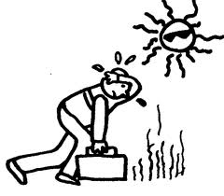be hot ( He is hot) 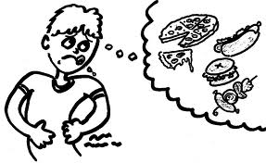 be hungry ( I am hungry)
be years old ( I am 12 years old) 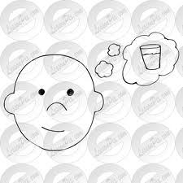 be thirsty ( He is thirsty)

Complete! I …………………..French and my best friend …………English. She ………….13 years old and she ……………from Brighton. She ………………………..two brothers. I(not)…………………………………any brothers and sisters but I ………………………………..two hamsters and a guinea pig! Today, it………………cold and I …………….tired and I………..hungry and my friends (not)…………………………………………..nice to me. It…………………a bad day.
Pair work : Yes /No questions ( BE HAVE).
Ask your friend these questions. You have the correct answer into brackets ( ) Whisper. Then, change roles. Your friend asks you the questions.
Are you French? (Yes, I am) ( No, I’m not)
Are you English? (Yes, I am) ( No, I’m not)
Are you 12 years old? (Yes, I am) (No, I’m not)
Are you cold? (Yes, I am) (No, I’m not)
Are you tired? (Yes, I am) (No, I’m not)
Is it hot today? (Yes, it is) (No, it isn’t)
Is Rihanna French? (No, she isn’t)
Is your best friend English? (No, he isn’t)
Are your parents strict? (Yes, they are) (No, they aren’t)
Are your teachers strict? (Yes, they are) (No, they aren’t)
Have you got a pet? (Yes, I have) (No, I haven’t)
Have you got any brothers and sisters? (Yes, I have) (No, I haven’t)
Have you got a problem? (Yes, I have) (No, I haven’t)
Has Barack Obama got blue eyes? (No, he hasn’t)
Has your friend got glasses? (Yes, he/she has) (No, he/she hasn’t)
Have your parents got a Ferrari? (No, they haven’t) (Yes, they have)
Have you got a computer at home? (Yes, I have) (No, I haven’t)

